**Reach Funding 2024**

**Application Form for Funding**

**Note: All DDLETB Reach Fund 2024 projects must be:**

1. **Submitted by 8th March 2024**
2. **Completed in their entirety on or before 31st December 2024**

**Section 1. Community Group/Project Information**

**Part 1 - to be completed by all applicants**

**Part 2 – only applicable where the ETB does not have the up-to-date details relating to Tax Clearance and Bank Account and where an external applicant is requesting fixed-term staffing sanction costs under Reach Funding**

|  |  |  |  |  |  |  |  |  |  |  |
| --- | --- | --- | --- | --- | --- | --- | --- | --- | --- | --- |
| **Section 1 – Part 1 – Community group/project** | | | | | | | | | | |
| **Name of Community Group:** | | |  | | | | | | | |
| **Title of project proposed:** | | |  | | | | | | | |
| **Proposed Duration of Project** *(please indicate if the project is to run for a fixed term with provisional dates or continuously throughout 2024):* | | |  | | | | | | | |
| **Contact details** | | | | | | | | | | |
| **Contact Person** | |  | | **Role within organisation** | | | |  | | |
| **Community Group Address** | | |  | | | | | | | |
| **Email** |  | | | | **Phone number** |  | | | | |
| **Funding** | | | | | | | | | | |
| **Have you previously received the Reach Fund (formerly known as Mitigating against Educational Disadvantage Funding - MAEDF)?** | | | | | | | | | **Yes** | **No** |
| **If yes, but not previously funded by DDLETB, please provide source(s) of this funding below:** | | | | | | | | | | |
|  | | | | | | | | | | |
| Have you applied forand received Reach Funding from another source in 2024? | | | | **Yes** | | | **No** | | | |
| If yes, please answer the following question | | | | | | | | | | |
| Source(s) of this funding | | | | Intended purpose of this funding | | | | | | |

|  |  |  |  |  |  |  |  |  |
| --- | --- | --- | --- | --- | --- | --- | --- | --- |
| **Section 1 – Part 2 – Complete if applicable** | | | | | | | | |
| **Tax Clearance – please provide details of your Tax Clearance Access with your application** | | | | | | | | |
| **Tax registration number:** | | | | | | | |  |
| **Tax clearance certificate number:** | | | | |  | | | |
| **CHY number (if applicable)** | | | | |  | | | |
| **Bank details – please attach header of bank statement with any financial details redacted.**  ***Please note: If awarded Reach Funding 2024 it will be a requirement to provide bank statements.*** | | | | | | | | |
| **Name of bank** | | |  | | | | | |
| **Address of bank** | | | |  | | | | |
| **Sort code** | |  | | | | **Account number** |  | |
| **IBAN** |  | | | | | | | |
| **External Applicants Only - Staffing Sanction Request – Limited to Fixed-term contractual arrangements only (if applicable):** | | | | | | | | |
| **Will you require additional staff for the purposes of this initiative:** | | | | | | | | **YES/NO** |
| **If yes, for what purpose?** | | | | |  | | | |
| **If yes, please give provisional duration of additional staffing requirement:** | | | | |  | | | |
| **Please provide details below of staffing sanction requests and attach relevant documentary evidence* of any such arrangements**  ***Note: Evidence of staffing costs are for the specific purpose of Reach Fund 2024are a requirement for this area of funding and must be provided in advance of the closing date of 8th March 2024 or this request will not be considered.***  ***\*Acceptable examples of evidence include:***   * Advertisements for posts for fixed-term staff for the specific purpose of the Reach Fund 2024 initiative * Employment contracts (with personal details redacted) for the specific purpose of the Reach Fund 2024 initiative * Payslips (with personal details redacted) for staff employed for the specific purpose of Reach Fund 2024 | | | | | | | | |
|  | | | | | | | | |

|  |  |  |  |  |  |  |
| --- | --- | --- | --- | --- | --- | --- |
| **Section 2 – project costs/funding** | | | | | | |
| **Cost of project** | **€** | |  | | | |
| **Grant request** (the grant amount sought in this application) | | | | **€** | | |
| If the total cost of the project is greater than the amount of the grant sought, please outline where and how the balance of funding will be secured: | | | | | | |
|  | | | | | | |
| **Project costs for each of the following, where applicable (***grant amount sought for each***)** | | | | | | |
| **Community Education Learner Assistance Support** | | **Green Projects** | **Participation of priority/target cohorts** | | | **Equality Awareness** |
| **€** | | **€** | **€** | | | **€** |
| **The Adult Literacy for Life (ALL) focused on specific three actions** | | **Pre-development phase community groups supporting marginalised groups** | | | **Support for refugee groups** | |
| **€** | | **€** | | | **€** | |

| **Section 3 – Project details** | | | |
| --- | --- | --- | --- |
| **Project outline and aims (maximum word count 250)** | | | |
|  | | | |
| Please provide a synopsis of the project proposed under the specific funding criteria **(as outlined in the Reach Fund 2024 Guidelines)** that the grant is sought for: | | | |
| **Funding Criteria** | **Target Group(s)** | | **Funding Purpose**  **(maximum word count 100)** |
| **Community Education Learner Assistance Support** |  | |  |
| **Green Projects** |  | |  |
| **Participation of priority/target cohorts** |  | |  |
| **Equality Awareness** |  | |  |
| **The Adult Literacy for Life (ALL) focused on specific three actions** |  | |  |
| **Pre-development phase community groups supporting marginalised groups** |  | |  |
| **Support for refugee groups** |  | |  |
| **Please select the target group(s) you wish to add to support this application as outlined in the guidelines and include any additional information regarding the groups (maximum word count 100)**  **E1** Priority/specific target group  **E2** ALL (Adult Literacy for Life) Strategy target cohorts  **E3** Educationally disadvantaged adult learners  **E4** Other FET learners accessing Community Education | | | |
|  | | | |
| **Please provide information demonstrating how this funding intends to mitigate against educational disadvantage for the cohort you are working with (maximum word count 200)** | | | |
|  | | | |
| **Please outline how the funding can complement and/or enhance the current provision of similar education in the area (maximum word count 150)** | | | |
|  | | | |
| **Please clarify how this funding will support your learners to achieve positive educational outcomes as a result of this support (maximum word count 150)** | | | |
|  | | | |
| **In relation to the above (positive educational outcomes) would you like DDLETB to provide a training course/educational to support this project? – YES/NO** | | **If yes, please expand (maximum word count 50)** | |
| **Please provide an estimated number of the beneficiaries of this project** | |  | |
| **How will the benefits of this funding be measured? (maximum word count 150)** | | | |
|  | | | |
| **Please provide information on how this project represents value for money and indicate what steps the project has taken to ensure avoiding duplication with existing services in the area (maximum word count 150)** | | | |
|  | | | |

|  |  |  |  |  |
| --- | --- | --- | --- | --- |
| **Section 4 – Submission Details** | | | | |
| **I declare on behalf of** *insert organisation name* | | | | |
| That I have the appropriate authority to make this submission for funding. This application for funding form is fully completed and the information provided is a full and accurate account of how the funding (if allocated) will be used in 2024.  I have also read the guidelines in the appendices below on DDLETB public procurement procedures, furniture & equipment capital grant limits, fixed-term staffing sanctions and I agree to abide by these in my application for Reach Funding 2024. | | | | |
| **Signature** |  | | **Print name** |
|  |  | |  |
| **Position in organisation** |  | | **Date** |
|  |  |  | |

**Applications to be submitted to DDLETB** *reachfund@ddletb.ie*

**Closing date for receipt of applications *Friday 8th March 2024 at 5.00pm***

APPENDIX I – DDLETB PUBLIC PROCUREMENT GUIDELINES ON THE REQUIREMENT FOR SUPPLY OF QUOTATION DOCUMENTS

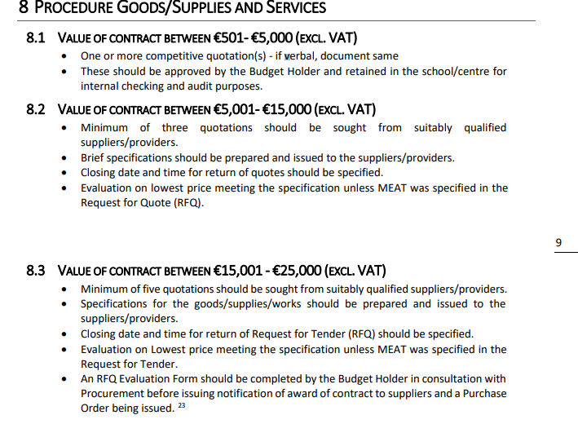

APPENDIX II – DDLETB GUIDELINES ON CAPITAL GRANT LIMITS FOR ITEMS OF FURNITURE & EQUIPMENT

***Furniture & Equipment Capital Limit***

The limit for the capitalisation of furniture & equipment is **€3,000 inclusive of VAT**.

This means that individual furniture & equipment items under €3,000 inclusive of VAT will be funded and managed by ETBs, in this case DDLETB, as outlined by SOLAS.

APPENDIX III – LIMITED FIXED-TERM STAFFING SANCTIONS (EXTERNAL APPLICANTS ONLY)

***There is limited scope to fund additional fixed-term staffing costs for external bodies for the purposes of Reach Funding 2024 initiatives***

We request that any staffing sanction request solely for the purposes of a project funded by Reach Funding 2024 is supported by ***documentary evidence\*\**** of the non-recurring, fixed-term nature of costs to the external non-ETB applicant. **All documents must be received before the closing date of 8th March 2024 or staffing cost applications will not be considered. Recurring or undocumented costs cannot be accommodated.**

***\*\*Acceptable examples of evidence include:***

* Advertisements for posts for fixed-term staff for the specific purpose of the Reach Fund 2024 initiative
* Employment contracts with personal details redacted for the specific purpose of the Reach Fund 2024 initiative
* Payslips with personal details redacted for staff employed for the specific purpose of Reach Fund 2024

*See section 1, part 2 of this form.*