Minutes of meeting of Dublin and Dun Laoghaire Education and Training Board held on MS Teams and using conference call.
Meeting: 4:30 pm, 17th May 2021

Documentation Uploaded Electronically

1 | Present:  Cllr Kazi Ahmed, Cllr Michael Clark, Cllr Yvonne Collins, Cllr Pamela, Conroy, Ken Farrell,  Anne Genockey, Daneve Harris, Cllr Peter Kavanagh, Cllr Pamela Kearns, Colm Kilgallon, Claire Markey, Gerry McGuire, Cllr Joe Newman, Brendan O'Halloran, Cllr John Walsh  Apologies:  Cllr Brigid Manton  Absent:  Cllr Cathal Boland, Paul McNally, Cllr Ed O'Brien, Cllr Una Power  In Attendance:  Caitríona Murphy, CEO; Debbie Howlett, Director of Organisation Support and Development; Nichola Spokes, Director of Schools, Trevor Moore, Director of Further Education and Training, Emma Maloney, PA to SMT.
2 | Declaration of Conflicts of Interest  No conflicts were declared
3 | Matters for the Resolution of the Board
 | Minutes:  The minutes of previous meetings held on 23rd February and 29th March 2021 were approved subject to amendments.  Action Log:  Members reviewed the action log. 4 action items were added and 5 action items were closed since the last meeting. | Proposed:  Gerry McGuire Seconded: Cllr  Kazi Ahmed  Agreed

 | Establishment of a Scholarship (R) Grange CC  The O’Riordan family wish to donate €1,000 per annum to be awarded to the Leaving Cert student with the best grade under the Anne Marie O’Riordan Award in memory of the former Deputy Principal who passed away. | Proposed:  Gerry McGuire  Seconded: Cllr  Pamela Kearns
 | Annual Report (R)  The Annual Report was presented to members reflecting what has been achieved in 2020 during an exceptional year. This is a template report issued by the Department of Education.  Chairperson‘s Statement  The executive confirmed that we as an organisation are compliant in all points of the statement. | Proposed: Cllr  Peter Kavanagh  Seconded: Cllr  John Walsh  Agreed
 | Committees of the Board (R) including Finance and Audit Committees | None
 | Standing Orders  Amendments to section 19 & 20 | Proposed: Cllr  Joe Newman  Seconded: Cllr  John Walsh
 | Board of Management Members Appointments  Members were asked to consider vacant board of management seats including DFEI | Deferred
4. | Matters for noting by the Board
 | Correspondence from The Departments Members noted circulars from the department. | Noted
 | Correspondence from Other Sources  Cllr Kazi Ahmed was nominated as DDL representative to IPB. | Proposed: Cllr  Michael Clark  Seconded: Cllr Joe Newman.

 | Policies  Members noted the policies for renewal | Noted
5. | Matters Submitted by the Executive
 | Report from the Chief Executive  CEO Report – Monday 17th May 2021  As we continue to operate in line with public health and government advice including that from the Department of Education and the Department of Further and Higher Education, all schools returned in full from the 12th April. Staff are still working from home in Head Office unless essential. This will remain the case over the summer months as we monitor the current situation.  I want to acknowledge and thank all of the schools, colleges and centres for their commitment and hard work in the re-opening of education and training services. I wish to thank all schools for the work currently on-going in relation to the accredited grades process for Leaving Cert students.  Since our last meeting, the Directors and OSD team have concluded the Annual Report, which will be presented to you here today. Thanks to all those involved in this work so that the members can carry out their reserved functions as outlined in the ETB Act. There is a significant effort required to meet the deadlines as part of our statutory obligations and I would like to thank all staff and particularly staff in Finance and Treasury.  In relation to fraud, I wish to advise you that we are requested by the Department to make a quarterly return in relation to any fraudulent activity that has occurred. We will make this return available to you also for information.  I acknowledge the leadership of the Directors and the work all staff – teaching/instructing/management, administration and support services – the wider DDLETB team and community. Each of the Directors continues to work in support of ETBI and have lead a number of events over the last number of weeks.  In relation to the OSD reports, we want to ensure we have enough time for the updates in relation to Buildings, HR and Finance. Debbie will take you through those after the updates from the Directors of Schools and the Director of FET. The Directors have worked | Noted

tirelessly to support each school, college and centre and all HO staff during the last challenging 15 months. I want to acknowledge them here today.

I want to remind you all about the Summer Connect Charity Week, a wonderful followup to our Winter Connect Event in December 2020. Firstly, we want to celebrate the hard work and achievements of everyone in our community of DDLETB. Secondly, we are supporting our chosen charity partner, As I Am and to raise awareness about Autism in Ireland and across DDLETB. We have an exciting week ahead with something for everyone; your support is very much appreciated. I want to thank Thea and Emma who brought this event to the SMT for approval and the digital team including Sam for supporting the roll-out of the event which kicked off this morning at 10am.

One of the Boards reserved functions is the approval of the Statement of Strategy and we want to commence the consultation with the Board in the first instance for the 20222027 Strategy Statement. This is a significant piece of work that we propose to have in place for the June meeting as we have met, if not exceeded, our responsibility in terms of meetings etc. Directors of Schools
Board of Management
Module two of the Board of Management training took place in April and May. Session two focused on the role of the Board as a corporate entity, effective Board meetings and the constitution of the Boards across all educational sectors within the ETB. These sessions were delivered via Teams Live with over 600 members attending over two sessions.
Module three takes place in June. This session will focus on the statutory obligations of the Board of Management in relation to Child protection Procedures, Child Safeguarding and the role of the Board in relation to the Admissions Act.
Schools Principal and Deputy Principal meetings took place for all schools on 6th May. These meetings focused on planning for the coming academic year and policy review in conjunction with Corporate Services in DDLETB.

The ETBI ICT Conference will take place on 14th June. This Conference is aimed at
Principals, Deputy Principals and all digital leaders/coordinators from schools across the ETB sector. The Conference will focus on how technology has been used by schools since March 2020 and what schools should prioritise for the next academic year.

Remote teaching and learning continues for all schools where required with communities of practice development and co-facilitation of digital school leads for inhouse training with DDLETB Digital Learning Lead continuing.
Directors of Schools continue to facilitate pop-up meetings with Principals and Deputy Principals.

Director of Further Education and Training
The phased return of learners to FET settings has continued since the last Board meeting. The most recent groups to return include VTOS, BTEI, LTI, Skills to Advance and Traineeship learners. The primary delivery mode continues to be online; the on-site return is limited to practical tuition and skills based assessments. DDLETB are following the guidance of ETBI and the FET Stakeholders Working Group.

DDLETB made a submission to the Fingal Development Plan 2023-2029. The submission outlined specific actions that support the expansion of education & training and youth service provision. The proposal included ambitions for a new FET College, new outdoor education facilities as well as growth of current service provision.
Development of the new Early Learning and Care programme on behalf of the 16 ETBs is nearing completion. The Programme Development Team will present the programme to an external validation panel of 6 QA and Childcare experts over two days at the end of May, after which the programme will hopefully be recommended for validation.
May is the busiest assessment period of the year, and the QA Unit has been supporting the Internal Verification (IV) and External Authentication (EA) processes taking into account the ongoing COVID 19 restrictions. Weekly training and drop-in clinics have been available to all teachers and QA staff to support them in the remote IV processes. Training has been delivered to EA’s who are authenticating remotely. There is also the option of in-centre visits for EA’s.

DDLETB led the Our Balbriggan Loves Learning Festival during the month of April. This promoted learning and upskilling opportunities across the community and in collaboration with partners such as Fingal County Council and the Department of Social Protection. The Festival was an enormous success with significant online engagement. There were over 3,500 views on the festival YouTube channel alone.

 | Finance  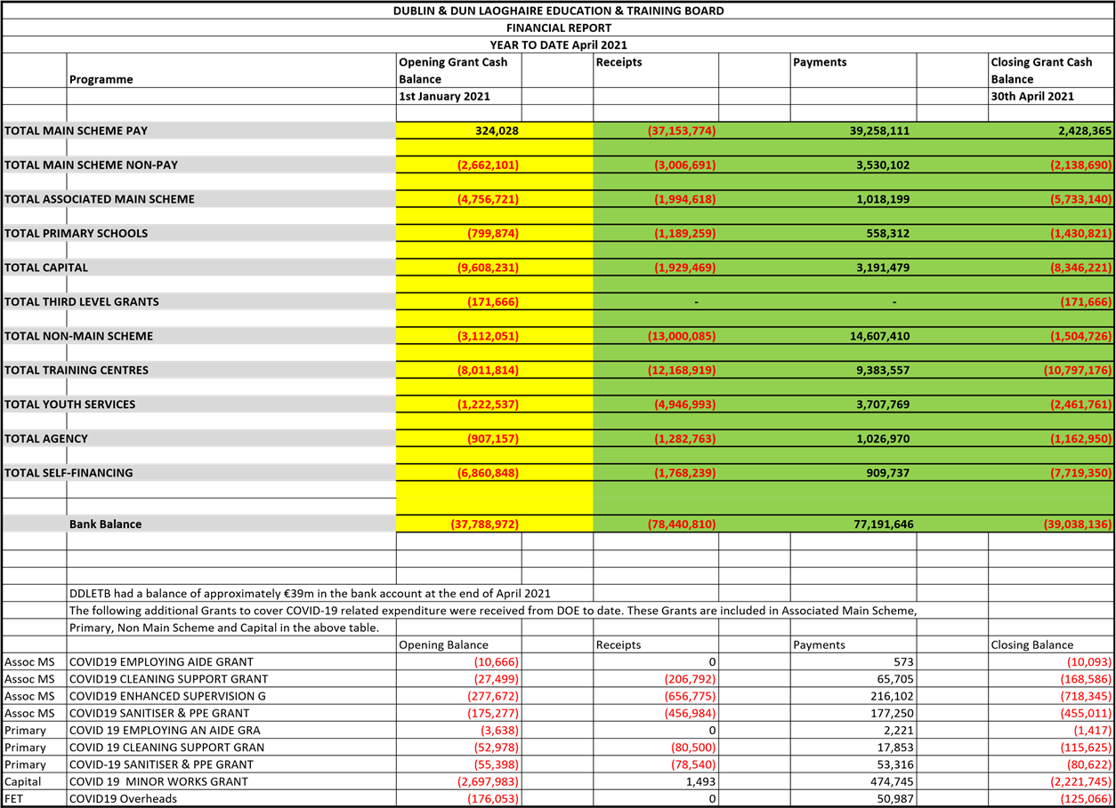 | Noted

 | DDLETB Meeting May 2021 Capital & Building Programme Report  Major Capital Projects 2021 |  |  |  |  | Noted
 |  | Name & Address Of Project. | Area. | Project Status/Update.
 |  | Balbriggan Community College, Pine Ridge, Chapel Street, Balbriggan. | North County Dublin  Fingal County Council Area | Construction of new School, Stage 2B being prepared for the Department of Education.
 |  | St Finian’s Community  College, Castle farm, Swords. | North County Dublin  Fingal County Council Area | Construction of Extension, 13 General Classroom’s & Specialist Rooms.  DDLTEB working with the DOE on a revised Scope.
 |  | Ardgillan Community College, Castle land, Balbriggan, Co.  Dublin. | North County Dublin  Fingal County Council Area | Planning Permission is now lodged for Remediation works. Awaiting DoE decision on Tender
 |  | Lucan Community College, Esker Drive, Lucan. | South West Dublin  South Dublin County Council. | Extension & Refurbishment. Stage 2B report comments received from DoE. Budget approved. DT comments issue to DOE. Awaiting approval  Pre-Qualification of  Contractors ongoing by Design  Team
 |  | Colaiste Chillian, 96-116 Old Nangor road, Clondalkin, Dublin 22. | South West Dublin,  South Dublin County Council. | Pre-Qualification of  Contractors complete.  Awaiting Stage 2b approved. Awaiting programme from DT with regards to tender
 |  | Benicasa Special School.  1 Mount Merrion Avenue,  Blackrock, Co. Dublin | South East Dublin. Dunlaoghaire/Rathdown County Council. | Refurbishment of existing Building.  Addressing Stage 2b comments

 |  |  |  | from DoE.Comments due end of May
 |  | CAPITAL PROJECTS CONTINUED
 |  | St Kevin’s Community College, Font Hill Road, Clondalkin.  Dublin 22. | South Dublin County Council Area. | SEN 2 Classrooms. Awaiting Stage 1 approval from DOE
 |  | Danu Community Special  School, Barnwell  Road, Hansfield, Dublin. | West County Dublin.  Fingal County Council Area. | Refurbishment of Classrooms. Design Team Tenders and Cost Plan approved by DOE. Preparation of tender documents ongoing
 |  | GS Reachrann,  Grange Abbey Road, Dublin  13. | North Co. Dublin | Pre- qualification of contractors ongoing. Awaiting DoE comments on  Stage 2b
 |  | Skerries Community College, Balbriggan St, Town parks, Skerries, Co. Dublin. | North Co Dublin.  Fingal County Council Area. | Design Team procurement up on ETenders
 |  | Mount Seskin Community College, Jobs town, Tallaght, Dublin 24. | South Co Dublin  South Dublin County Council | Budget Approved for new SNU. Design team being approved.
 |  | Collinstown Park  SEN, Rowlagh, Clondakin, Dublin 22. | South Co Dublin  South Dublin County Council. | Design Team Appointed.  Stage 1 report approved by  DOE. Planning Lodged
 |  | Summer Work’s Programme  2020. |  | Appointment of contractors being processed.
 |  | TEMPORARY ACCOMMODATION PROJECTS 2021
Name & Address of Project. Area. Project status/Update.

Fingal TA North Co Dublin Ongoing discussions between
Sea town Rd, Town parks, Fingal County Council Area the DOE, Fingal County
Swords, Co. Dublin. Council and the DDLETB.

Property Update : Leases/Licences
Leases

- Baldoyle Training Centre Satellite Unit – Lease for this centre was out in April 2020. The renewal lease is with our solicitors for review at present. Final Comments received from Solicitor.
- Dundrum Town Centre: FET Training unit. Lease renewal is being worked on at present with our solicitor. This will be ready for signing June 2021. Licences
- Lucan Community College – A 2 year licence was issued in January 2020 for use of the schools playing pitch by Arthur Griffith Park FC.

- Holmpatrick National School – Licence Expired in October 2020. A new License is now ready for signing.

- Scoil Aoife Community National School – Licence being drafted to allow Care & Cuddles Pre-school use an area in the school. With our solicitor at present.

- City west Campus – Temporally being used by the Department of Education & Skills to house schools affected by remedial works – Licence drafted and going to DoES for consideration.

Service Level Agreements: We are currently working with Fingal County
Council/Major stakeholders and Tulsa, to set up Service Level Agreements with all parties within shared buildings, this is to create more transparency on who is responsible for different area’s etc. The main building’s we are working on now.
- Ballydowd
- Balbriggan sports hall.

- Castle land’s Community Centre.
- Phibblestown Community Centre.
 | Staff Profile  Retirements  Resignations  Career breaks & Job Shares  (Note on Clarity for Career Break: A Career Break is a period of unpaid special leave for no less than 1 school year. It may be extended on an annual basis if the total period of the Career Break is not longer than 5 years at any time, and is a maximum of 10 years during a teacher’s career.)  Extension of the secondment arrangement in place for Paddy Lavelle for another year. | Noted  Noted  Noted  Proposed:  Gerry McGuire Seconded:  Cllr Michael  Clark
 | Risk Management Register  Risk register is available on SharePoint | For  Information
6. | Risk
 | - Risk Register  - Report from Audit & Risk Committee | Noted None
7. | Matters Submitted by the Members
 | Items submitted by the board.  In line with Standing Orders  Motion 1. Danu CSS/Riversdale CC; -  Request made that a letter on behalf of the board is sent to the Department to reconsider the decision on the Danu CSS and Riversdale CC. site. Motion 2. Posts of Responsibility; | Proposed:  Claire Markey Seconded:  John  Walsh  Proposed:  Claire  Markey
Seconded:
Gerry
Maguire
8. | Date of Next Meeting:  Monday 21st June 2021 | Noted

