Ergonomics Set Up Guide

Introduction:
Working from home poses some challenges, however, there are easy, straightforward steps, which can be taken to minimise risks and to maximum comfort and productivity.

2.0 Purpose:
This guideline has been developed to help guide employees on how to achieve a similar ergonomic set-up to that achieved at work.

3.0 Scope:
This guideline applies to all employees within DDLETB who are part-taking in remote working.

4.0 Organising your workspace at home:
The objective at home is to try to achieve a similar ergonomic set-up to that achieved at work. A neutral upright posture should be adopted. Ensuring your work desk/work station is set-up correctly will facilitate good posture and reduce the likelihood of musculoskeletal disorders (MSDS) including Work Related Upper Limb Disorders (WRULDs) and Repetitive Strain Injuries (RSIs), which may cause soft tissue injuries that affect the muscles, tendons, nerves, ligaments, joints and/or blood vessels.

4.1 Ergonomic tips to improve your workspace at home:

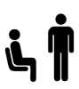
Position your screen correctly Change positions

To reduce eyestrain, position you Avoid awkward, static postures by screen arm’s length from your face. regularly changing position from sitting to standing.

Lighting
Glare on the screen should be avoided to reduce eyestrain. To avoid glare, situate the screen away from window light and close blinds/curtains when necessary.

Give your eyes a break
Every 20 minutes, for 20 seconds focus object 20 feet away.

This allows allow eye muscles to rest.

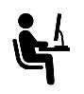
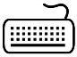
Keyboard Chair
Awkward wrist, arm and shoulder Adjust your chair so your feet are flat on positions may lead to discomfort the floor or use a foot rest if and/or injury. Adjust the height of required. Ensure your lower back is fully
the keyboard if possible so that your supported by the lumbar support in wrists are in line with your forearm. chair.

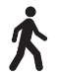
Get up and move
Break up long spells of screen work with rest breaks (at least 5 minutes every hour) or changes in activity.

4.2 Regular Stretching:

The following stretches can be performed at any time during the day. All of the stretches should be performed slowly and in a controlled manner. Not everyone has the same range of movement so, if at any time, you feel any discomfort or pain beyond the intended stretch, do not push beyond it, stop and return to centre.

Figure 1: Simple Stretches:
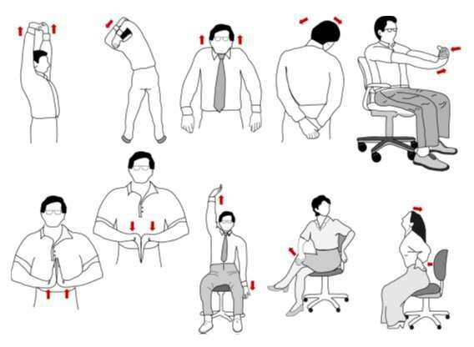

5.0 A Worked Example

A) Laptop Set-up without adaptation

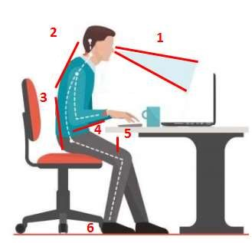 | 1, 2 Viewing angle, Head and Neck Position;  Target: The top of screen should be at eye level or just below eye level.  Picture: This angle is quite steep and results in the head and neck bending forward.  3 Back Position and Support;  Target: Ensure a vertical upright back, keep the shoulders square and relaxed. The chair should support a natural spinal curve.  Picture: Not everyone working from home / working remotely may have an office chair. However, the type of chair you use should be upright and provide support to the lower back.  4, 5 Forearm & wrist position;  Target: The hands wrists and forearm should form a level line from the keyboard to the elbow. The wrists should not be bent and should reside (float) above the keyboard during use. The wrist should be kept free of the desk surface when using the mouse. The mouse should be moved through a combination of elbow and shoulder movements, the wrist should not be involved. The forearm will form a 90-degree angle with the upper arm. Picture: The elbow is lower than the wrist, causing the wrist to bend.  6 Legs and Foot Placement;  Target: Feet flat on the floor. The chair will not make contact with the back of the knees. Thighs are parallel to the floor.  Picture: In this case both feet are placed flat on the floor there is no excess or pressure on the back of the legs.

B) Improved set-up using laptop stand, separate keyboard and mouse.

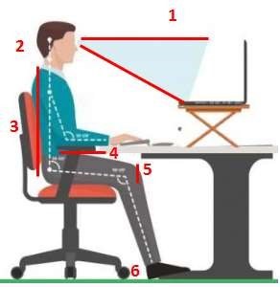 | 1, 2 Viewing angle, Head and Neck Position; the laptop stand brings the head up, straightening the neck, shoulders and back. If a laptop stand is not available then books may be used to improve the viewing angle.  3 Back Position and Support;  A cushion can be used to support a more upright posture especially where employees may be working from a kitchen chair.  4, 5 Forearm & wrist position;  A 90-degree angle is formed between the upper arm and forearm there is no pressure on the wrists. Again cushions can be used to elevate the seating position to achieve a neutral position of the forearm, wrist and hands, which are all level.  6 Legs and Foot Placement;  A footrest should be used to ensure the thighs remain almost parallel to the floor, with the hip slightly higher than the knee. Space is maintained between the back of the knees and the edge of the chair. A footrest can be anything such a plastic box.

END

