  - Advice for First Aid Responders:
Covid-19 : Advice in support of the Governments Return to the Workplace Safely | First Aid Responders
June 2020

Table of Contents
Introduction 3
Symptoms of COVID-19 and How COVID-19 is Spread 3
Providing First Aid Assistance when Safe Physical Distancing is Unavoidable 5
Providing First Aid Assistance to Someone who may be Symptomatic and Suspected of having COVID-19 6
Personal Protective Equipment (PPE) Whilst Providing First Aid 6
Cardiopulmonary Resuscitation (CPR) & COVID-19 7
Hand Hygiene 8
What to do after the First Aid Situation 9
Actions if First Aid Responder becomes unwell following contact with an at risk person 9
Additional Information 10

Introduction

The COVID-19 crisis presents unique challenges to the provision of First Aid and of care to injured and ill people. This is due to the risk of cross infection being present and the separation distance (currently 2m) is mostly unavoidable when caring for an injured or ill person. Responders may encounter patients with suspected COVID19 within their workplace or when tasked to normal everyday emergency incidents. Responders may also come across an incident by chance where pre‐hospital emergency care is required.
This guide is intended to provide some practical guidance and reassurance to First Aid Responders [FAR] in DDLETB.

Symptoms of COVID-19 and
How COVID-19 is Spread
First Aid Responders should be familiar with the symptoms of COVID-19, as per graphic below. The most up to date advice on symptoms is available at https://www2.hse.ie/conditions/coronavirus/symptoms.html.
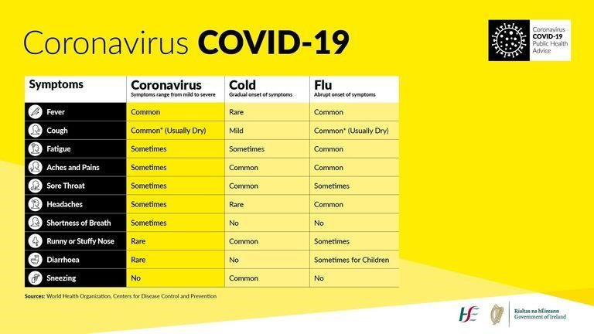

The Order of Malta Ireland Guidelines on Providing First Aid in the Workplace outline that respiratory secretions (droplets) containing the virus are likely to be the most critical means of transmission; these are produced when an infected person coughs or sneezes. There are two key ways people can become infected with COVID-19:

- Secretions can be directly transferred into the mouths, eyes or noses of people who are nearby (within 1m) or possibly could be inhaled into the lungs.

- It is also possible that someone may become infected by touching a person, a surface or object that has been contaminated with respiratory secretions and then touching their face.

Providing First Aid Assistance when Safe Physical Distancing is Unavoidable

To minimise risk, it is advised that DDLETB First Aid Responders avoid close contact with a person who may require first aid unless absolutely necessary in an emergency situation or if Personal Protective Equipment (PPE) is available. Avoiding close contact with a person requiring treatment, of course, will not be possible in the event of having to provide emergency lifesaving measures such as an incident of cardiac arrest, heart attack, choking or stroke.

As per the Order of Malta Ireland Guidelines on Providing First Aid in the Workplace, when PPE is available, First Aid Responders should comply with the following advice:

Scene Safety: The First Aid Responder should always practice good hand hygiene before and after administering First Aid.

PPE: A surgical face mask, eye protection, apron and gloves should be worn by the First Aid Responder.
- The First Aid Responder should don a face mask, apron, eye protection and gloves prior to
entering the scene.
- Perform good patient assessment – Primary and Secondary Survey as you were trained
- Follow the training (PHECC Clinical Practice Guidelines) for assessment and treatment in order of
priority.
- Document all treatment administered.
- Ask others who are not involved in providing assistance to stay at least 2 meters away from the patient.
- If a patient presents feeling unwell with a high temperature and/or flu like symptoms, contact the GP and management immediately to report this. Refer to next section for further advice.
- A face mask should also be made available for the patient who may don it themselves. If the patient is unable to don the mask, e.g. unconscious, the First Aid Responder should apply the PPE to the patient.

Providing First Aid Assistance to Someone who may be Symptomatic and Suspected of having COVID-19

Standard infection control precautions should be applied when treating all patients. Patients should be treated according to the PHECC FAR Clinical Practice Guidelines, however if there is a presentation as outlined in the ‘case definition’ above then the patient should be treated as a suspected COVID‐19 case and First Responders are advised to immediately contact the GP and management, to request guidance and assistance.

If possible, have the patient place a face mask over their nose and mouth, if they have not done so already, and limit contact by staying back at least 2m, if possible, until that person has done so.

Personal Protective Equipment (PPE)
Whilst Providing First Aid
The First Aid Responders should have access to PPE to enable them to respond to first aid requests. Face masks, gloves and aprons should be worn by the First Aid Responders for all first aid situations.

FFP2/N95 masks are only required where there is a risk of aerosol generating procedures – for example during CPR or airway management.

Cardiopulmonary Resuscitation (CPR) & COVID-19

Immediate cardio-pulmonary resuscitation (CPR) and use of an automated external defibrillator (AED) are vital to the survival of people who have a cardiac arrest. If a First Aid Responder decides that they are able to provide CPR to a patient and there is a perceived risk of infection from COVID-19 the following advice, as outlined in the Order of Malta Ireland Guidelines on Providing First Aid in the Workplace and in line with school/centre/offices own emergency response procedures, should be implemented:
- Contact the management immediately to ask for assistance and an AED
- If you have access to a mask and gloves use them (you will still need to wash your hands when you take off the gloves)
- Provide chest compression only CPR
- Do not give mouth to mouth rescue breaths
- To avoid contact with the airway and to reduce the scatter of droplets from their airway, cover the mouth and nose with a cloth or a tissue
- Avoid any contact of your hands with the airway (for example putting your hands into the mouth) to reduce the risk if the person has COVID-19
- Keep your hands away from your face and thoroughly clean your hands (soap and water or alcohol hand rubs) as soon as you finish attending to the patient.

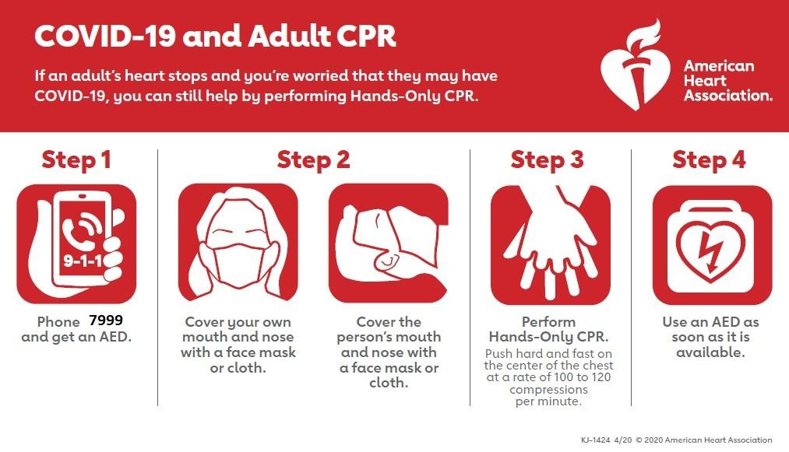

Hand Hygiene

After contact following the provision of first aid to an individual, you should:

- Avoid touching your mouth, eyes or nose, unless you have recently cleaned your hands after having contact with the individual
- Wash your hands thoroughly with soap and warm water
- If soap and water are not available, then use an alcohol-based hand sanitiser.

Whilst hand sanitisers are not a replacement for good hand hygiene and frequent hand washing with soap and warm water, their use is beneficial when immediate hand cleaning is desired. Hand sanitiser will be made available to all First Aid Responders. There will also be hand sanitising stations available in all schools/centres/offices.

What to do after the First Aid Situation

The area should be demarcated so that no-one enters within two meters. All surfaces, that the patient has come into contact with, must be cleaned including:
- Disinfecting and cleaning the entire area and use appropriate anti-viral solutions
- Ensuring all affected surfaces, floor areas etc. are appropriately cleaned
- All equipment and cleaning products should be double bagged and disposed of according to the DDLETB Guidelines.

Document the incident and report it following local protocols and PHECC Guidelines. Incident report forms should be returned to Corporate Services.

Actions if First Aid Responder becomes unwell following contact with an at risk person

First Aid Responders who have come into contact with persons known or suspected to have COVID19 should monitor themselves for symptoms, (fever, cough, breathing difficulties/shortness of breath, or other symptoms) in the 14 days following contact. If these symptoms occur within the 14 days of contact, they should self-isolate and immediately contact their healthcare provider.

Do not come to work:
- If you are suffering from a temperature or any respiratory distress (e.g. sore throat, cough, etc).
- If you have experienced any such symptoms in the previous seven days
- If you have been diagnosed with COVID-19 (until you are advised it is safe to do so)
- If you have been outside the island of Ireland in the last 14 days
- If you are awaiting COVID-19 test results
- If you have been advised to self-isolate
- Only come to work if you are well.
- If at any time you feel unwell at work / are exhibiting COVID-19 symptoms call your GP and advise school/centre/office manager.

Additional Information
- HSE Coronavirus (Covid-19)
- Gov.ie/Coronavirus
- Order of Malta Ireland

