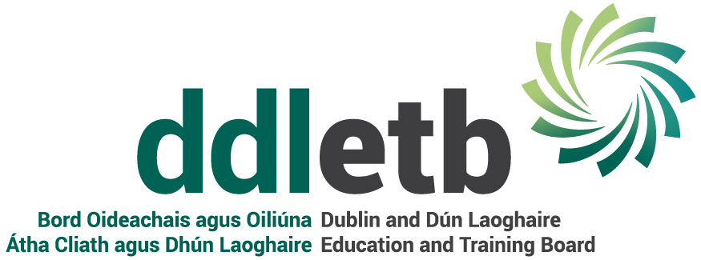
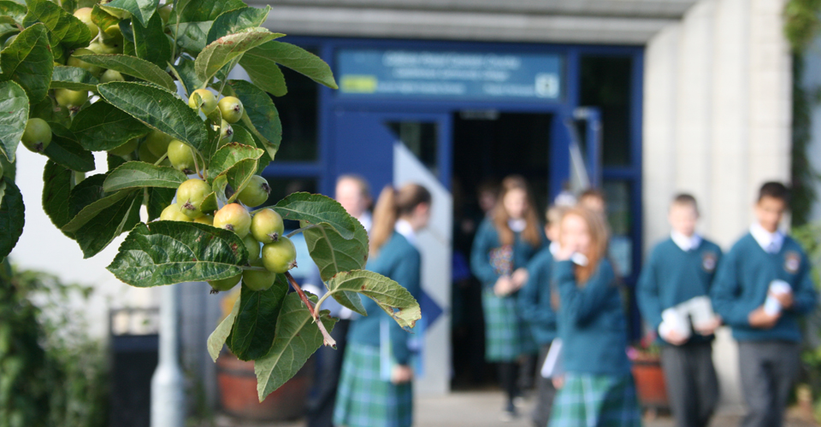

  - Checklist 2
Covid-19 : Checklist 2 in support of the Governments Return to the Workplace Safely | Staff Awareness
June 2020

COVID-19 Return to Workplace Safely Protocol
Staff
This checklist has been developed to help inform staff about what they need to do to help prevent the spread of COVID-19 in their workplace. Employers and staff must work together to protect everyone at the workplace. Further information can be found at www.Gov.ie, www.hse.ie, www.hpsc.ie and www.hsa.ie

 | Control | Action needed | Completion Date | Person Responsible
1. | Do you feel well and fit enough to return to work? |  |  | Staff member
2. | Are you keeping up to date with the latest COVID-19 advice from Government? |  |  | Staff member
3. | Are you aware of the signs and symptoms of COVID-19? |  |  | Staff member
4. | Do you know how the virus is spread? |  |  | Staff member
5. | Have you completed COVID-19 return-to-work form and given it to your employer? (See template Return-to-Work form) |  |  | Staff member
6. | Have you told your employer if you fall into any of the at-risk categories? |  |  | Staff member
7. | Have you been given an induction before returning to work and made aware of the control measures your employer has put in place to minimise the risk of you and others being exposed to COVID-19? (See Checklist No. 2 Control Measures) ? |  |  | Staff member
8. | Did your employer communicate effectively with you on control measures in place? |  |  | Staff member
9. | Do you know who your Staff Representative is and how to contact him / her? |  |  | Staff member
10. | Do you know how to contact your Staff Representative if you have any concerns about exposure to COVID-19, control measures not been maintained or have any suggestions that could help prevent the spread of the virus? |  |  | Staff member
11. | Do you know what to do in relation to physical distancing, good hand hygiene and respiratory etiquette? |  |  | Staff member
12. | Do you know how to wash your hands properly? |  |  | Staff member
13. | Do you know when to wash your hands: i.e.  - before and after eating and preparing food  - after coughing or sneezing  - after using the toilet  - before smoking or vaping  - where hands are dirty  - before and after wearing gloves  - before and after being on public transport  - before leaving home  - when arriving/leaving the workplace/other sites  - after changing tasks  - after touching potentially contaminated surfaces  - if in contact with someone displaying any COVID-19 symptoms |  |  | Staff member
14. | Do you know where your nearest hand washing / hand sanitising stations are? |  |  | Staff member
15. | Do you know to avoid touching your face? |  |  | Staff member
16. | Do you know to keep 2 metres physical distancing from others at all times at work, including in any canteen or wash/changing room? |  |  | Staff member
17. | Do you know to avoid any physical contact with colleagues, customers or visitors? |  |  | Staff member
18. | Do you know what to do if you start to develop symptoms of COVID-19 while at work, including where the isolation area is? |  |  | Staff member
19. | Do you understand your obligation to give your employer any necessary information to maintain a COVID-19 contact log? |  |  | Staff member
20. | Do you understand any proposed new staff rosters, changing of start / finish times, rostering of breaks etc? |  |  | Staff member
21. | Have you been made aware of any changes to risk assessments relevant to your work activities and any changes in the safety statement in response to controls to minimise the risk of you and others being exposed to COVID-19?? |  |  | Staff member
22. | Have you been made aware of any changes to the emergency plans or first aid procedures for your workplace in response to controls to minimise the risk of you and others being exposed to COVID-19? |  |  | Staff member
23. | Are you aware of best practice when it comes to sharing items? |  |  | Staff member
24. | Have you been made aware that any personal items brought into work must be cleaned and to avoid leaving them down on communal surfaces or to clean the surface after the personal item is removed? |  |  | Staff member
25. | Have you been provided with cleaning materials to clean your own workspace? |  |  | Staff member
26. | Can you avoid work-related travel as far as possible and are you able to conduct meetings with colleagues / clients / customers in other forms e.g. phone, online rather than in person? |  |  | Staff member
27. | If you have to share a work vehicle, have you followed the national guidelines in relation to travel? |  |  | Staff member
28. | Do you know when you have to wear PPE and how to fit, use, remove, clean, store and dispose of any required PPE? |  |  | Staff member
29. | Do you know what supports are available to you if you are feeling anxious or stressed? |  |  | Staff member

