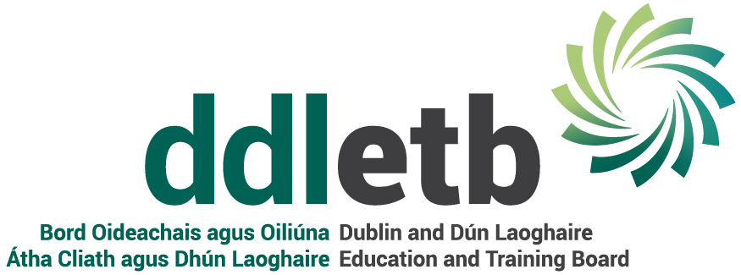
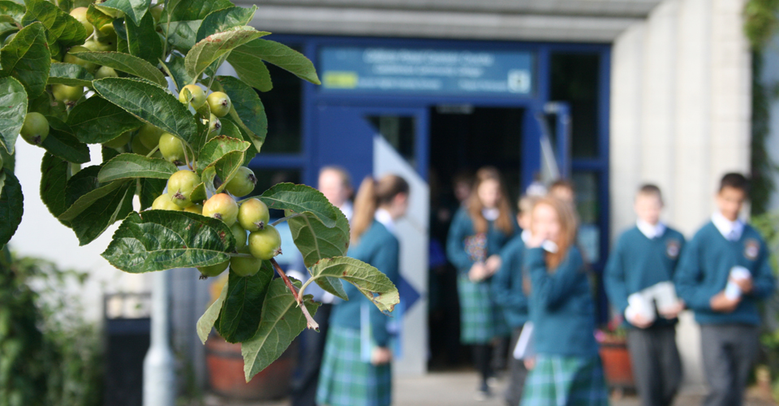 | 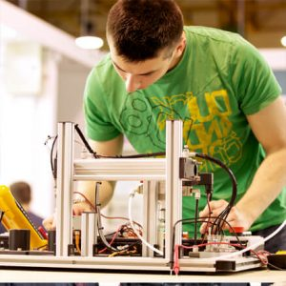

  - Checklist 1
Covid-19 : Checklist 1 in support of the Governments Return to the Workplace Safely | Planning & Preparing, Control Measures, Induction, Cleaning & Disinfection, Suspected Cases
June 2020

COVID-19 Return to Work Safely Protocol
Planning and Preparing, Control Measures, Induction, Cleaning & Disinfection,Suspected Cases
These checklists have been prepared to help DDLETB to get schools/centres up and running again in a way that will help prevent the spread of Covid-19. Further information can be found at www.Gov.ie, www.hse.ie, www.hpsc.ie and www.hsa.ie
No | Control | Centre Action Required | Completion Date | Person Responsible
 | Have you a system in place to keep up to date with the latest advice from Government and to adjust your plans and procedures in line with that advice?
2. | Have you prepared / revised your business COVID-19 response plan?
3. | Have you a system in place to provide your staff with information and guidance on the measures you have to put in place to help prevent the spread of the virus and what is expected of them?
4. | Have you consulted with your staff on measures, provided a system for staff to raise issues or concerns and to have them responded to?
5. | Have you identified the control measures you will need to put in place to minimise the risk of staff being exposed to COVID-19? (See Control Measures 32-79)
6. | Have you reviewed and updated your risk assessments and safety statement to take account of any controls to help prevent the spread of COVID-19?
7. | Have you updated your emergency plans, in particular to take account of physical distancing?
8. | Have you sent each staff member a COVID-19 return-to-work form to be completed and returned 3 days before they return to the workplace? (See template Return-to-Work form)
9. | Have you sent each staff member information on the HSE guidance on people most at-risk and asked them to tell you if they fall into any of these categories?
10. | Have you assessed who can do their work from home and given them the facility to do so, in particular at-risk or vulnerable staff members?
11. | Have you told staff members they must stay at home if sick or if they have any symptoms of COVID-19 and informed them of their entitlements if they are sick or need to quarantine?
12. | Have you appointed and trained a Staff Representative to help advise staff members and to monitor compliance with COVID-19 control measures in the workplace?
13. | Have you agreed with staff¹ about any adjustment of staff rosters, organising of teams, breaks etc. needed to reduce the number of people in the workplace at any one time and to maintain physical distancing?
14. | Have you updated your workplace induction / familiarisation training to include all information relating to COVID-19? (See Checklist 80-108)
15. | Have you organised to carry out meetings, training and information sessions online or by phone as far as possible?
16. | Have you identified the activities that involve interacting with customers / visitors and put in place measures to prevent physical contact, as far as possible?
17. | Have you contacted suppliers and arranged contactless delivery, invoicing and payment?
18. | Have you stopped all non-essential business / work travel?
19. | Are the number of staff sharing a vehicle kept to a minimum, are face coverings provided and are staff informed of the need for interior touch points to be cleaned/wiped at the start and end of each shift?
20. | Have you advised staff to clean their hands before and after using public transport before arriving to work?
21. | Have you set up workstations, desks and tables to help with physical distancing?
22. | Have you put in place supports for staff who may be suffering from anxiety or stress and told your staff about these supports?
 | Personal Protective Equipment (PPE)
23. | Have you identified, selected and sourced the PPE needed for your staff and arranged enough supplies of it?  – (see checklist 142-159)
24. | Have you arranged to train your staff in the proper fitting, use, removal, cleaning, storing and disposal of PPE?
25. | Have your first aiders been given updated training on infection prevention and control re hand hygiene and use of face masks?
26. | If you have mechanical ventilation does it need cleaning or maintenance before the workplace reopens?
27. | Does your hot water system need flushing at outlets e.g. showers, backwashes etc. following low usage to prevent Legionnaire’s Disease?
28. | Have you lifting or other equipment (e.g. lifts, forklifts, tail-lifts, autoclaves, etc.) due a statutory examination and have you arranged for a competent person to do this before the workplace reopens? (See HSA FAQ's)
29. | Has this competent person provided you with details of how they plan to do this task safely and what they require from you to do so?
30. | Have you visually checked, or had someone check, all vehicles and equipment in the workplace for signs of deterioration or damage before staff use it again?
31. | Has the workplace, including all equipment, workstations, benches, doors and frequent touched surfaces points, been thoroughly cleaned?
 | Hand Hygiene Facilities:
32. | Are there enough hand washing and hand sanitising stations in place to accommodate staff, and others adhering to hand hygiene measures?
33. | Are hand washing and hand sanitising stations in convenient locations that can be easily and frequently accessed?  Have you considered:  - all entry/exit points  - high traffic areas  - the need for staff to wash their hands before, during or after a work task  - the distance staff are from hand washing /hand sanitising facilities including wash/bathrooms  - the number of staff members and any shift arrangements  The number of learners/students
34. | Have you made arrangements to ensure hand hygiene facilities are regularly checked and well-stocked e.g. hot running water, soap dispensers, paper towels, touch-free bins and hand-sanitiser?
 | Hand sanitising
35. | Does the alcohol-based hand sanitiser have at least 60% ethanol or 70% isopropanol as the active ingredient?
36. | Are there stations at entry/exit points to the workplace?
37. | Are there stations in areas that have high touchpoints or high footfall?
 | Employee awareness around hand hygiene in the workplace
38. | Have you informed staff and others about the importance of hand washing?
39. | Have you trained/shown staff and others how to wash their hands (with soap and water for at least 20 seconds) and dry them correctly? (HSE video resource available)
40. | Have you shown staff and others how to use hand sanitiser correctly and where hand-sanitising stations are located?
41. | Have you displayed posters on how to wash hands correctly in appropriate locations?
42. | Have you told staff and others when they need to wash their hands?  This includes:  - before and after eating and preparing food  - after coughing or sneezing  - after using the toilet  - before smoking or vaping  - where hands are dirty  - before and after wearing gloves  - before and after being on public transport  - before leaving home  - when arriving/leaving the workplace/other sites  - after changing tasks  - after touching potentially contaminated surfaces  if in contact with someone displaying any COVID-19 symptoms
43. | Have you provided facilities for staff and others working outdoor to frequently practice hand hygiene?
44. | Have you provided staff and others with hand sanitiser for use in work vehicles?
 | Respiratory hygiene
45. | Have you told staff and others of good respiratory measures to limit the spread of the virus:  - avoid touching the face, eyes, nose and mouth  - cover coughs and sneezes with an elbow or a tissue  dispose of tissues in a covered bin
46. | Have you made tissues available to staff and others and covered bins or bin bags for their safe disposal?
47. | Is there a system in place to regularly empty bins so they don’t over fill?
 | Physical Distancing – staying 2 metres apart
48. | Have you looked at how you can change the layout of your workplace to allow for physical distancing?
49. | Have you a system to regularly remind staff and others to stay 2 metres apart?
50. | Have you identified the activities that involve interacting with customers, visitors and others and put in place measures to help prevent contact and ensure physical distancing, as far as possible?
51. | Can you rearrange working times and shifts to minimise the number of people at work together?
52. | Can you rearrange break areas and times to comply with physical distancing? (e.g. placing tables and chairs further apart, staggering breaks)
53. | Can you organise staff into teams who consistently work and take breaks together?
54. | If it’s not possible to maintain physical distancing in the canteen, have you considered making alternative arrangements?
55. | Can you provide a one way system for entering and exiting the school/centre, where practical?
56. | Have you implemented physical distancing for outdoor work activities?
57. | Where staff are sharing accommodation provided by the employer, at a place of work, are you following the guidance as laid out in the Return to Work Safely Protocol (Pg.18) ?
58. | Have you reduced the number of people working in enclosed spaces by:  - facilitating working from home  - reducing the number of work tasks  - postponing non-essential work  - modifying work tasks?
59. | Have you put floor markings in place to remind everyone in the school/centre of the 2 metre physical distance required?
60. | If it is not possible to ensure a 2 metre physical distance between staff and others, have you put in place alternative measures:  - installed physical barriers, such as clear plastic sneeze guards between staff  - to maintain at least a distance of 1 metre or as much distance as is practical  - to minimise any direct staff member close contact  - to provide hand washing or hand sanitising aids nearby, so that hands can be cleaned as soon as the task is complete  - made face masks available to staff in line with Public Health advice and ensuring that masks are clean and not shared or handled by other stff members.  Note: wearing face masks is not a substitute for other measures outlined above.
61. | Have you staggered entry into the workplace including the entry of customers or clients?
 | Minimising Contact
62. | Have you minimised the need for business trips or for staff to gather for meetings and interactions e.g. by making available technology for online or phone meetings?
63. | If staff and others have to meet, do you make sure they meet in a large space where physical distancing can be done and for as short a time as possible?
64. | Have you put in place a system that eliminates or reduces the need for staff to travel together in vehicles?
65. | In the case where vehicles must be shared, have you told staff members to sit as far apart as possible, to wear face coverings, and to clean the frequently touched surfaces in the vehicle as a minimum at the start and end of each shift?
66. | Have you advised staff to travel alone if using their cars for work?
67. | Have you told staff to clean and disinfect surfaces and shared equipment, not to shake hands and to avoid any physical contact?
 | Personal Protective Equipment (PPE) [Guidance open to change]
68. | Note: PPE use cannot take the place of other preventative measures. For COVID-19, employers should check public health advice. Gloves are generally not required for infection prevention and control and are not a substitute for hand hygiene.
69. | Has the correct PPE been identified based on the hazard and staff work activity?
70. | Is there a sufficient supply of relevant PPE required to allow a safe return to school/centre?
71. | Have you trained staff and others in the correct fitting, use, removal, cleaning, storing and disposal of PPE?
72. | Have you made arrangements for the cleaning, inspection, maintenance and disposal of PPE, where appropriate?
 | At Risk Groups
73. | Have you determined which, if any, staff and others are at higher risk from COVID-19? Check out HSE At Risk groups.
74. | Have you enabled at risk or vulnerable staff and others to work from home where possible?
75. | Have you enabled at risk staff and others to maintain a physical distance of 2 metres?
 | Changes to Work Practices
76. | Have you considered other changes to schools/centre practices to minimise the spread of COVID-19?
77. | Have you arranged for safe delivery of goods to the wchool/centre?
 | Visiting Contractors / Workers
78. | Are there arrangements in place to inform other workers, contractors or visitors of the workplace measures to help prevent the spread of infection?
79. | Is there a system for recording visits to the site/workplace by workers and others, as well as visits by staff to other sites? (COVID-19 Contact log)
 | Control
80. | Have you a system in place to keep up to date with the latest COVID-19 advice from Government and to pass that advice on to staff?
81. | Have you a completed COVID-19 return-to-work form for each staff member at the induction? (See template Return-to-Work form) (see Checklist 8)
82. | Have you covered the signs and symptoms of COVID-19?
83. | Have you explained to staff how the virus is spread?
84. | Have you covered the control measures you have put in place to minimise the risk of staff being exposed to COVID-19? (See Checklist 5)
85. | Have you demonstrated physical distancing, good hand hygiene and respiratory etiquette to staff?
86. | Have you given staff information on At Risk Groups and asked them to let you know privately if they fall into any of these categories?  (see checklist 9)
87. | Have you told staff they must stay at home if sick or if they have any symptoms of COVID-19 and informed them of their entitlements if they are sick or need to quarantine?
88. | Have you told staff what to do and what to expect if they start to develop symptoms of COVID-19 in the workplace, including where the isolation area is? (See Checklist No. 4)
89. | Have you told staff of the purpose of the COVID-19 contact log in the workplace?
90. | Have you covered any relevant changes in your business COVID-19 response plan? (See template COVID-19 Response Plan)  (see checklist 2)
91. | Have you included any relevant updates (to minimise the risk of you and others being exposed to COVID-19) in your risk assessments and safety statement?  (see checklist 6)
92. | Have you included information on changes to your emergency plans?
93. | Have you explained any changes to first aid procedures to minimise the risk of you and others being exposed to COVID-19?
94. | Have you identified the Staff Representative(s) to all staff members and explained what their purpose is?
95. | Have you explained any new staff rosters, changing of start / finish times, rostering of breaks etc ?
96. | Have you told staff to wash their hands before leaving home and on arrival in the workplace, and at regular intervals throughout the day (Pg.16)?
97. | Have you explained the importance of staff avoiding touching their faces?
98. | Have you explained the need for staff to avoid physical contact with colleagues, customers or visitors?
99. | Have you explained the need for the twice-daily cleaning regime of frequently touched surfaces such as door handles, light switches, kettles, coffee machines, toasters, microwaves, fridge doors etc.?
100. | Have you explained the need to avoid sharing items such as cups, bottles, cutlery, pens etc.?
101. | Have you provided each staff member with cleaning materials, including disinfectant wipes, and advised them to clean their own workspace twice daily?
102. | Have you advised staff of the public health recommendation to use a face covering on public transport?
103. | Have you advised staff to reduce work-related travel as far as possible and provided means for them to have meeting in other ways e.g. phone/ online rather than in person?
104. | Have you advised staff to travel alone if using their cars for work?
105. | Have you advised staff who have to share a vehicle to wear a face covering and to clean the vehicle’s frequently touched surfaces at the start and end of each shift?
106. | Have you told staff about the supports available to them if they are feeling anxious or stressed?
107. | Have you explained the proper fitting, use, removal, cleaning, storing and disposal of any required PPE?
108. | Have you a system that allows your staff to raise issues or concerns and have these responded to?
No | Control
 | Procedures and Information
109. | Have you a system in place to identify and isolate staff or others who start to display symptoms of COVID-19 in the workplace?
110. | Have you a COVID-19 contact / group work log in place to facilitate contact tracing?  (see checklist 79)
111. | Have you informed staff of the purpose of the log?  (see checklist 89)
112. | Have you consulted with staff on the purpose of the isolation procedure and when it should be used?
113. | Have you displayed the COVID-19 posters in suitable locations highlighting the signs and symptoms of COVID-19?
 | Instructions if a person(s) develops signs and symptoms of COVID-19 at work
114. | Have you instructed your staff about what they need to do if they develop signs and symptoms at work?
115. | Have you provided your staff with up to date public health information on COVID-19 issued by the HSE , HPSC and GOV.ie?
 | Reporting
116. | Have you made your staff aware of reporting procedures if they develop signs and symptoms at work for COVID-19?
 | Response team
117. | Have you appointed a manager to deal with any suspected case of COVID-19?
118. | Have you allocated staff to support a response team(s) to deal with a suspected case of COVID-19 in the workplace and trained this team in what actions to take?
 | Isolation area(s)
119. | Have you identified a place that can be used as an isolation area, preferably with a door that can be closed, in the event of a suspected case of COVID-19?
120. | Is this isolation area accessible, including to staff with disabilities?
121. | Is the route to the isolation area accessible?
122. | Have you a contingency plan for dealing with more than one suspected COVID-19 case? e.g. If more than one person is displaying signs and symptoms of COVID-19, are there additional isolation areas?
123. | Are the following available in the isolation area(s)?  - ventilation, e.g. fresh air ventilation/ability to open a window  - tissues  - hand sanitiser  - disinfectant and/or wipes  - gloves, masks  - waste bags  pedal-operated, closed bin
 | Isolating a person(s) displaying COVID-19 symptoms
124. | Are procedures in place for the manager or a member of the isolation team to accompany the affected person to the isolation area, along the isolation route, while maintaining physical distancing (2 metres) from them?
125. | Is the manager and response team familiar with this procedure?
126. | Have others been advised to maintain a distance of at least 2 metres from the affected person at all times?
127. | Is there a disposable mask available for the affected person to wear while in a common area and when exiting the building?
 | Arranging for the person to leave workplace/Exit Strategy
128. | Have you established, by asking them, if the affected person feels well enough to travel home?
129. | If the affected person considers themselves able to travel home, have you directed them to do so and to call their GP and self-isolate at home?
130. | If the affected person feels unable to go home, has the manager/isolation team let them remain in isolation, and enabled them to call their GP?
131. | Has the affected person been advised to avoid touching other people, surfaces and objects?
132 | Has the affected person been advised to cover their mouth and nose with the disposable tissue(s) provided when they cough or sneeze, and to put the tissue in the waste bag provided?
133. | Has transport home or to an assessment centre been arranged if the affected person has been directed to go there by their GP?
134. | Has the affected person been advised not to go to their GP’s surgery or any pharmacy or hospital?
135. | Has the affected person been advised they must not use public transport?
136. | Has the affected person been advised to continue wearing the face mask until the reach home?
 | Follow-up
137. | Have you carried out an assessment of the incident to identify any follow-up actions needed?
138. | Are you available to provide advice and assistance if contacted by the HSE?
 | Disinfection
139. | Have you taken the isolation area and any work areas were the person was involved out-of-use until cleaned and disinfected?
140. | Have you arranged for cleaning and disinfection of the isolation area and any works areas involved, at least one hour after the affected person has left the building?
141. | Have the cleaners been trained in dealing with contaminated areas and supplied with the appropriate PPE?
No. | Topic
142. | Have you a system in place for checking and keeping up to date with the latest public health advice from Government and to adjust your cleaning procedures in line with that advice?  (also checklist number 1)
143. | Have you a system in place of thorough and regular cleaning of frequently touched surfaces?
144. | If disinfection of contaminated surfaces is required, has it been done following cleaning?
145. | Have the following frequently touched surfaces been included in your cleaning plan: for example  - table tops and desks  - door handles and light switches  - toilets and toilet doors, taps  - remote controls  - kettles, coffee machines, toasters, microwave, fridge handles  kitchen surfaces and cupboard handles?
146. | Are frequently touched surfaces visibly clean at all times and cleaned at least twice a day?
147. | Are washrooms and surfaces in communal areas being cleaned at least twice a day and whenever visibly dirty?
148. | Have you provided staff with cleaning materials such as disinfectant or wipes to keep their own workspace clean?
149. | Have you told staff what they need to do to keep their own workspace clean?
150. | Staff are responsible for cleaning personal items that have been brought to work and are likely to be handled at work or during breaks. e.g. mobile phone. Have you told staff to clean personal items that they have brought to work, such as mobile phones, to avoid leaving them down on communal surfaces or they will need to clean the surface after the personal item is removed?
151. | Have no-touch bins been provided, where practical?
152. | Have arrangements been made for the regular and safe emptying of bins?
153. | Have you sufficient cleaning materials available to allow for increased cleaning?
154. | Have cleaning staff been trained in the new cleaning arrangements?
155. | Have staff been instructed to read and follow instructions on the product label/ Safety Data Sheet for any cleaning product(s) before use and that where relevant appropriate PPE is worn by cleaners?
156. | If cleaning staff have been instructed to wear gloves when cleaning are they aware of the need to wash their hands thoroughly with soap and water, both before and after wearing gloves?
157. | Is there is system in place for the disposable of cleaning cloths and used wipes in a rubbish bag? Current HSE guidance recommends waste such as cleaning waste, tissues etc. from a person suspected of having COVID-19 should be double bagged and stored in a secure area for 72 hours before being presented for general waste collection.
158. | Is there a system in place to make sure reusable cleaning equipment including mop heads and non-disposable cloths are clean before re-use?
159. | Is there a system in place to ensure that equipment such as buckets are emptied and cleaned with a fresh solution of disinfectant before re-use?
 | Additional Information
 | Recommended that new caretaker/cleaner training be provided
 | Recommended that Safety Protocol Officer in each centre receive Infection Control Training
 | Recommendation of remote training course for all staff to complete similar to GDPR test, perhaps following the provision of induction (e.g. training provided by Safety Solutions)

and Trade Unions were applicable
and Trade Unions were applicable

