Contents
Interview Form 2
Name, Date & Suggested Topics for Interview
Student File Form 3
Name, Mobile, Guardian & Comments
Centre Code YA Form 4
Name, Age, Address, PPSN, Commencement, Termination, Meal Deduction & Student Contribution Agreement
Electronic Fund Transfer Form 5
Bank Details
Link to SOLAS PLSS Log In 6
Site Page Images, Descriptions & SOLAS Form Access Location for All Learner Detail Forms
Link to Training Allowance Entitlement Form F103 7
Image of Form F103
Photographic & Videographic Image Consent Form 8
Centre Withdrawal of Consent Form 10
Youthreach Template Letter to Parents of Over 18 Student Data Sharing 12
Youthreach Template Over 18 Request Form to Share Personal Data with Adult 13

Interview
Student Name
Interview Date
Topics
GDPR
ATTENDANCE & PUNCTUALITY
HEALTH AND WELL BEING ISSUES
POLICIES & PROCEDURES
SPECIAL EDUCATION NEEDS
CODE OF BEHAVIOUR
CENTRE RULES
LLN
WORK EXPERIENCE
OTHER
Student File
Student Name
Student Mobile
Parent/Guardian
Parent/Guardian Mobile
Date | Comments

Centre Code YA
Student Name
Student Address
DOB/Age
PPSN
Date Commenced
Date Terminated

Meal Deduction
I _____________________________________ authorise Dublin & Dunlaoghaire ETB to deduct on a weekly basis, the following monies from my training allowance: ______ Euro meal allowance and ______ Euro meal deduction
Student Signature ____________________________________________

Student Contribution Agreement
I ____________________________________ enter into this agreement with (insert Centre
Name). I agree to pay a weekly contribution of ________ Euro towards the cost of materials. I authorise Dublin & Dunlaoghaire ETB to deduct this amount each week from my weekly training allowance.
Student Signature __________________________________
Co-ordinator Signature ______________________________

Electronic Fund Transfer
Bank Account Number

Bank Sort Code (BIC)
IBAN

Bank Name

Bank Branch

Bank Address

Name in which bank account is held (Block Capitals Letters)

Address of Student

Student Signature __________________________________
Date _______________________

Link to SOLAS PLSS log in: - https://ddletb.plss.ie/ncc/Default.aspx - (Right click and open hyperlink)
Log in: -
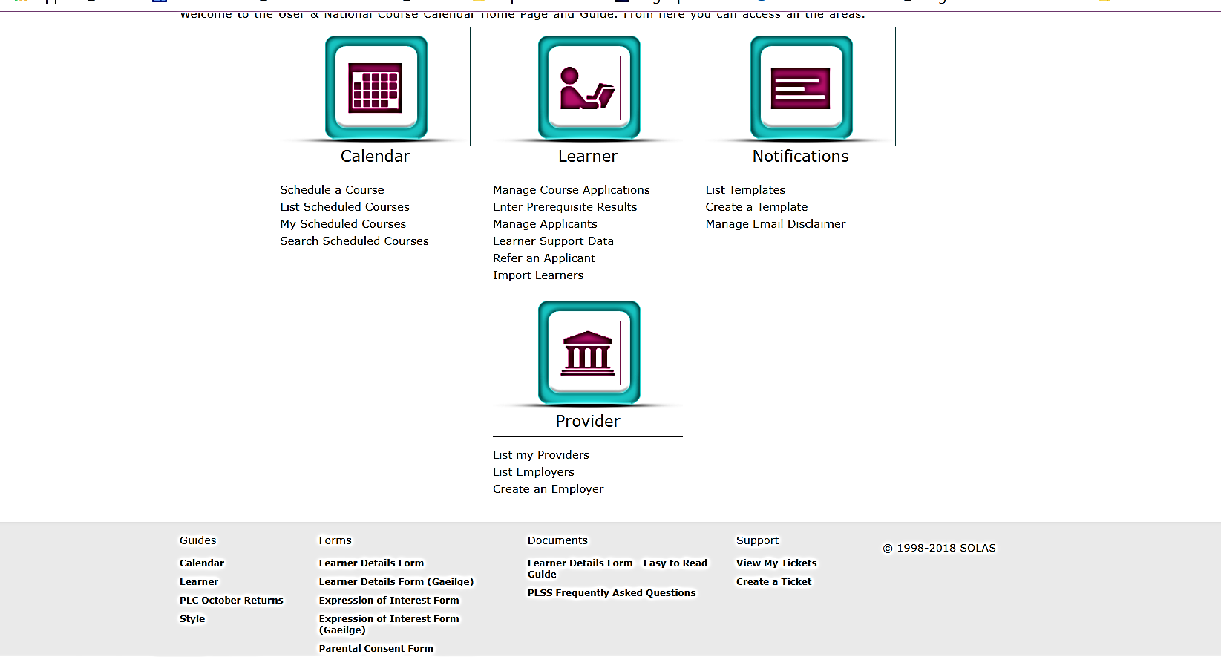
Bottom of page FORMS.
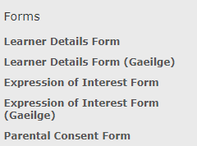
When clicked can access all the SOLAS forms to be completed for student.

Link to TRAINING ALLOWANCE ENTITLEMENT – FORM F103
https://documentcloud.adobe.com/link/track?uri=urn%3Aaaid%3Ascds%3AUS%3Aa50119b4-54ce-45db-ad44-a927eaaf8211
(Right click and open hyperlink)

PHOTOGRAPHIC & VIDEOGRAPHIC IMAGE CONSENT FORM
Photographs and videos are stimulating forms of media which can motivate and inspire students. Research has shown that using such forms of media in education can help encourage creativity, motivation, as well as improve communication and team-working skills.
[Insert name of centre] asks that parent(s)/guardian(s) consent to their son/daughter being featured in photographic and videographic promotional material if their son/daughter is under 18 years of age. Where a student is 18 or older, he/she is capable of giving such consent. This form is requesting that consent be given for each use of photograph or video footage. If such consent is given, the following procedures will apply with regard to taking photographs or video footage of students in [insert name of centre]:
- Staff will be aware of possible Child Protection issues when taking photographs of students and in relation to where these photographs are used.
- Students may be identified in these publications in recognition of their participation in events/activities, except where the publication is online.
- Students in photographs or videos published on DDLETB’s and/or Youthreach.ie website will not be named or identified in any way other than by group e.g. finalist football team.
- Consent to the processing of a photograph and/or video can be withdrawn at any time by filling out a Consent Withdrawal Form which can be requested directly from the centre or downloaded from Youthreach Enrolment Pack available at [http://www.ddletb.ie/youth/youthreach/youthreach-enrollment-pack/] and submitting it to the centre directly or emailing it to insert person responsible] at [insert email address]. If you chose to withdraw your consent, the centre will no longer use your photographic or videographic image for the purposes set out below. However, processing already carried out may not be able to be redacted e.g. if a photograph was published in a newspaper or past centre book already printed.

- All online media promotion on behalf of the Centre is underpinned by DDLETB Youthreach Internet Safety Policy which can be obtained directly from the Youthreach centre or online at [http://www.ddletb.ie/youth/youthreach/youthreach-enrollment-pack/].
I ________________________ [insert signature of Parent/Guardian/Student over 18 years] consent that photographs and video footage of ________________________ [student’s name here] may be taken and used by or on behalf of [insert centre’s name] to promote its activities (currently and in the future) in the following circumstances; as selected by me:
Photographic Image and/or Videographic footage of the student for the purpose of:
Please tick as appropriate | Yes | No
On [insert centre’s name] website, and/or DDLETB’s website, social media and any other online publication associated with DDLETB’s centres/programmes/services.
Given to third parties, with the student’s name, for the purpose of being used in print media e.g. newspapers, magazines, brochures/leaflets, posters, prospectus, reports books and other similar publications, e.g. a student attaining distinction in major awards or a football team winning a competition.
Displayed within the centre and including the student’s name e.g. an image of a student awarded ‘Student of the Year’ with his/her name below.
In centre yearbooks with the student’s name also used.
For promotional purposes related to the centre e.g. centre prospectus or a video of a centre production.
In circumstances not listed above where the student’s photographs or videos are sought, your consent as a parent/guardian/student over 18 years will be requested separately at a later date.

Student’s Name (IN BLOCK CAPITALS): ____________________________
Name of Parent(s)/Guardian(s): ____________________________
[Where student is under 18 years] ____________________________
Date: ____________________________
Withdrawal of Consent Form Photographic & Videographic Image

Details of the Controller (College/Centre):
This request is made to: [Insert name of centre]
Address of Controller (Centre) named above: [insert address of college/centre]

Details of data subject:
I am a:
- Parent/Guardian
- Learner (over 18 years)

My Full Name:
My Address:
Contact Number:
Name of Data Subject (Learner):

For the purpose of proving my identity, I attach a Garda verified copy of 1 of the following:
- Passport
- Birth Certificate
- Driving License
- Recent utility bill

Details of my request
I ________________________ [insert signature of Parent/Guardian/Learner over 18 years] wish to withdraw my consent (under section 71(3) (C) of the Data Protection Act 2018) that photographs and video footage of ________________________ [learner’s name here] may be taken and used by or on behalf of [centre’s name] to promote its activities (currently and in the future) in the following circumstances; as selected by me:
Photographic Image and/or Videographic footage of the learner for the purpose of:
Please tick the use for which you wish to withdraw consent
On [centre’s name] website, and/or DDLETB’s website, social media and any other online publication associated with DDLETB’s centres / programmes / services.
Given to third parties, with the learner’s name, for the purpose of being used in print media e.g. newspapers, magazines, brochures / leaflets, posters, prospectus, reports books and other similar publications, e.g. a learner attaining top results in their course/apprenticeship/traineeship.
Displayed within the centre and including the learner’s name e.g. an image of a learner awarded the highest result in his/her course with his/her name below.
In centre yearbooks with the learner’s name also used.
For promotional purposes related to the centre e.g. centre prospectus or a video of a college/centre production.

Signed:
Printed Name:
Date:
Please return this form to: the relevant Youthreach Centre/ETB/Data Protection Officer.
Note: We require proof of the applicant’s identity to ensure that the person making this request is acting legitimately within sections 91(3) or 92(5).
Date request received:
Proof of identity provided:
Any other relevant comments:
Office Use Only
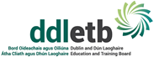
Dear Parent/Guardian,

Under the Education Act 1998, Youthreach centres are required, among other things, to “regularly evaluate students and periodically report the results of the evaluation to the students and their parents.” However, that Act also requires that a centre use its resources to “ensure that parents of a student, or in the case of a student who has reached the age of 18 years, the student, have access in the prescribed manner to records kept by that centre relating to the progress of that student in his or her education.” Essentially, this means that the centre statutory basis for communicating student data with parents/guardians ends when the student reaches 18 years of age.

Therefore, I am writing to inform you that when your son/daughter reaches the age of eighteen years, we are legally obliged to share his/her personal data with him/her only, unless s/he requests for the centre to continue to communicate with you as before. If s/he so wishes for the centre to communicate with you as before, the attached Data Sharing Request Form needs to be completed. If s/he does not complete this form, then the centre needs full up-to-date contact information for him/her and so the Adult Student Contact Form needs to be completed by him/her. We would ask that one of the above forms, when completed, be brought to the centre administration office on the last centre day before the student reaches eighteen years of age.

Please be advised that if your son/daughter does not request for the centre to communicate with you in relation to educational matters after s/he turns 18 years of age, it will mean that you will not have access to his/her file. This means that the student will be fully responsible for the making of payments etc. to the centre, which now legally arise in his/her name. Please also make your son/daughter aware of this.

Despite the above, if there is any concern regarding the vital interests of your son/daughter, e.g. health or behavioural concerns, which the centre views as negatively affecting his/her vital interests, or if disclosing certain information to parents is in the public interest, then, under the legislation, the centre can communicate such information to parents/guardians of adult students. Also, next-of-kin information for the student will also be retained by the centre for use in an emergency situation, in line with the student’s vital interests.

Yours sincerely,

Coordinator
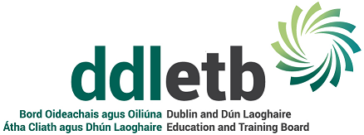

Insert centre logo here
Data Sharing Request Form for students over 18
I, _____________________________ student at (insert name of centre here and then delete this bracket), aged 18 years or older, hereby request and give consent to (insert name of centre here and then delete this bracket) providing the parent(s) / guardian(s) nominated below with my personal data, on the same or similar basis as such was communicated to my parent(s) / guardian(s) prior to my reaching 18 years of age.
I understand that, as a result of this request, the centre will continue to communicate with my parent(s) / guardian(s) using SMS text message, email and/or ordinary post, depending on the nature and purpose of the communication, in line with centre policy, e.g. text messages for notifications, email for correspondence etc.
(Please note that your next-of-kin information previously provided to the centre will still be used where it is in your vital interests, e.g. a medical emergency or where the centre fears for your safety etc.)

For the purpose of this request, please inform each parent / guardian of your decision to nominate him / her and obtain from him / her the contact information required below.

Please also have your parent(s) / guardian(s) sign this request form, and you as the data subject, are also required to sign this form (overleaf).

 | Parent / Guardian 1 |  |  |  |  |  |  |  |  |  | Parent / Guardian 2
Prefix: (e.g. Mr. / Ms. / Ms. etc.)
First Name:
Surname:
Mobile phone no.:
Landline tel. no.:
Email address:
Postal Address:
Eircode:

I _______________________________________ acknowledge and declare that I have made this request to share my personal data of my own free will and volition and was not coerced to do so, nor was I under duress at the time of signing this nomination form, and that I have chosen to make this request voluntarily and knowingly and can withdraw this request in writing at any time.

Signed: _____________________________ Date: __________________________
(Student / Data Subject)

I _______________________________________ acknowledge this request and hereby consent to the nomination such that I will receive from the centre personal data regarding the data subject. I give this consent voluntarily and knowingly.

Signed: _____________________________ Date: __________________________
(Parent / Guardian 1)

I _______________________________________ acknowledge this request and hereby consent to the nomination such that I will receive from the centre personal data regarding the data subject. I give this consent voluntarily and knowingly.

Signed: _____________________________ Date: __________________________
(Parent / Guardian 2)

Data Protection Notice
The processing of the personal data supplied on this Data Sharing Request Form is required to enable the centre to comply with section 9(g) of the Education Act 1998. The personal data disclosed in this Data Sharing Request Form may be communicated internally within the centre for the purpose of contacting the student and/or his/her parent(s)/guardian(s). Such personal data will be kept for the duration of any statutory obligation on the part of the centre and for the purposes set out in section 70(1) of the Data Protection Act 2018, in line with DDLETB’s Data Retention Policy, which is available from dataprotection@ddletb.ie on request.

A copy of the full DDLETB Data Protection Policy is available at http://www.ddletb.ie/wp-content/uploads/2018/11/Data-Protection-Policy.pdf Any person who provides personal data through this form has a right to request access to that data. S/he also has a right to request the changing of any information if it is factually incorrect. A request for erasure of the data can also be made by or on behalf of any data subject but this will only be acceded to where the data is no longer necessary for the purpose for which it was collected and where the school does not have a legal basis for retaining it. If you as a data subject have any complaints regarding the processing of your personal data, you have the right to lodge a complaint with the Data Protection Commission.

