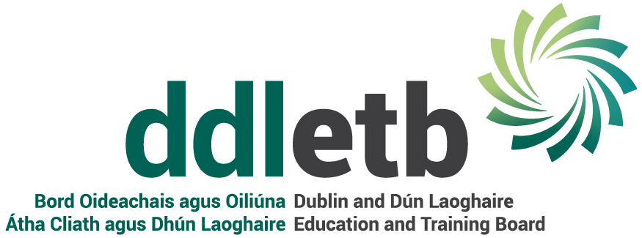
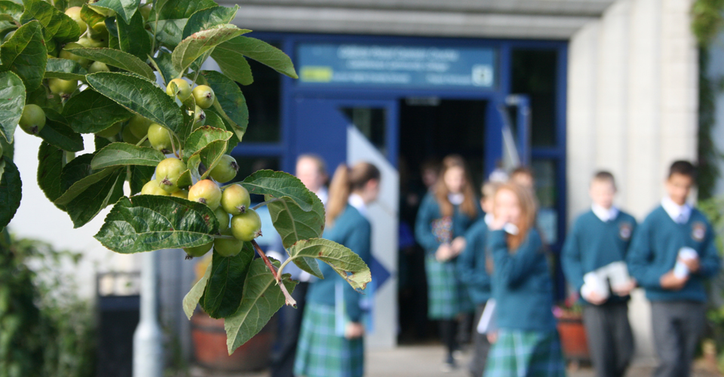

  - Checklist
Covid-19 : Checklist in support of the Governments Return to the Workplace Safely | Parents/Caregivers and Community Members
June 2020

COVID-19 Return to School Safely Protocol
Students and Children
Children and young people should understand basic, age-appropriate information about COVID-19, including its symptoms, how it is transmitted and how to prevent transmission. They should stay informed about COVID-19 through reputable sources such as HSE, HPSC, UNICEF, WHO and national advice on the radio and television. They should be aware of fake information/myths that may circulate by word-of-mouth or online.

1. | In a situation like this it is normal to feel sad, worried, confused, scared or angry. Know that you are not alone and talk to someone you trust, like your parent or teacher so that you can help keep yourself and your school safe and healthy.  • Ask questions, educate yourself and get information from reliable sources.
2. | Protect yourself and others  - Wash your hands frequently, always with soap and water for at least 20 seconds;  - Remember to not touch your face;  - Do not share cups, eating utensils, food or drinks with others.  - Practice physical and social distancing as much as possible
3. | Be a leader in keeping yourself, your school, family and community healthy.  - Share what you learn about preventing disease with your family and friends, especially with younger children;  - Model good practices such as sneezing or coughing into your elbow and washing your hands, especially for younger family members.
4. | Don’t stigmatize your peers or tease anyone about being sick.
5. | Tell your parents, another family member, or a caregiver if you feel sick, and ask to stay home.

