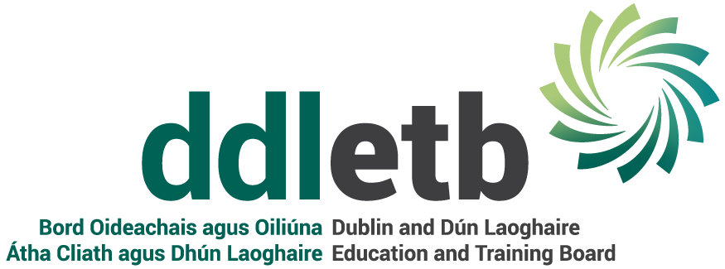
WORKPLACE WELL-BEING POLICY

1 Purpose
The purpose of this policy is to outline DDLETB’s commitment to workplace
well-being. DDLETB defines workplace well-being as any workplace health promotion activity or organisational policy designed to support a culture of healthy behaviour and attitudes in the workplace and to improve health outcomes for employees. This policy applies to all employees of the ETB, full time, part time and temporary.

DDLETB recognises the importance of employee well-being and that a work environment that fosters and supports employee well-being is hugely beneficial for all concerned. DDLETB is committed to taking a proactive approach to this area and to regularly reviewing its approach in line with internal and external developments which may impact on employee well-being.

2 Principles
The principles which underpin DDLETB’s approach to employee well-being are outlined below.

  - Employee Involvement
DDLETB is committed to involving employees. This can be achieved through seeking employee feedback and through involving employees in the design and deployment of particular employee well-being initiatives. Any individual employee who wishes to do so, may approach their manager for a confidential discussion on their own
well-being in the workplace.

2.2 Regular review
DDLETB will regularly review available data to identify any areas where a renewed focus on employee well-being is warranted. This may include a review of company-wide absenteeism/attendance data or actively sourcing employee feedback on specific issues. Where the business is experiencing change or heightened demands, the well-being of employees affected will be a key consideration.

2.3 Support for managers and employees
DDLETB will make certain that appropriate steps are taken to ensure that managers are equipped to deal with questions on employee well-being. Details of the Employee Assistance Scheme are available from the Human Resources Department

  - Communication
DDLETB is committed to communicating its policy on well-being to employees and to ensure that supports available are known to staff. Employees are encouraged to bring suggestions and feedback to the attention of management.

2.5 Monitoring and management
DDLETB will ensure that responsibility for the monitoring and management of employee well-being is considered when associated policies, such as the Health and Safety and flexible working are being updated.

- Resources
3.1 Flexible work options/policy
Employees can access flexible work arrangements in line with this policy.

  - Absence management policy
The ETB is committed to monitoring and managing absenteeism cases to ensure a timely and supported return to work. The ETB will access resources such as occupational health referrals and other professional advice when necessary to support the management of absenteeism.

  - Equality and diversity policy
This policy outlines the ETB’s commitment to a workplace free of any harassment and workplace bullying. The ETB’s commitment to embracing diversity in the workplace as well as the resources available to employees to address any concerns regarding potential breaches of this policy are outlined in this policy. The ETB will also ensure that it meets its obligations in relation to provision of reasonable accommodation to any employees with a disability in the workplace.

  - Feedback to employees
DDLETB recognises the value of timely and objective feedback to employees in relation to their performance. The ETB will ensure that managers and employees are equipped to have regular conversations on performance.

3.5 Health and Safety policy
The ETB attaches paramount importance to the health and safety of employees in the workplace. The Health and Safety policy, along with the Health and Safety statement, outlines the company’s commitments and employees’ responsibilities in this regard.

3.6 Working Time
This policy on rest periods and break times can be found in the Working Time Acts 1997-2015 and managers should routinely ensure that employee work hours and break-times are compliant with legislation and consistent with a work environment that fosters employee well-being.

3.7 Term Time Leave/Job Share/Career Break policies
This policy outlines the ETB’s approach to managing requests for leave from work for personal reasons.

3.8 Communication
DDLETB will provide access to resources and information on workplace well-being on an ongoing basis. Such topics may include physical exercise, diet and mental health.

3.9 Employee Assistance Programme (EAP)
In order to provide more specialised support to employees where needed access details can be found here.

These policies and all DDLETB Policies are available on the DDLETB Website.

4 Workplace well-being events/promotions
DDLETB is committed to hosting a number of key workplace well-being events annually. Our key events/promotions include, but are not limited to
- Workplace well-being day
- Mental health awareness month in May
- Invitation to key note speakers to discuss well-being
- Healthy eating promotions
- Fitness/Activity classes
- Mindfulness training
- Themed weeks e.g. happy heart week, cancer awareness week.

DDLETB’s Psychological Support Services ‘Take Five’ Sessions are available on the Stream App within your DDLETB Microsoft Account.

5 Review of this policy
DDLETB will update this policy from time to time to reflect any changes and developments in its approach to workplace well-being.

