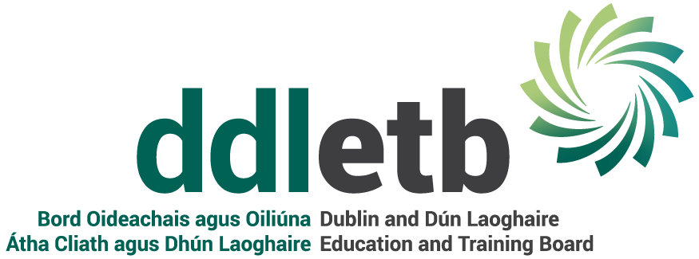
REMOTE WORKING POLICY – FAQs

1 | How long will a remote working arrangement last?  Can an employee ask to revert to their previous working arrangement at any time during the 12 month period? | Remote working arrangements will be subject to formal application on an annual basis. The arrangement will also be reviewed regularly to evaluate its suitability and effectiveness.  For each year of application there will be an initial trial period of 3 months. A review meeting will take place at the end of the trial period. The arrangement can then be extended to a 12 month period (inclusive of the 3 month trial period) or the arrangement may cease. If the arrangement ceases, the employee reverts to their previous working arrangement.  No. Each arrangement is subject to an initial 3 month trial period and a formal review on an annual basis.
2 | After a period of time can an employee claim custom and practice? | No. Every arrangement is subject to annual application/review and will cease where it no longer works to the benefit of DDLETB.
3 | What are the daily/weekly hours of an employee who is working remotely? | Employees on remote working are expected to fulfil their standard daily and weekly hours in accordance with their contract.
4 | What is the weekly fixed number of days based on? | The weekly fixed number of days is based on a full-time equivalent. 20% equates to 1 day per week, regardless of an employee’s actual number of hours/days worked.
5 | Can an employee work from a hub/abroad? | Employees cannot work in a hub or abroad from a security and Revenue point of view.
6 | Can an employee be asked to attend a meeting at their work base on a day when they would normally work remotely?  In this case, can the employee request to work remotely on an alternative day in that week? | Yes. Working remotely is marked as time in work and existing obligations under contract of employment, role and responsibilities remain unaltered.  Employees are obliged to engage with their work base work in accordance with the schedule set by their manager.  No. Employees cannot work remotely on an alternative day.
7 | Where an employee is required to attend the office on a scheduled remote working day, can they carry over that day into the following week? | No. Employees cannot carry over remote working days.
8 | Can an employee be requested to change their remote working days at short notice? | Yes. In exceptional circumstances such as sick leave or holiday cover, an employee can be requested to change their remote working days at short notice.
9 | Can an employee be requested to work remotely on days they are scheduled to work in their work base location? | Yes. An employee may be requested to work remotely in response to exceptional circumstances, eg a Covid outbreak.
10 | Can an employee be in the office in the morning and avail of working from home in the afternoon? | Working from home will be based on a full day.
11 | Can an employee who is on the  flexi-time system also avail of remote working? | No. Employees cannot avail of both arrangements.
12 | When working in the office can an employee work flexible hours? | Employees can avail of flexible hours once they complete their contractual weekly hours. However, employees cannot accrue time in lieu or flexi-leave.
13 | When working remotely, does an employee who is on a clocking system clock out for lunch? | Employees on a clocking system should record their lunch break as well as clocking in/out when commencing and finishing work, as per the Organisation of the Working Time Act and Health and Safety.
14 | Is contact limited to email if an employee does not have a work mobile | No, if an employee avails of remote working policy they must be contactable by phone.
15 | Does section/department have to be manned every day. | Each manager/section must ensure the section/department is covered 5 days per week. This is part of the planning process.
16 | Do I have to cover DDL equipment on my home insurance? | No, DDLETB’s Public & Employers Liability will continue to operate on equipment provided by DDLETB,  however employees have a responsibility to take reasonable care to avoid damage & safeguard DDLETB equipment.
17 | What happens if I have an accident at home. | Employees working from home have a responsibility to take reasonable care of themselves. In the event of an accident they should contact their line manager and Corporate Services via insurances@ddletb.ie as soon as possible.

