Minutes of meeting of Dublin and Dun Laoghaire Education and Training Board held on MSTeams and using conference call.

Meeting: 4:30 pm, September 2021

Present: Cllr Kazi Ahmed, Cllr Cathal Boland, Cllr Michael Clark, Cllr Yvonne Collins, Cllr Pamela Conroy, Ken Farrell, Anne Genockey, Daneve Harris, Cllr Peter Kavanagh, Cllr Pamela Kearns, Colm Kilgallon, Paul McNally, Claire Markey, Gerry McGuire, Cllr Joe Newman, Brendan O’Halloran, Cllr Una Power, Kenneth Rea, Cllr John Walsh.

Apologies: Cllr Brigid Manton

In Attendance: Caitríona Murphy, CEO; Debbie Howlett, Director of Organisation Support and Development; Adrian Flynn, Director of Schools, Nichola Spokes, Director of Schools, Siobhan Lynch, Director of Further Education and Training, Thea Jordan, Public Affairs Officer, Emma Maloney, PA to SMT.

Documentation:
Uploaded Electronically

- Apologies & Condolences
- Declaration of Conflicts of Interest
- Matters for the Resolution of the Board
- Matters for noting by the Board
- Matters Submitted by the Executive
- Matters submitted by the Board/Committees of the Board
- Next meeting

Welcome
The Cathaoirleach, Daneve Harris, welcomed everyone to the meeting and thanked board member Paul McNally for his service to the board over the last two years. Daneve welcomed new board member Kenneth Rea to the meeting. Paul officially resigned from the board with effect from the end of today’s meeting.

- Apologies were noted
Condolences were extended to all families of staff who have been bereaved over the last two months. A minutes silence was also observed.

- Declaration of Conflict of Interest
No conflicts were declared

- Matters for the Resolution of the Board
Minutes The minutes of previous meetings held on 17th May and 21st June 2021 were approved.
Proposed: Cllr John Walsh, Seconded: Cllr Michael Clark

Annual Report Noted
ETBI AGM 2021
Members who wish to attend the AGM were noted as, Cllr Joe Newman, Cllr Kazi Ahmed, Colm Kilgallon and Anne Genockey.

Rotation of the Chairperson to the Board
Daneve Harris will submit resignation as Cathaoirleach, with effect from close of today’s meeting.
Cllr Joe Newman was appointed as Cathaoirleach.
Proposed: Cllr Cathal Boland
Seconded: Cllr Kazi Ahmed

Board of Management Members Appointments
Members were asked to consider vacant board of management seats including DFEI.

- Matters for noting by the Board
Correspondence from Department Circulars Noted
Policies
For renewal only

Board Composition
Correspondence has been sent to the JMB/ACCS regarding a replacement for board member Eileen Salmon.

- Matters Submitted by the Executive
CEO Report – Monday 20th September 2021
Extend our thanks to the Board. As we continue to operate in line with public health and government advice including that from the Department of Education and the Department of Further and Higher Education - schools/colleges and centres have all returned as per and in line with the appropriate guidelines. Meetings are being held online also in line with government advice. Staff are still working from home where possible in Head Office and we will continue in a very careful and phased manner as we develop and consult on a Remote Working and Right to Disconnect Policy as we attempt to live with Covid while also reconnecting together to focus on T&L in all of our settings.
We extend thanks to all staff in our schools/colleges and centres (teaching/instructing/management, administration and support services – the wider DDLETB team and community) who have worked so hard to prioritise the health, safety and wellbeing of our students and staff. We wish all of our LC and LCA students the very best as they continue their education and/or working journey (Round 2 CAO places offered today).
Acknowledging also the leadership of the Directors of Schools, OSD and FET now and over the last 19 months. I would like to welcome Siobhan Lynch to the role of DFET as you may know Trevor Moore moved to the Civil Service in August. We are delighted to have Siobhan on the SMT. Previous role as AEO in the North East of the county.
Since our last meeting in June, I want to thank those of you who attended the Statement of Strategy meeting in June and for you time and participation in order to carry out your reserved functions as outlined in the ETB Act. There is a significant effort required to meet all of the deadlines as part of our statutory obligations. We will be working over the next number of months on this priority and will update you at each meeting as we progress and will require your input at various stages.
In relation to the OSD reports, we want to ensure we have enough time for the updates in relation to Buildings, HR and Finance. Debbie will take you through those. Beforehand, the Directors or Schools will take to through the updates from the schools.

Directors of Schools
Board of Management
Module three of Board of Management Training took place in June 2021. The session focused on the statutory obligations of the Board of Management in relation to Child protection Procedures, Child Safeguarding and the role of the Board in relation to the Admissions Act.
Directors of Schools will circulate presentations to the Principals for delivery at their respective Board of Management meetings, ensuring new Board members are catered for since the last academic year.
Schools
Induction Programmes for all newly appointed Principals and Deputy Principals took place on 21st August, with the second session due to take place October 1st. The first session focused on Working with Teams, Preparing for the Year ahead in relation to Staff meetings, SSE and Admissions in addition to supports and services within the ETB.
Induction programmes will take place for all newly appointed teachers across Primary and Post primary this coming September and October.
The induction programme for Primary teachers will focus on Community National Schools – living the ethos and values in addition to initial delivery of the Patron’s Programme, Goodness Me Goodness you (GMGY). Training took place remotely on Tuesday, 14thSept. 2021 (3pm-4.30pm) and the second session will take place next Thursday, 23rd September 2021 (3pm-4:30pm) on Zoom.

The Post Primary Teacher Induction Programme will take place remotely again this year. This year newly appointed teachers, NQTs and PMEs are invited to engage in two sessions on Wednesday 29th September and Wednesday 6th October, from 4.15pm on Teams.
The first session will cover an overview of the organisation, the supports we offer our teachers and an input from HR. The second session will be an entirely new input this year and focuses on Diversity through an exceptional 'Anti- Bias, Anti- Racism' training designed by a DDL teacher Briana Fitzsimons.

ETBI ICT Conference took place on 14th June. This Conference was aimed at Principals, Deputy Principals and all digital leaders/coordinators from schools across the ETB sector. The Conference focused on how technology has been used by schools since March 2020 and what schools should prioritise for the next academic year. It was very successful with over 500 participants attending.
ETBI held a comprehensive workshop for all ETB Principals across ETBs in preparation for the coming academic year on 23rd August. The session was provided by LSSU in relation to the Admissions Act/Sections 29s. All school admission policies are currently being reviewed for CE ratification.
Directors of Schools continue to facilitate communities of Practice among all our schools with DDLETB support officers in areas of SEN, DEIS and Leadership (TLP) with these programmes developing responsively to the needs of the schools over the coming year.
Youth Services
Alternative Learning Programme (ALP) has been developed by DDLETB in response to the recognition of the limited opportunities available to young people who are currently not engaged in formal education and who are below the age of 16 years. There are many and varied reasons which lead to a student leaving school early, often the current system cannot cater for the diverse needs of these young people.
Currently running in five locations across the DDLETB Administrative Area
- Dún Laoghaire
- Swords
- Tallaght
- Clondalkin
- Balbriggan
46 young people engaged with the programme from September 2020-May 2021.
Progression pathways for those who have finished ALP Back to School: 10
- Youthreach: 5
- Training/Education Centre: 5
- Referred back to EWO: 8
- Other: (please specify): 1- Home Tuition

- The programme recommenced for the coming academic term on Monday 13th September 2021. ALP tutors and Youth Workers are liaising with the Educational Welfare Service regarding referrals to the programme. 12 young people are returning to the programme in September 2021.
- Dual Purpose Sport Centres
- The Youth and Sport Development Service manages six Dual Purpose Sport Centres across the South Dublin County Council and Fingal County Council Administrative Areas. These centres are located in areas of high disadvantage.
- From today, Monday 20/09/21 indoor space is once available to rent to groups in line with public health requirements. All centres will be operating under the mixed immunity guidelines until October 22nd.
- Summer Provision
- A variety of activities were offered to target young people in the DDLETB area between June and August of 2021. This included:
- Summer sports workshops. Approx 65 targeted young people participated in sports workshops provided by youth sports officers. This included young people from Foroige Youth Services (Whitechurch, Tallaght, Blanchardstown) Crosscare Youth Services (Clondalkin, Ronanstown, Dundrum /Rathdown Y) MCA, Clondalkin Travellers Youth Service,
- Summer Sailing: 68 sessions of sailing were provided to targeted young people. These sessions were organised by Sports Officers in partnership with Baltinglass Outdoor Education Centre. Sailing sessions took place on Blessington Lakes
- Palmerstown Summer Camps: Sports Officers supported DDLETB summer camps for young people in Palmerstown
- Ballydowd: Sports Officers alongside DDLETB youth workers provided five weeks of programmes to four young people in Ballydowd special care unit

Director of Further Education and Training
- Re-opening of FET
- FET colleges and centres in DDLETB continue to follow the guidance of ETBI and the FET Stakeholders Working Group including the “Safe Return of FET Statement.” Our goal is to maintain a focus on the welfare and safety of learners and staff while facilitating access to the centres to as many students as can be safely accommodated onsite under the current restrictions. At this stage in the pandemic, we recognise the need to encourage both personal responsibility and shared collective responsibility to facilitate the safe operation of FET colleges and centres. Local management are planning accordingly and as appropriate to the needs of their learners, staff, and facilities.
- The Inaugural Review
- The FET Quality Assurance team are planning for the first external review of FET quality assurance systems. Our participation in the Inaugural Review process will offer additional assurances to learners and the public that the learning experience within DDLETB is being monitored for good practice and that there are effective arrangements in place for the quality assurance of our services.
- As part of the review, a detailed Self Evaluation Report will be compiled in the coming weeks. The Self Evaluation report is submitted to a panel of independent reviewers and will include in an accurate reflection of DDLETBs current approach to quality assurance and quality assurance enhancement.
- Next Spring, we look forward to welcoming a panel of independent reviewers to our FET centres and colleges. They will spend 5 days meeting with a range of learners, staff at all levels throughout the organisation as well as external stakeholders, to establish that their experience of our FET provision is in line with that outlined in our Self Evaluation report. The Inaugural Review is a fantastic opportunity for DDLETB to gain external advice on how we can improve our quality assurance procedures and processes which will result in a better experience for learners, staff, and stakeholders in the future.
- Mitigating Against Educational Disadvantage Fund (MAEDF)
The FET planning team and the Adult Education Services have been supporting community organisations to apply for funding under the MAEDF fund again this year. Over 30 applications have been received by the closing date and they are currently being screened to ensure they are in line with the criteria for funding issued by SOLAS. An Approval Panel has been established which will make recommendations to SMT later this week in relation to the applications received. The successful organisations will be informed of the outcome as soon as SOLAS confirms the allocation of this funding for the successful applications.
CAO
The FET Planning team are currently working with ETBI to ensure that programmes at level 5 & 6 delivered in FET colleges and centres that are targeted at school leavers can be applied for via the CAO in 2022. The aim is to make FET PLC programmes more accessible to this cohort. As these programmes will be more visible on the CAO it is hoped that they will increasingly be seen as an attractive and valued option by school leavers.
Development of the new Early Learning and Care programmes on behalf of the 16 ETBs was approved and I want to pay special thanks to Clodagh Beare and her team. We are commencing the Inaugural review of DDLETB by QQI.
Early Learning and Care Awards
Development of the new Early Learning and Care programme on behalf of the 16 ETBs was approved by the QQI validation panel and I want to pay special thanks to Clodagh Beare and her team in DDLETB.

Director of OSD
Debbie Howlett presented the OSD report:

Pobal Audit was Proposed: Gerry McGuire Seconded: Cllr Joe Newman

Risk Register Noted

Proposed ETB meeting dates 2021/2022 Noted

2021
Oct 18th
Nov 15th

2022
17th Jan
28th Feb
28th March
16th May
20th June
19th Sept

5.1 Finance Report
DUBLIN & DUN LAOGHAIRE EDUCATION & TRAINING BOARD
FINANCIAL REPORT
YEAR TO DATE August 2021
 | Programme | Opening Grant Cash  Balance |  | Receipts |  | Payments |  | Closing Grant Cash  Balance
 |  | 1st January 2021 |  |  |  |  |  | 31st Aug 2021
TOTAL MAIN SCHEME PAY |  | 324,028 |  | (78,095,329) 77,755,262 |  |  |  | (16,039)
TOTAL MAIN SCHEME NON-PAY |  | (2,662,101) |  | (5,625,428) 5,758,663 |  |  |  | (2,528,866)
TOTAL ASSOCIATED MAIN SCHEME |  | (4,756,721) |  | (4,752,618) 2,104,737 |  |  |  | (7,404,602)
TOTAL PRIMARY SCHOOLS |  | (799,874) |  | (1,764,143) 1,039,819 |  |  |  | (1,524,198)
TOTAL CAPITAL |  | (9,608,231) |  | (10,947,880) 6,459,352 |  |  |  | (14,096,759)
TOTAL THIRD LEVEL GRANTS |  | (171,666) |  | - - |  |  |  | (171,666)
TOTAL NON-MAIN SCHEME |  | (3,112,051) |  | (26,130,989) 26,004,069 |  |  |  | (3,238,971)
TOTAL TRAINING CENTRES |  | (8,011,814) |  | (25,432,898) 19,363,756 |  |  |  | (14,080,956)
TOTAL YOUTH SERVICES |  | (1,222,537) |  | (7,772,309) 6,158,817 |  |  |  | (2,836,029)
TOTAL AGENCY |  | (907,157) |  | (2,085,087) 2,599,346 |  |  |  | (392,898)
TOTAL SELF-FINANCING |  | (6,860,848) |  | (2,940,192) 1,841,377 |  |  |  | (7,959,663)
Bank Balance |  | (37,788,972) |  | (165,546,873) 149,085,198 |  |  |  | (54,250,647)
 | DDLETB had a balance of approximately €54m in the bank account at the end of August 2021
 | The following additional Grants to cover COVID-19 related expenditure were received from DOE and SOLAS to date. These Grants are included in Associated Main Scheme,
 | Primary, Non Main Scheme, Capital and Non Main Scheme in the above table.
 |  | Opening Balance |  | Receipts |  | Payments |  | Closing Balance
Assoc MS | COVID19 Grant | 0 |  | 0 |  | 0 |  | 0
Assoc MS | COVID19 EMPLOYING AIDE GRANT | (10,666) |  | 0 |  | 573 |  | (10,093)
Assoc MS | COVID19 CLEANING SUPPORT GRANT | (27,499) |  | (375,843) |  | 202,018 |  | (201,324)
Assoc MS | COVID19 ENHANCED SUPERVISION G | (277,672) |  | (1,073,336) |  | 580,403 |  | (770,605)
Assoc MS | COVID19 SANITISER & PPE GRANT | (175,277) |  | (830,168) |  | 281,953 |  | (723,492)
Primary | COVID 19 EMPLOYING AN AIDE GRA | (3,638) |  | 0 |  | 2,221 |  | (1,417)
Primary | COVID 19 CLEANING SUPPORT GRAN | (52,978) |  | (146,312) |  | 51,380 |  | (147,910)
Primary | COVID-19 SANITISER & PPE GRANT | (55,398) |  | (143,364) |  | 97,899 |  | (100,863)
Capital | COVID 19 MINOR WORKS GRANT | (2,697,983) |  | 0 |  | 1,014,786 |  | (1,683,197)
FET | COVID19 Overheads | (176,053) |  | (277,569) |  | 77,574 |  | (376,048)

5.2 Buildings Report
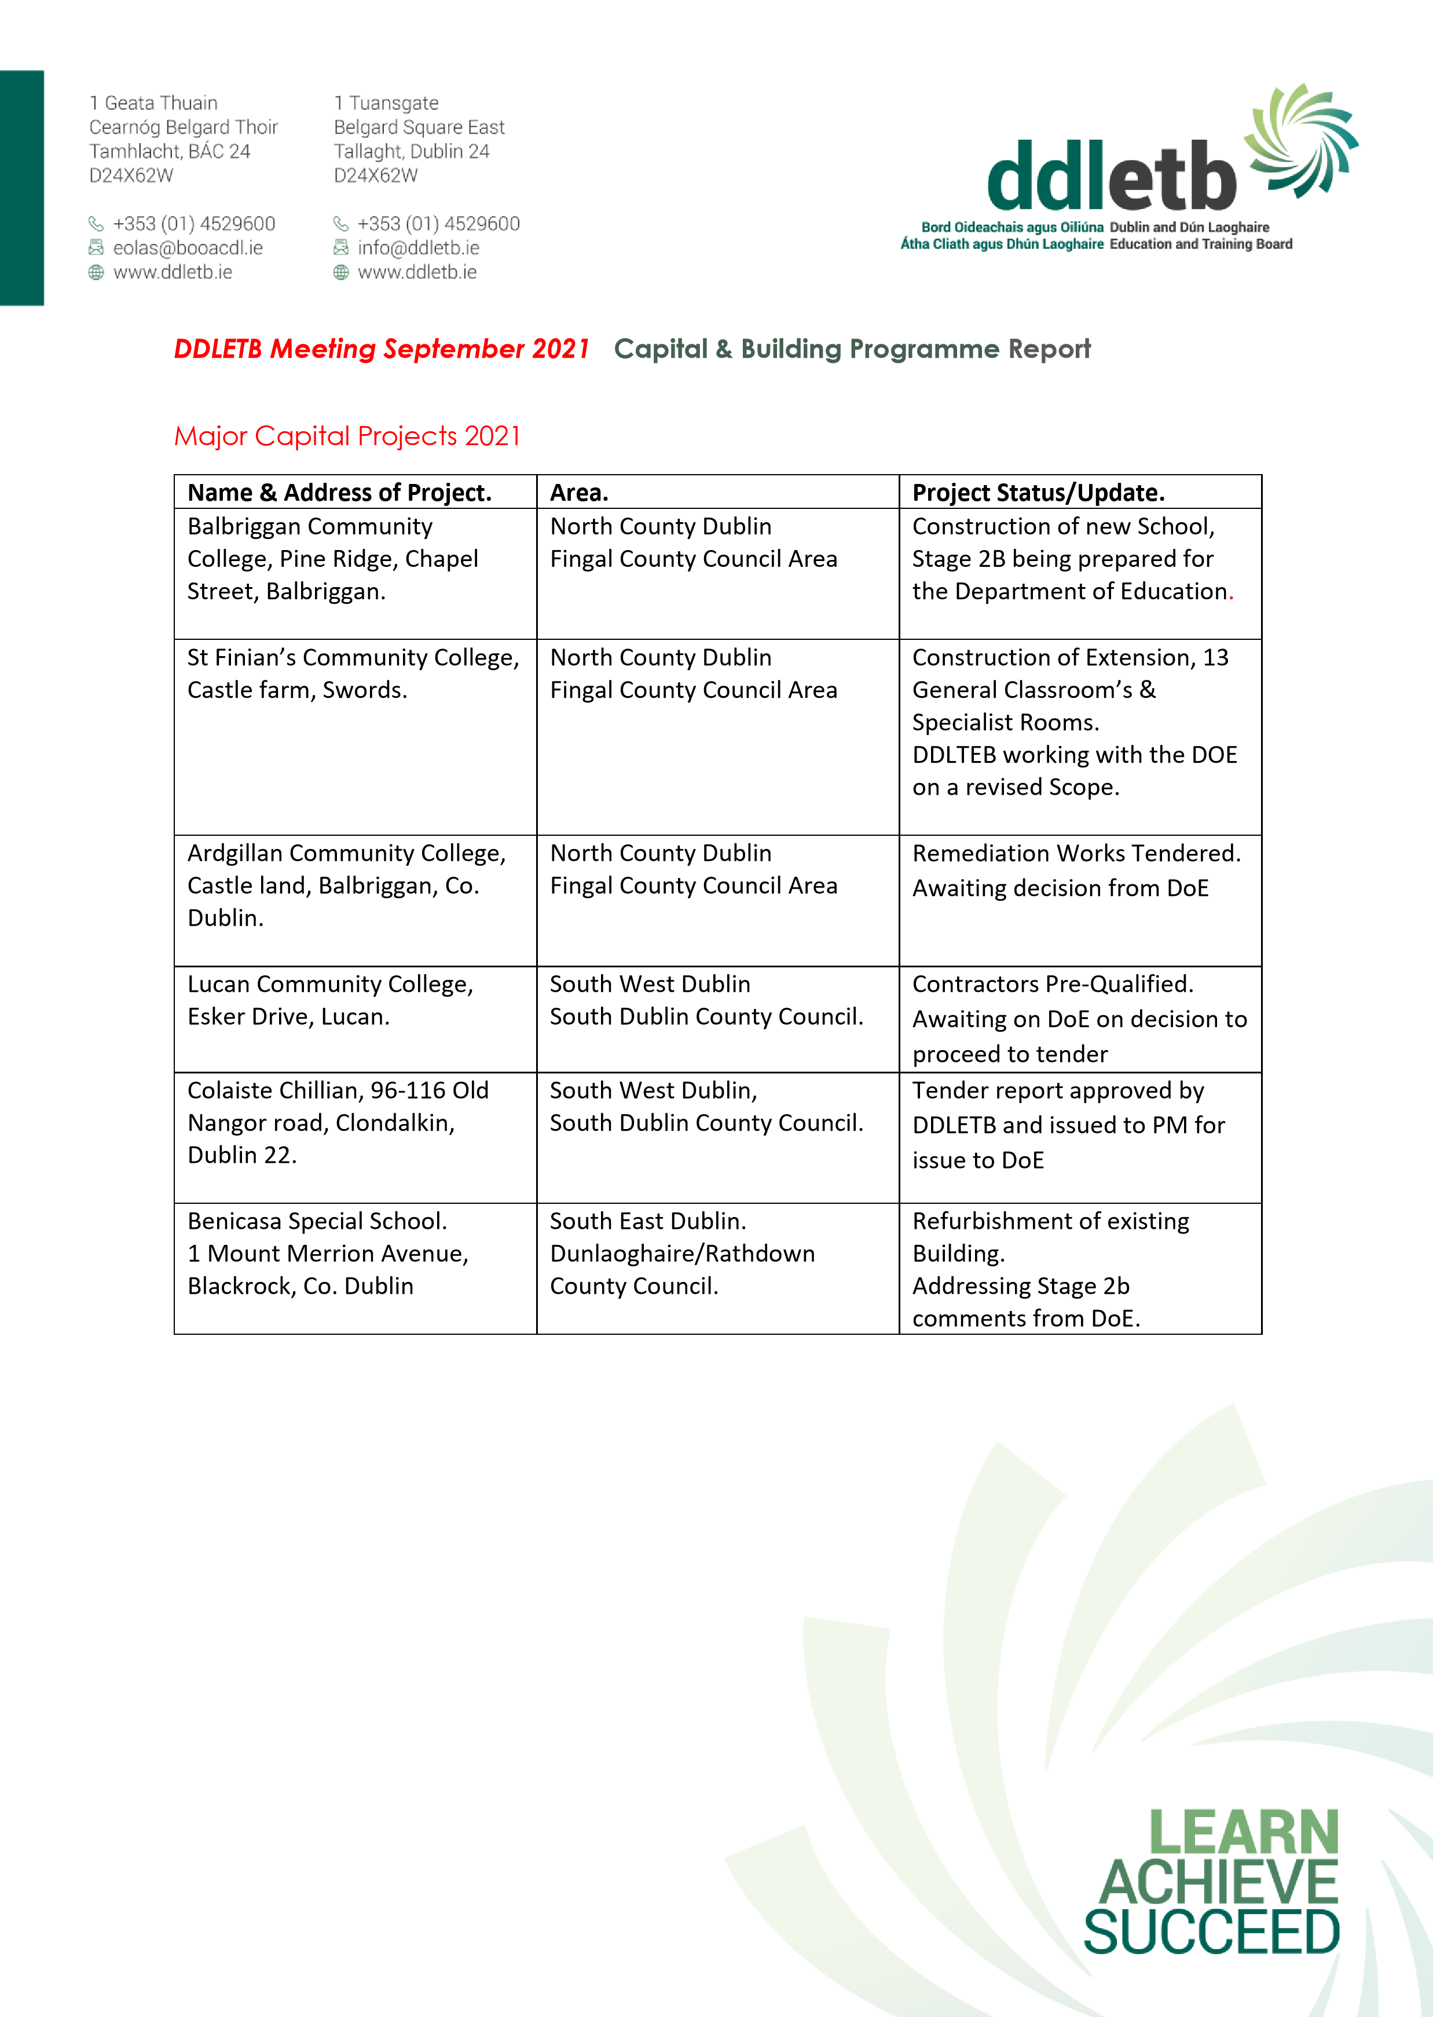
CAPITAL PROJECTS CONTINUED
St Kevin’s Community College, Font Hill Road, Clondalkin.  Dublin 22. | South Dublin County Council Area. | SEN 2 Classrooms.  Design works halted. Whole school evaluation on going
Danu Community Special School, Barnwell Road, Hansfield, Dublin. | West County Dublin.  Fingal County Council Area. | Construction works on going
GC Reachrann,  Grange Abbey Road, Dublin 13. | North Co. Dublin | Pre- qualification of contractors complete. Awaiting DoE approval to proceed to tender
Skerries Community College, Balbriggan St, Town parks, Skerries, Co. Dublin. | North Co Dublin.  Fingal County Council Area. | Design Team procured with the exception of Consultant Architect. Discussions ongoing  with DoE
Mount Seskin Community College, Jobs town, Tallaght, Dublin 24. | South Co Dublin  South Dublin County Council | Budget Approved for new SNU. Design team being approved.
Collinstown Park SEN, Rowlagh, Clondakin, Dublin 22. | South Co Dublin  South Dublin County Council. | Planning Fire Safety Cert and DAC received. DT currently preparing Stage 2b report
Summer Work’s Programme 2020. |  | All works 95% complete
TEMPORARY ACCOMMODATION PROJECTS 2021
Name & Address of Project. | Area. | Project status/Update.
Fingal TA  Sea town Rd, Town parks, Swords, Co. Dublin. | North Co Dublin  Fingal County Council Area | Ongoing discussions between the DOE, Fingal County Council and the DDLETB.

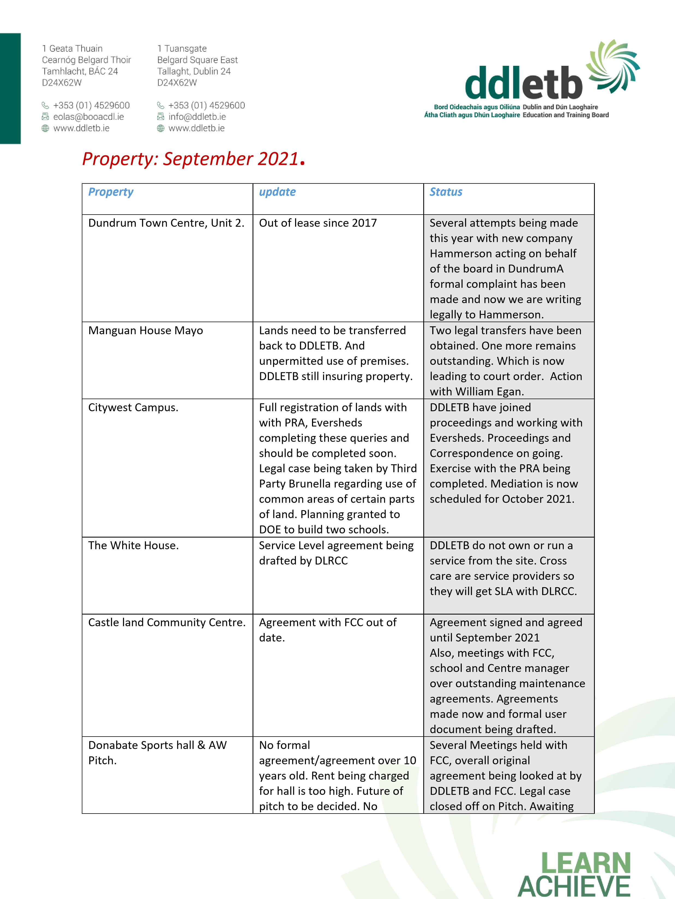
 | maintenance being paid by DDLETB. Legal case outstanding on flooding of pitch. | outstanding fees from Solicitor on fees going back 10 years. Future leasing and running of pitch to be decided.
Phibblestown  Community/sports centre | FCC want lease on building. | Meetings held regarding this. DDLETB feel not necessary to lease to FCC. A memorandum may be drawn up instead. DDLETB need to formalise Faroige being there.
The Yes Centre | In Lease, new landlord had a H & S inspection, two floors we took on are not suitable under h & S. Also, would not pass under fire safety. | Inspected site, meeting being held with our solicitor, the landlord and stokes property management. Recommended  no use of two floors going forward. Not up to Fire safety.
The Old Garda station, Blanchardstown. | OPW want to formalise agreement, none in place, we have been tenants for 20 years. | William Egan has sent correspondence in the past to clarify ownership and looking for transfer to us. OPW do not want this, talking to the department on this and going forward.
Baldoyle Supplement lease | Out of date. Agreed to continue for next 3 years. | Signed and agreed with Landlord and Baldoyle TC.
Service Level Agreements | Ballydowd completed. | Being sent to TUSLA.
Property Registration Exercise. | All property needs to be registered. DDLETB working with Solicitor and DOE. | In progress. Stage three completed. Moving on to next stage.
Balbriggan Sports Hall. | The building opened at the start of Covid. School maximised usage. FCC and DDLETB want centre back to what its main purpose was meant to be a community/sports centre. | Several meetings with Staff and school to get rooms back.  Steering group being set up. Meetings with FCC around funding and going forward.

5.3 Staff Profile Updates Noted
- Retirements
- Appointments & Promotions
- Resignations
- Career breaks & Job Shares

- Matters Submitted by the Board/Committees of the Board
In line with Standing Orders
- Next Meeting: 18th October 2021

