Minutes of meeting of Dublin and Dun Laoghaire Education and Training Board held on MSTeams and using conference call.

Meeting: 4:30 pm, 29th March 2021

Present: Cllr Kazi Ahmed, Cllr Yvonne Collins, Claire Markey, Cllr Brigid Manton, Cllr Joe Newman, Cllr John Walsh, Brendan O’Halloran, Cllr Cathal Boland, Gerry McGuire, Colm Kilgallon Cllr Michael Clark, Ken Farrell, Cllr Peter Kavanagh, Cllr Pamela Conroy, Daneve Harris.

Apologies: Cllr Una Power, Paul McNally

In Attendance: Caitríona Murphy, CEO; Debbie Howlett, Director of Organisation Support and Development; Thea Jordan, Public Affairs Officer; Adrian Flynn, Director of Schools, Nichola Spokes, Director of Schools, Trevor Moore, Director of Further Education and Training, Allen Buckley, APO Finance, Gillian Doherty, Chairperson Audit & Risk Committee, Emma Maloney, PA to SMT.

- Apologies & Condolences
- Declaration of Conflicts of Interest
- Matters for the Resolution of the Board
- Matters for noting by the Board
- Matters Submitted by the Executive
- Matters submitted by the Board/Committees of the Board
- Next meeting

Welcome
The Cathaoirleach, Daneve Harris, welcomed everyone to the meeting

Condolences
Votes of Sympathy were expressed to the following:

To our colleague in Head Office, Mary Kenny, on the passing of her father, Jim Kenny.
Teresa McHale, Dun Laoghaire Adult Education, on the passing of her brother, Bill McHale.
A minute silence was observed.

- Apologies/Condolences were noted

- Declaration of Conflict of Interest
No conflicts were declared

- Matters for the Resolution of the Board
Gerry McGuire was appointed as Deputy Chairperson until September 2021.
Proposed: Cllr John Walsh
Seconded Cllr Joe Newman

Minutes: minutes of previous meeting held on 23rd February were deferred for amendments

Annual Financial Statement:
Chairperson of the Audit and Risk Committee, Gillian Doherty, presented the Statement of Internal Control to the Board.
Chairperson of the Finance Committee, Gerry McGuire, presented the Annual Financial Statement to the board. Adopted
Proposed: Gerry McGuire
Seconded: Peter Kavanagh

Committees to the Board
Chairperson of the Audit and Risk Committee, Gillian Doherty presented the Report from the Audit & Risk Committee which included the Risk Report and Summary of Risk.
On behalf of the Board, the Chairperson expressed sincere gratitude for the hard work, diligence, commitment & wisdom of the Risk Committee in their efforts to protect the organisation from a risk perspective.
Gillian Doherty then left the meeting.

Standing Orders: Deferred

- Matters for noting by the Board
Correspondence from Department: Circular letters
Correspondence from Other Sources: Ltr dated November 2020, to CE from Committee of Public Accounts.

A member of the board raised a request for the escalation of the letter to ETBI regarding interview fees of board members. The board agreed.

- Matters Submitted by the Executive
Update from the Chief Executive

CEO Report – Monday 29th March 2021

We are continuing to operate within Level 5 restrictions and await updates on the 5th April 2021. Staff working from home unless absolutely essential and the phased return to schools and centres commenced in line with guidance from the DoE and DFHERIS (See DoS report below).
I want to acknowledge and thank all of the Schools, Colleges and Centres for their commitment and hard work in the re-opening of education and training services.
Since our last meeting, the Finance unit has been working on the preparation of the annual financial statements (AFS) for 2020. These will be presented to you here today. Thanks all those involved in this work so that the members can carry out their reserved functions as outlined in the ETB Act. As you know, your functions under Section 12 are clearly outlined. There is a significant effort required to meet the deadlines as part of our statutory obligations and I would like to thank all staff and particularly staff in Finance and Treasury. And to the Finance Committee and A&R Committee.

I wish to advise you also about a communication from the PAC requesting a further breakdown on the non-compliant procurement in 2018 to include the number of contracts, the associated expenditure and the reason for the non-compliance. This information was supplied in full to the PAC within the requested deadline. We have received a similar letter from the PAC requesting the same information in relation to the 2019 accounts. There was a significant reduction in expenditure in this category and a further reduction is evidenced in 2020. Correspondence is uploaded for your information.

In relation to fraud, I wish to advise you that we are requested by the Department to make a quarterly return in relation to any fraudulent activity that has occurred. We will make this return available to you also for information.

With regard to the A&R committee, we are continually reviewing the audit logs in order to close out, as appropriate, all aged items identified prior to 2018. The executive is committed to carrying out this work to completion with a review in Autumn 2021.

I have attached two reports for information for you. Firstly, the Funding Allocation Request to SOLAS which show the narrative that supports all of our course plans and a detailed budget submission. Secondly, the update to Goal 2 High Quality Experience for Learners from our Statement of Strategy to give you all a sense of the work carried out by DDLETB to deliver on our commitments and the progressive work in teaching and learning. It is important to brief you on the progress as we commence the planning process for the new Statement of Strategy 2022-2027.

In relation to Collinstown CC, I have attached a correspondence from the DoE in relation to a previous arrangement which has now been changed by the Department and which is of greater benefit to the College.
A written request to the last meeting has been emailed to the Board member and is uploaded for your information.

I want to acknowledge the leadership of the Directors and the work all staff – teaching/instructing/management, administration and support services – the wider DDLETB team and community.

Directors of Schools
Board of Management
Session two and three of Board of Management training modules will take place in April and May, dates of which will be sent to all Board members after the Easter break. These modules will take the form of a live Webinar. Phase 2 will focus on the role of the Board of Management as a corporate entity and the operations of a Board meeting. Session 3 will focus on the statutory obligations of the Board of Management in relation to Child protection Procedures and the Child Safeguarding.

Schools
Building on the return to school in recent weeks of students in special schools and in special classes at primary and post-primary level, the full re-opening of all Primary school classes took place Monday 15th March. All primary and Special schools are now fully re-opened. Post Primary schools re-opened for fifth year and leaving certs.
Detention and Special Care Units fully re-opened Monday 15th March for all students. Youth Services ALP provision will resume on 12th April, in line with DES guidelines. ETBI Principal and Deputy Principal Conference took place Thursday 25th March. CPD modules on sleep and anxiety during Covid and the management of accredited grades were facilitated by Directors. Post Primary Principals and Deputy Principals participated in CPD on ‘Clarifying the Ethos of DDLETB Schools’. Remote teaching and learning continues for all schools with communities of practice development and co-facilitation of digital school leads for in-house training with DDLETB Digital Learning Lead continues. Directors of schools continues to facilitate pop-up meetings with Principals and Deputy Principals.

Director of Further Education and Training
Simon Harris, Minister for Further and Higher Education, Research, Innovation and Science, paid a virtual visit to Collinstown Park Community College today Monday March 29th. Collinstown Park hosts PLC, BTEI and Traineeship provision. In addition, it hosts the Microsoft Data Centre Academy; the first of its kind in Europe. The Minister will be engaged directly with learners on this virtual visit. DDLETB will host a virtual launch of a targeted initiative towards Hospitality & Tourism Sector Employers on April 16th. This information event is in partnership with SOLAS and the Irish Hotels Federation. The event will showcase opportunities to upskill or reskill employees in the Hospitality & Tourism sector via the Skills to Advance programme.
The FET Strategy & Planning Unit have scheduled a number of consultation workshops for April on the Future FET Funding Model. SOLAS have proposed a new funding model and DDLETB will be one of the pilot ETBs. The process is at an early stage and the workshops are to gather feedback from DDLETB FET management on the newly proposed funding model. On Friday March 26th, Minister Harris and Minister Collins announced €20 million in capital funding to expand apprenticeship provision across further and higher education. This will fund the delivery of almost 4,000 additional craft apprentice places. DDLETB has formally submitted apprenticeship expansion plans to SOLAS for all three Training Centres – Baldoyle, Tallaght and Loughlinstown. DDLETB will engage with SOLAS and the sector on expansion developments. The new DDLETB External Authenticator panel has been finalised, and training was given to 97 new External Authenticators

    - Finance Report

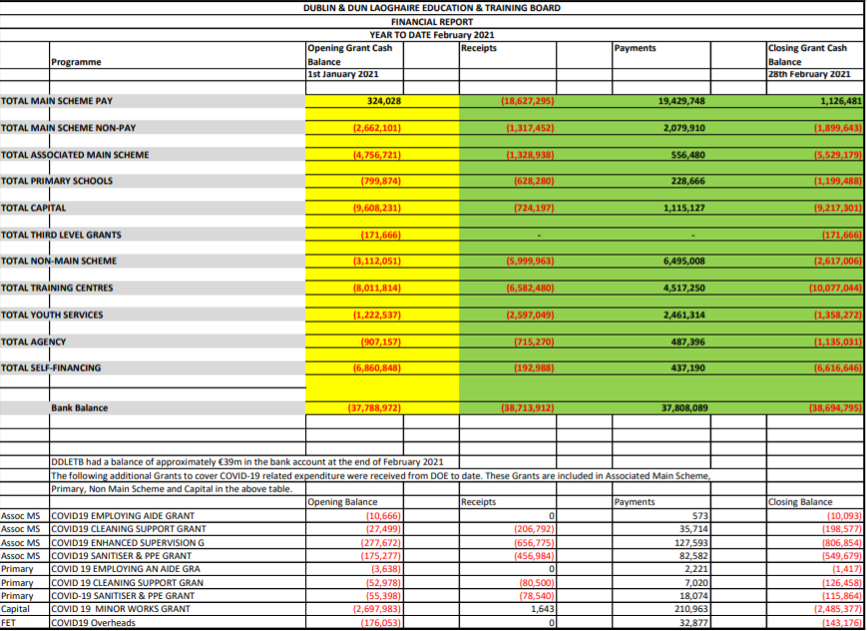
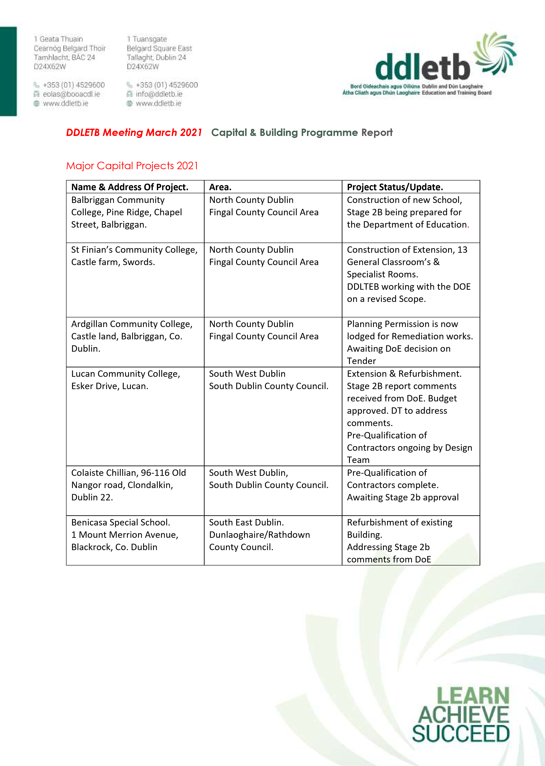
- CAPITAL PROJECTS CONTINUED
St Kevin’s Community College, Font Hill Road, Clondalkin.  Dublin 22. | South Dublin County Council Area. | SEN 2 Classrooms.  Awaiting Stage 1 approval from DOE
Danu Community Special School, Barnwell Road, Hansfield, Dublin. | West County Dublin.  Fingal County Council Area. | Refurbishment of Classrooms.  Design Team Tenders and Cost Plan approved by DOE. DT appointed
GS Reachrann,  Grange Abbey Road, Dublin 13. | North Co. Dublin | Pre- qualification of contractors ongoing. Awaiting DoE comments on Stage 2b
Skerries Community College, Balbriggan St, Town parks, Skerries, Co. Dublin. | North Co Dublin.  Fingal County Council Area. | PM preparing documents for appointment of Design Team
Mount Seskin Community College, Jobs town, Tallaght, Dublin 24. | South Co Dublin  South Dublin County Council | Budget Approved for new SNU. Design team being approved.
Collinstown Park SEN, Rowlagh, Clondakin, Dublin 22. | South Co Dublin  South Dublin County Council. | Design Team Appointed. Stage 1 report approved by DOE. DT preparing planning documents
Summer Work’s Programme 2020. |  | Appointment of contractors being processed.
TEMPORARY ACCOMADATION PROJECTS 2021

Name & Address of Project. | Area. | Project status/Update.
Fingal TA  Sea town Rd, Town parks, Swords, Co. Dublin. | North Co Dublin  Fingal County Council Area | Ongoing discussions between the DOE, Fingal County Council and the DDLETB.

Staff Profile Updates
- Appointments and Promotions
- Retirements
- Resignations

- Matters Submitted by the Board/Committees of the Board
Items submitted by the Board/Committees of the Board (ARC/Finance)
- Audit & Risk Committee Annual Report to the DDLETB Board 2020
- Youth & Sports Sub Committee Minutes 28th November 2019

- Board of Management Members appointments
Dundrum FEI: Cllr Michael Clark was appointed to the BoM, Proposed: Cllr Peter Kavanagh, Seconded: Ken Farrell
Tallaght CNS: Anne Genockey was appointed to the BoM, Proposed: Cllr Peter Kavanagh, Seconded: Gerry McGuire

- Items submitted by the board: N/A

- Next meeting: Monday 17th May 2021

