Minutes of meeting of Dublin and Dun Laoghaire Education and Training Board held on MSTeams and using conference call.

Meeting: 4:30 pm, 23rd February 2021

Present: Cathaoirleach, Daneve Harris, Cllr Kazi Ahmed, Cllr Yvonne Collins, Claire Markey, Cllr Brigid Manton, Paul McNally, Cllr Joe Newman, Cllr John Walsh, Brendan O’Halloran, Cllr Cathal Boland, Gerry McGuire, Colm Kilgallon Cllr Michael Clark, Cllr Una Power, Ken Farrell, Cllr Peter Kavanagh, Cllr Pamela Conroy.

Apologies: Anne Genockey, Cllr Pamela Kearns

In Attendance: Caitríona Murphy, CEO; Debbie Howlett, Director of Organisation Support and Development; Thea Jordan, Public Affairs Officer; Nichola Spokes, Director of Schools, Trevor Moore, Director of Further Education and Training, Shay Heneghan Psychological Services, Emma Maloney, PA to SMT.

Documentation:
Uploaded Electronically

- Apologies & Quorum
- Declaration of Conflict of Interest
- Action Log
- Minutes of previous meeting
- Committees and Reporting
- Service Plan 2021
- Correspondence from Department
- Board Effectiveness Evaluation
- Board of Management Members’ review
- Any other business
- Next meeting 29th March 2021

Welcome
Cathaoirleach, Daneve Harris, welcomed everyone to the meeting.

Condolences
Votes of Sympathy were expressed to the following:

Pat Stevenson, head office, on the death of her brother, Christy.
Catherine Bruen, Finance Committee on the death of her husband, Frank. A minute silence was observed.

- Apologies were noted

- Declaration of Conflict of Interest
No conflicts were declared

3. Approval of Previous Minutes
Members noted adjustment on the January Finance Report. The minutes of previous meeting held on 18th January 2021 were approved

Proposed: Gerry McGuire Seconded: Cllr Michael Clark

4. Committees and Reporting
a. Committees to the Board minutes are available for information on Boards SharePoint. b. Reports from the Executive

CEOs Report

Chief Executive Officer Update

Tuesday 23rd February 2021
We are continuing to operate within Level 5 restrictions with all remote learning taking place on line to date and all staff working from home unless absolutely essential. We have worked closely with the Department in relation to the return of special education classes from 11th February 2021 and also for the recently announced phased reopening of schools in March and April 2021.
I want to acknowledge and thank the students from our schools and centres who have represented DDLETB in the national media over the last few weeks from St Kevin’s CC, Fingal CC and Tallaght Training Centre.

Long-Term Projected Enrolments
Also, I want to brief you on a request from the DoE to increase the long term projected enrolment in a number of schools under the patronage of DDLETB. We have engaged with the Principals of our schools and have outlined to the Department what is required in terms of supports and additional accommodation in order to support the request. We have also requested time for BOM and staff to be briefed on the future plans in the first instance. A request for the Lucan area is also being considered.

SPA | School | Existing LTPE | Proposed LTPE
Rush & Lusk | Lusk CC – RN: 76213T | 1,000 | 1,300 + 2 additional SEN
Blanchardstown | Éiru CC – RN: 76574F | 1,000 | Full 1st year intake 2021
Castleknock | Castleknock CC–N:76062B Luttrelstown CC-RN:76130P | 1,000  1,000 | 1,500 + 2 additional SEN  1,200 + 2 additional SEN
Newcastle/Rathcoole | Cól Pobail Fóla – RN: 76594L | 1,000 | Full 1st year intake 2021
Balbriggan | Balbriggan CC – RN: 70010V | 1,000 | Full 1st year intake 2021
Swords | Swords CC – RN: 76475D St Finian’s CC – RN: 70120F | 1,000  1,000 | Increase to 1,200 students Full 1st year intake 2021

Organisation Support and Development
An important section in relation to the Service Plan is put before you today for adoption and I want to thank the Executive and the Finance Committee for their work on this. Debbie will update you in relation to the Finance and Building Reports shortly but I just want to note the work of all of the OSD staff. The last few weeks and the next few weeks are an extremely busy and important time for the organisation in relation to the governance commitments outlined in the ETB Act. The work of the Finance and A&R Committees are extremely important at this time to meet our legal obligations. We have many additional requests from both the Department and the C&AG in relation to the 2019 accounts and also the plans now for the 2020 audit. The Internal Audit Unit are also commencing their work for 2021.

Directors of Schools

BoM Training
Phase 1 of the Board of Management training is now complete, with over 300 Board members trained across Primary, Post Primary and FET over a four-week period.
Phase 2 and 3 will be coordinated and facilitated by the Directors of Schools with a focus on the Role of the Chair, Role of the Secretary, BoM Meeting Agenda, Enrolment, Finance Oversight, CPOR, Managing Inspections and the role of the Board in relation to oversight of mandatory policies.

Schools
Special schools re-opened Friday 11-02-21 at 50% capacity and Special classes in Mainstream schools at both Primary and Post primary fully re-opened at 100% capacity on Monday 22/02/21.
In-supplementary tuition in addition to remote learning continues for pupils with SEN in mainstream at both primary and Post Primary.
Remote teaching and learning continues for all schools with communities of practice development and co-facilitation of digital school leads for in-house training with DDLETB Digital Learning Lead.
The development of the new NCCA curriculum framework for Detention and Care Units is underway, with two of our schools piloting the curriculum changes this term following consultation with NCCA steering curriculum committee, NCCA officer and Principals of the care units.
Directors of schools continues to facilitate pop-up meetings with Principals and Deputy Principals.

Director of Further Education and Training

Phased re-opening
SOLAS have agreed a number of critical and time sensitive Apprenticeship classes to return to Training Centres as of
March 1st 2021. This plan is based on based on full adherence to the current national public health guidelines and health
& safety regulations. This will mean Apprentices in Baldoyle (one electrical, one Electrical Instrumentation, one Motor),
Tallaght (Carpentry) and Loughlinstown (Electrical) will return to training from March 1st 2021,

Skills to Advance
SOLAS have identified as a priority programme again for 2021. A recent meeting was held with SOLAS to discuss strong performance in 2020. There was a 45% increase in employed learners participating in upskilling courses at Levels 5 and 6. This represented an increase from 794 in 2019 to 1194 in 2020. Projections for 2021 are planning for significant further growth. The shift to online learning has had a positive impact on employed learner engagement.
Contingency Guidelines for learners missing work placement agreed with QQI, and briefing sessions rolled out for all centres. Communities of practice established for subject matter teachers to share good practice in assessing vocationally specific practice skills within the context of COVID-19 restrictions.
QA Unit review of the conversion of all examinations to alternate assignments to ensure that standards of assessment will be maintained in the event that learners are unable to complete their examinations in-centre. 20% of all amended assessments will be forwarded to the FET Programmes Committee for approval, to ensure ETB-level governance oversight.

Presentation - Shay Heneghan from the Psychological Support Service (PSS)

Sincere thanks to Shay and his team for the work that they do and particularly in relation to the supports provided during the various lockdown periods over the last 12 months.
Shay Heneghan gave a presentation to the board on the work that Psychological Services are doing and online supports that are available.

Legal Advice
We have made the legal advice available to you again with some additional information from ETBI and a note to clarify and simplify some of the documentation. As follows;
A subgroup of Chief Executives and ETBI was set up to review and respond to the Legal Advice Working Group.
Items agreed upon included the following;
- Admissions Policy (it is the CEO’s decision as patron)
- Other BOM policies do not need patron approval (BOM decision for noting to the CEO)
- Minutes of BOM meetings (the CEO notes the minutes and does not need to bring to the Board)
- School building use after hours (to be governed by an explicit licence or statement from CEO to BOM to govern use of buildings). The Compliance Group under OSD can issue the licence as advice to ETBs.

The BOM Handbook is being updated so that any conflicts noted in the advice are removed. The update to the handbook and training for ETBs will take place as soon as possible. The Manual has to be approved by the Minister. Alignment of the Code of Governance with the legal advice is to be undertaken by the Review Group dealing with the Code and with the Post Primary Admin Section. DDLETB are represented on this group.
The group also discussed the ETB meetings. The schedule of matters was briefly reviewed. It was noted that Boards approach agenda making differently but there are agenda items that require action for example;
- Minutes of last meeting to be adopted.
- Executive reports (buildings, finance and director reports) are for information.
- BOM minutes - there is a choice i.e. for information or leave with CEO for noting.
- Committee Reports; o Audit & Risk and Finance Reports - to be reported on or noted (as per Code of Governance) but conflicts with section 44(18) of the Act which states subject to confirmation.
o Finance i.e. AFS and Annual Service Plan – to be adopted in line with the Act.

Committees may arise in accordance with ETB needs related to the reserved functions of the board. It is required under Section 15(4) that the executive be accountable to the Board for the due performance of their executive functions and committees may serve to exercise that role for the Board and therefore should be adopted if such committees are established.

1.1.1. Finance Report

DUBLIN & DUN LAOGHAIRE EDUCATION & TRAINING BOARD
FINANCIAL REPORT
YEAR TO DATE DECEMBER 2020
 | Programme | Opening Grant Cash  Balance | Receipts | Payments | Closing Grant Cash  Balance
 |  | 1st January 2020 |  |  | 31st December 2020
TOTAL MAIN SCHEME PAY |  | (182,916) | (113,225,553) | 110,753,569 | (2,654,901)
TOTAL MAIN SCHEME NON-PAY |  | 923,419 | (11,812,357) | 8,526,562 | (2,362,375)
TOTAL ASSOCIATED MAIN SCHEME |  | (3,322,194) | (4,976,774) | 3,496,683 | (4,802,285)
TOTAL PRIMARY SCHOOLS |  | (503,990) | (1,683,265) | 1,417,454 | (769,801)
TOTAL CAPITAL |  | (3,367,098) | (13,069,792) | 10,565,402 | (5,871,488)
TOTAL THIRD LEVEL GRANTS |  | (171,666) | - | - | (171,666)
TOTAL NON-MAIN SCHEME |  | (3,371,387) | (36,116,176) | 35,709,186 | (3,778,377)
TOTAL TRAINING CENTRES |  | (2,339,763) | (38,050,135) | 31,386,249 | (9,003,649)
TOTAL YOUTH SERVICES |  | (1,234,975) | (10,771,104) | 10,699,214 | (1,306,865)
TOTAL AGENCY |  | (561,423) | (3,294,943) | 3,356,357 | (500,009)
TOTAL SELF-FINANCING |  | (6,325,717) | (4,309,885) | 3,854,452 | (6,781,149)
Bank Balance |  | (20,457,712) | (237,309,984) | 219,765,331 | (38,002,565)
 | Summary C - Pay Liabilities
 | Summary B - Non-Pay Liabilities
 | Summary D - Debtors
 | Bank Interest
 | Profit/Loss
OVER ALL TOTAL |  | - | - | - | -
 | DDLETB had a balance of approximately €38m in the bank account at the end of December 2020
 | The following additional Grants to cover COVID-19 related expenditure was received from DES to date. These  Scheme, |  |  | Grants are included | in Associated Main
 | Primary, Non Main Scheme and Capital in the above table.
 |  | Opening Balance | Receipts | Payments | Closing Balance
Assoc MS | COVID19 Grant | 0 | 148 | 37,593.33 | 37,741
Assoc MS | COVID19 EMPLOYING AIDE GRANT | 0 | (78,109) | 68,869.93 | (9,239)
Assoc MS | COVID19 CLEANING SUPPORT GRANT | 0 | (206,958) | 216,691.29 | 9,733
Assoc MS | COVID19 ENHANCED SUPERVISION G | 0 | (657,615) | 378,713.87 | (278,901)
Assoc MS | COVID19 SANITISER & PPE GRANT | 0 | (761,926) | 595,108.65 | (166,818)
Primary | COVID 19 EMPLOYING AN AIDE GRA | 0 | (10,032) | 6,422.00 | (3,610)
Primary | COVID 19 CLEANING SUPPORT GRAN | 0 | (81,068) | 27,206.75 | (53,861)
Primary | COVID-19 SANITISER & PPE GRANT | 0 | (130,754) | 70,386.89 | (60,367)
Capital | COVID 19 MINOR WORKS GRANT | 0 | (2,306,096) | 943,535.92 | (1,362,560)
FET | COVID19 Overheads | 0 | (594,733) | 393,336.40 | (201,397)

1.1.2. Capital and Buildings Report

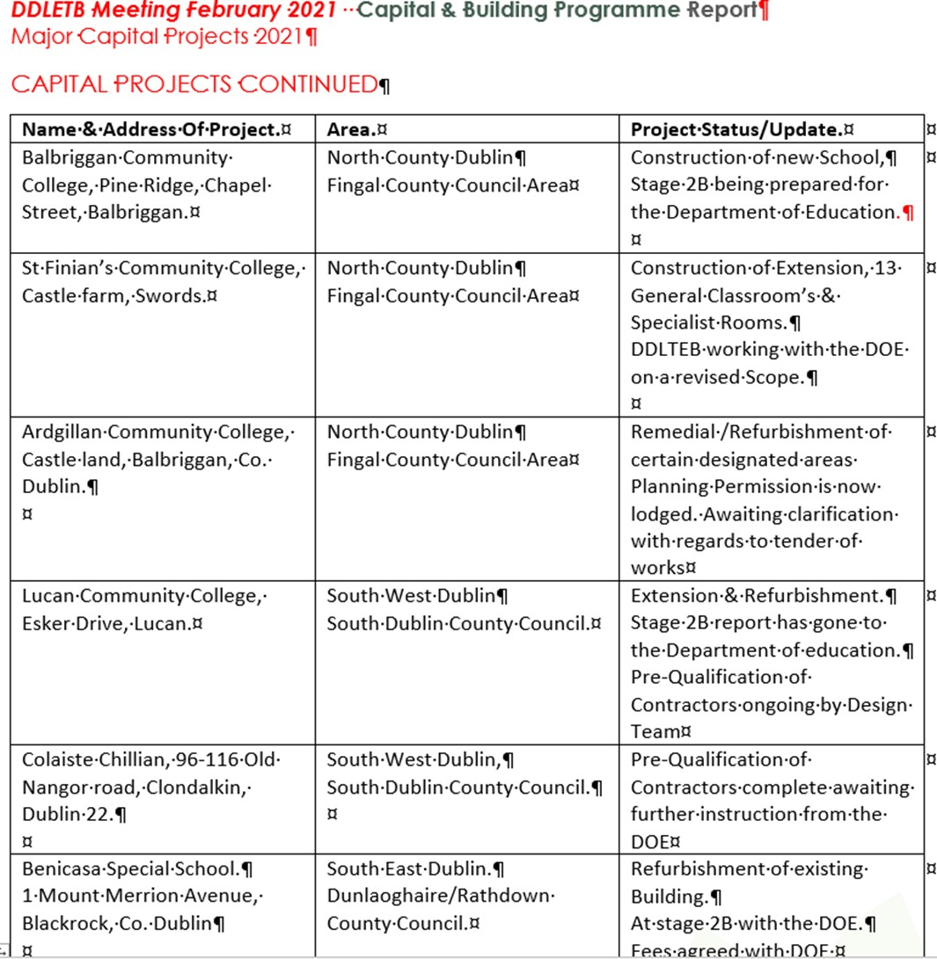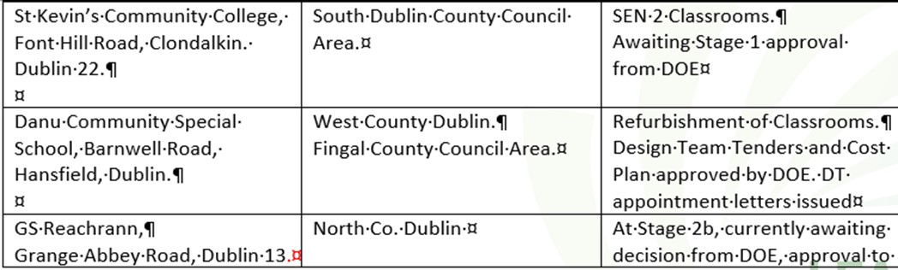

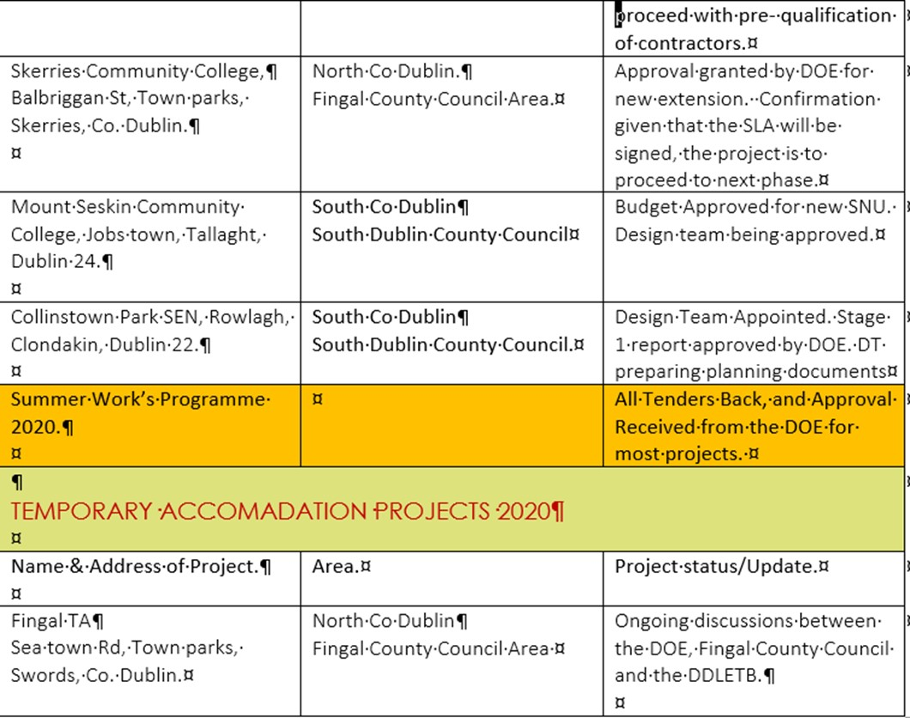

Property Update : Leases/Licences Leases
- Baldoyle Training Centre Satellite Unit – Lease for this centre was out in April 2020. The renewal lease is with our solicitors for review at present.
- Burgandy House Swords – New 9 year Lease completed and signed February 2021.
- Dundrum Town Centre: FET Training unit. Lease renewal is being worked on at present with our solicitor.

Licences
- Lucan Community College – A 2 year licence was issued in January 2020 for use of the schools playing pitch by Arthur Griffith Park FC.
- Holmpatrick National School – Licence Expired in October 2020. A licence is being drafted to renew the school’s occupation of our building for a further 5 years. With our solicitor at present.
- Scoil Aoife Community National School – Licence being drafted to allow Care & Cuddles Pre-school use an area in the school. With our solicitor at present.
- Former Senior College Dun Laoghaire (Eblana) – Temporally being used by the Department of Education & Skills to house Dun Laoghaire Educate Together National School. This is due to remedial works at their school – Licence drafted and awaiting signature.
- Citywest Campus – Temporally being used by the Department of Education & Skills to house schools affected by remedial works – Licence drafted and going to DoES for consideration.

Staff Profile updates were noted
  - Appointments & Promotions
  - Resignations
  - Retirements

5. Action Log
Cathaoirleach, Daneve Harris discussed the introduction of an Action log for ETB board meetings.
Board members agreed that this would be beneficial. It was agreed by members that rotation of Cathaoirleach would continue.EXPAND?

6. Service Plan 2021
Gerry McGuire as Cathaoirleach of the Finance Committee presented the Annual Service Plan 2021 to the board. Proposed: Gerry McGuire

Seconded: Ken Farrell

7. Correspondence from Government Departments Noted
- Department Circular letter
- Letter of Determination in respect of year ending December 31st 2021.
- Board Effectiveness Self Evaluation

- Board of Management members’ review
Scoil Ghrainne: Karen Donnelly was appointed to the board of management
Proposed: Cllr John Walsh Seconded: Cllr Peter Kavanagh
Broadmeadow CNS: Cllr Brigid Manton was appointed to the board of management
Proposed: Cllr John Walsh Seconded: Gerry McGuire
Colaiste Pobail Folá: Daneve Harris was appointed to the board of management
Proposed: Cllr Peter Kavanagh Seconded: Gerry McGuire
Fingal Community College: Gerry McGuire was appointed to the board of management

Proposed: Cllr Michael Clark Seconded: Cllr Peter Kavanagh

10. Any other Business
Cllr Daniel Dunne has resigned from the board of CFE Dundrum
A board member raised that it would be courteous to send questions to be included for AOB a few days before the ETB meetings.

11. Next meeting 29th March 2021

