Minutes of meeting of Dublin and Dun Laoghaire Education and Training Board held on MSTeams and using conference call.

Meeting 13: 4:30 pm, 18th January 2021

Present: Cllr Kazi Ahmed, Cllr Cathal Boland, Cllr Michael Clark, Cllr Yvonne Collins, Cllr Pamela Conroy, Ken Farrell,
Anne Genockey, Daneve Harris, Cllr Peter Kavanagh, Cllr Pamela Kearns, Colm Kilgallon, Cllr Brigid Manton, Claire Markey, Gerry McGuire, Paul McNally, Cllr Joe Newman, Cllr Ed O'Brien, Brendan O'Halloran, Cllr Una Power, Cllr John Walsh.

In Attendance: Caitríona Murphy, CEO; Debbie Howlett, Director of Organisation Support and Development; Thea Jordan, Public Affairs Officer; Adrian Flynn, Director of Schools; Trevor Moore, Director of Further Education and Training; Bill Kavanagh, Buildings Officer; Treacy Byrne, Buildings & Property Officer; Paul Byrne, IT Manager; Sam Conroy, Digital Lead TEL; Emma Maloney, PA to SMT.

Documentation:
Uploaded Electronically

- Meeting Agenda
- Declaration of Conflict of Interest
- Minutes of Previous Meeting
- Committees and Reporting
- Correspondence from Department
- Policies and Procedures
- Board Effectiveness Self Evaluation
- IADT Governing Body Nominees
- Board of Management Member Review
Welcome
Cathaoirleach, Daneve Harris welcomed everyone to the meeting and wished everyone a happy new year.

Condolences
Votes of Sympathy were expressed to the following:

Aisling Crowley, Youth Services, on the passing of her father, Donal.
Caitríona Murphy, CEO, on the passing of her mother, Kay.
Maria Culbert, Adult Education Services, on the passing of her mother, Margaret.
The passing of Therese Connolly, Dublin Northeast office.
The passing of Lisa Osborne, our colleague in Blackrock FEI and the old VEC building Dun Laoghaire. The passing of Paddy Scarlett, former music teacher in Riversdale Community College.

- Meeting Agenda
The meeting agenda was agreed

- Declaration of Conflict of Interest
No conflicts were declared

- Approval of Previous Minutes
The minutes of previous meeting held on 16th November 2020 were approved

Proposed: Cllr Kazi Ahmed Seconded: Cllr Peter Kavanagh

4. Committees and Reporting
- Committees to the Board were confirmed

- Reports from the Executive
Staff Profile updates were noted
  - Appointments & Promotions
  - Retirements

  - CEOs Report

Chief Executive Officer Update

CEO Report
I would like to wish the Board a happy and peaceful new year and every best wish to you and your families. Also, I want to thank you all for your recent participation in the Governance Training that took place on 9th December which I think was very worthwhile – thank you for your contribution to the session.
One of the items you raised during the session in December was how to manage AOB so that queries are sent in to the Executive in advance of the Board meeting to allow sufficient time to respond – important for 2021. Commencing this week, the SMT and some of our DDLETB Principals will provide a session for members of BOMs which is the start of the roll out of a number of sessions which will be delivered in 2021. The new Board of Management manual is being developed by ETBI (which will incorporate the legal advice) and will be made available to you as soon as complete. We will be writing to you all in relation to that in the coming weeks.

Since the recent government announcements and public health advice, we are now operating within Level 5 restrictions with all remote learning taking place on line. We are also working closely with Schools and the Department in relation to the return of special education classes from January 21st 2021. We will brief you shortly in relation to all of the work that has been done from an IT and Professional Development perspective for all of our teachers and staff and in particular all supports that have been put in place over the last few weeks and for the next weeks also.

Director of OSD
Covid-19
Staff are continuing to work remotely, attending the workplace only where it is essential to do so.

Governance
The recommendations of a GDPR Data Assessment, which was undertaken in all sectors of the organisation, are being implemented, initially in Head Office then in the wider context of DDLETB.

ICT
The ICT Department are continuing to support schools and centres. Following the distribution of in excess of 400 laptops at the start of the pandemic a further 370 devices have been purchase and are being prepared for distribution to our centres.

Finance
Following the upgrade of the Financial Management System (FMS), we are now implementing a move to a single FMS for the organisation. This will afford us an opportunity to assess and reassign functions in some areas.

Learner Payments phase two is underway with a move to ESBS shared services scheduled for Q2 2021.

Organisation Support and Development
The contract for the School Management Information System is due to expire in June 2021. The Department are taking on this project as part of the Shared Services Business. They are currently working on extending the existing contract.

The other OSD reports are available to you as part of the agenda.

Directors of Schools
The DDLETB CPD brochure will be made available to you for information. In Week 1 alone, we have had engagement by 1,178 staff. Our Digital Lead, Sam Conroy and IT manager Paul Byrne will give a quick update in relation to remote learning in all of our schools, colleges and centres’. The Directors of Schools and FET have supported pop-up meetings for all Principals and Managers since 4th January 2021.
Digital Lead, Sam Conroy and IT Manager Paul Byrne gave a PowerPoint Presentation on Remote learning in schools and centres and the huge success of the Winter Connect event.

Director of Further Education and Training
With short notice in November SOLAS launched the Mitigating Against Educational Disadvantage Fund (MAEDF). DDLETB welcomed applicants from the community to apply to the fund for supports to tackle educational disadvantage. I am pleased to say that DDLETB allocated €134,509 across 13 organisations.
At the end of this academic year, most exams will not be able to be held in the traditional manner. Similar to last year, FET exams will be converted into assignments, where appropriate. To support this process, the Quality unit delivered training to 150 FET teachers in revising assessment techniques throughout December 2020 and January 2021 to ensure that learners continue to be rigorously assessed as per our agreements with QQI and other awarding bodies.
SOLAS put out a call for additional capacity to address the backlog of Electrical Apprentices and Plumbing Apprentices. DDLETB have submitted proposals to increase capacity across all three Training Centres of Tallaght, Loughlinstown and Baldoyle.

A request in relation to the Governing Body of the IADT; who are seeking 3 Board nominees from the local authority to commence on the 1st April 2021.

Finance

Finance Report
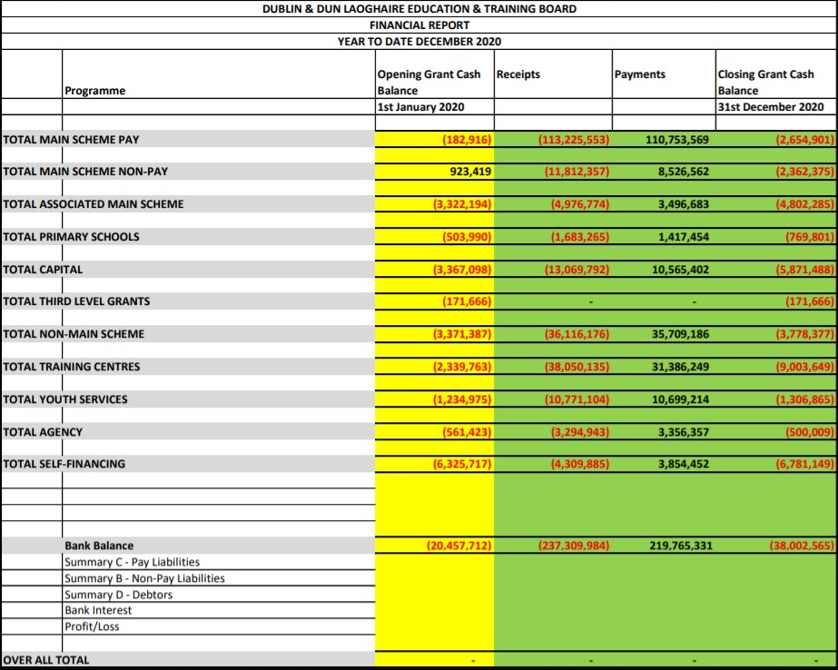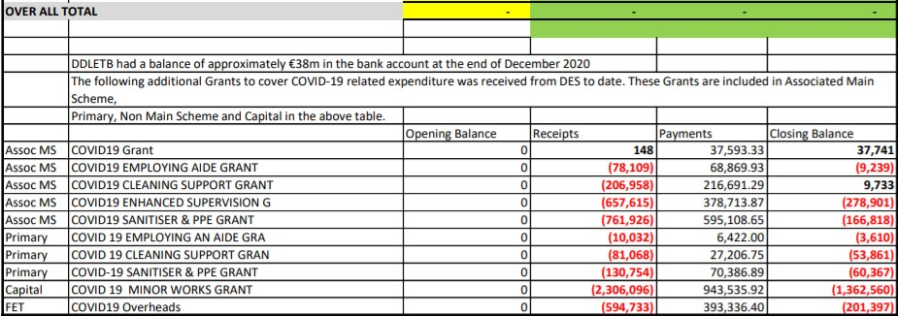

Capital and Buildings Report

DDLETB Meeting January 2021 Capital & Building Programme Report
Major Capital Projects 2021

Name & Address Of Project. | Area. | Project Status/Update.
Balbriggan Community College, Pine Ridge, Chapel Street, Balbriggan. | North County Dublin  Fingal County Council Area | Construction of new  School,  Stage 2B being prepared for the Department of Education. Outstanding Fee Up lifts approved by the Department.
St Finian’s Community College, Castle farm, Swords. | North County Dublin  Fingal County Council Area | Construction of  Extension, 13 General Classroom’s & Specialist Rooms.  DDLTEB working with the DOE on a revised Scope.
Ardgillan Community College, Castle land, Balbriggan, Co.  Dublin. | North County Dublin  Fingal County Council Area | The project is a remedial /refurbishment of certain designated areas within college. Being managed by the DOE. Planning Permission is now lodged by DOE for remedial works.
Lucan Community College, Esker Drive, Lucan. | South West Dublin  South Dublin County Council. | Extension & Refurbishment.  Stage 2B report has gone to the Department of education.  Approval to proceed with Pre-Qualification of Contractors.
Colaiste Chillian, 96-116 Old Nangor road, Clondalkin, Dublin 22. | South West Dublin,  South Dublin County Council. | Approval to proceed with Pre-Qualification of Contractors
Benicasa Special School.  1 Mount Merrion Avenue,  Blackrock, Co. Dublin | South East Dublin. Dunlaoghaire/Rathdown County Council. | Refurbishment of existing Building. At stage 2B with the DOE.  Also Awaiting a decision on a fee uplift.
CAPITAL PROJECTS CONTINUED

St Kevin’s Community College, Font Hill Road, Clondalkin.  Dublin 22. | South Dublin County Council Area. | SEN 2 Classrooms.  Design Team appointed.  Stage 1 report is being sent to the Department.
Danu Community Special School, Barnwell Road, Hansfield, Dublin. | West County Dublin.  Fingal County Council Area. | Refurbishment of Classrooms. Design Team Tenders Returned.
GS Reachrann,  Grange Abbey Road, Dublin 13. | North Co. Dublin | At Stage 2b, currently awaiting decision from DOE, approval to proceed with pre- qualification of contractors.
Skerries Community College, Balbriggan St, Town parks, Skerries, Co. Dublin. | North Co Dublin.  Fingal County Council Area. | Approval granted By DOE for new extension. Confirmation given that the SLA will be signed, the project is to proceed to next phase.
Mount Seskin Community College, Jobs town, Tallaght, Dublin 24. | South Co Dublin  South Dublin County Council | Budget Approved for new SNU. Design team being approved.
Collinstown Park SEN,  Rowlagh, Clondakin, Dublin 22. | South Co Dublin  South Dublin County Council. | Design Team Appointed. Stage  1 report is being sent to the Department.
Summer Work’s Programme 2020. |  | All Tenders Back, and Approval Received from the DOE for most projects.
TEMPORARY ACCOMADATION PROJECTS 2020

Name & Address of Project. | Area. | Project status/Update.
Ardgillan Community College Castle land, Balbriggan, Co.  Dublin. | North Co Dublin  Fingal County Council Area. | Projected Completed December 2020.
Fingal TA  Sea town Rd, Town parks, Swords, Co. Dublin. | North Co Dublin  Fingal County Council Area | Ongoing discussions between the DOE, Fingal County Council and the DDLETB.
Griffeen Community College, Ninth Lock Rd, Lucan, Co. Dublin | West Co Dublin.  South Dublin County Council. | Projected Completed December 2020.

Property Update: Leases/Licences Leases
- Sarsfield House Balbriggan – Lease negotiations for the renewal of the 2nd/3rd Floor Lease were ongoing since last year. Lease has been finalised and was signed this month. Done

- Baldoyle Training Centre Satellite Unit – Lease for this centre was out in April 2020. The renewal lease is with our solicitors for review at present.

- Burgandy House Swords – Lease negotiations coming to a close. Our solicitor should have a final lease for signing shortly.

Licences
- Firhouse CC Sports Complex – Part of the Sports Complex is licenced out to Small Steps Together Crèche Renegotiations of rents ongoing at present due to centre closure re Covid-19. Done

- Lucan Community College – A 2 year licence was issued in January 2020 for use of the schools playing pitch by Arthur Griffith Park FC.

- Holmpatrick National School – Licence Expired in October 2020. A licence is being drafted to renew the school’s occupation of our building for a further 5 years. With our solicitor at present.

- Scoil Aoife Community National School – Licence being drafted to allow Care & Cuddles Pre-school use an area in the school. With our solicitor at present.

- Former Senior College Dun Laoghaire (Eblana) – Temporally being used by the Department of Education & Skills to house Dun Laoghaire Educate Together National School. This is due to remedial works at their school – Licence drafted and awaiting signature.

- Citywest Campus – Temporally being used by the Department of Education & Skills to house schools affected by remedial works – Licence drafted and going to DoES for consideration.

Other
• Ériu Community College - Ériu CC are temporally using room in Luttrellstown Community Centre. User Agreement Signed with Fingal County Council

Risk Management
The DDLETB Risk Landscape was presented to the board. This is a summary of DDLETBs progress in assessing and reassessing risk as we implement our risk management plan. This risk landscape pulls data directly from the risk register in summary form. The full register is examined in detail on a quarterly basis by our Audit and Risk Committee.

5. Correspondence from Department
Department Circular letters

6. IADT Governing Body Nominees
The CEO asked members to consider putting themselves forward as a nominee for the board of the IADT.
Cllr Michael Clark Cllr Kazi Ahmed Cllr Una Power

Proposed: Cllr Kazi Ahmed Proposed: Cllr Michael Clark Proposed: Ken Farrell Seconded: Cllr John Walsh Seconded: Cllr Peter Kavanagh Seconded: Cllr John Walsh

- Policies and Procedures
Policies for renewal were confirmed
- Board Effectiveness Self Evaluation
The Cathaoirleach informed the board of the self-evaluation form which is to be completed within 2 weeks.
- Board of Management Members Review Deferred to next meeting
Cllr Ed O’Brien was appointed to the board of Adamstown CC

Proposed: Cllr Kazi Ahmed Seconded: Cllr Peter Kavanagh

10. Any other business
- A request was made that documentation be made available 7 days prior to the meeting was noted.
- A request for information in relation to interview procedures was made.
- Members requested that board of management meetings do not conflict with ETB board meetings.

11. Next Meeting Tuesday 23rd February 2021

Chairperson’s signature: Date:

