Minutes of meeting of Dublin and Dun Laoghaire Education and Training Board held on MSTeams and using conference call.

Meeting 12: 4:30 pm, 16th November 2020

Present: Daneve Harris, Cllr Kazi Ahmed, Cllr Yvonne Collins, Anne Genockey, Claire Markey, Cllr Brigid Manton, Paul
McNally, Cllr Joe Newman, Cllr Ed O’Brien, Cllr John Walsh, Brendan O’Halloran, Cllr Cathal Boland, Gerry McGuire, Colm Kilgallon Cllr Michael Clark, Cllr Una Power, Ken Farrell, Cllr Peter Kavanagh, Cllr Pamela Kearns, Cllr Pamela Conroy.

In Attendance: Caitríona Murphy, CEO; Debbie Howlett, Director of Organisation Support and Development; Thea
Jordan, Public Affairs Officer; Adrian Flynn, Director of Schools, Nichola Spokes, Director of Schools, Trevor Moore, Director of Further Education and Training, Bill Kavanagh, Buildings Officer, Treacy Byrne, Buildings & Property Officer, Emma Maloney, PA to SMT.

Documentation:
Uploaded Electronically

- Meeting Agenda
- Minutes of previous meeting
- Committees and Reporting
- Correspondence from Department
- Correspondence from other
- Annual Report
- Board of Management member appointment

Welcome
The Cathaoirleach, Cllr John Walsh, welcomed Cllr Pamela Conway to the board and welcomed everyone to the meeting. Having tendered his resignation to the CEO he thanked board members and DDLETB for their support during his year as Cathaoirleach. Cllr Walsh wished the new Cathaoirleach the best in their new role.

1. Appointment of Cathaoirleach
Daneve Harris was appointed as DDLETB Cathaoirleach

Proposed by Paul McNally Seconded by Colm Kilgallon

Gerry McGuire resigned as Deputy Cathaoirleach. It was agreed that the appointment of Deputy Cathaoirleach would be deferred until our next meeting on 18th January 2021.

Condolences
Votes of Sympathy were expressed to the following:

Ellen McManus, Head office, on the death of her father Jim. Past employee of ANCO/FAS.
Paul Fields, ETBI, on the death of his father, Patrick.
The passing of Ronan Connolly, former Principal of Jobstown CC (Mount Seskin) Bill Kavanagh, Head office, on the death of his father in law Bill.
Debbie Howlett, Head office, on the death of her mother in law Eilis.

- Meeting Agenda
The meeting agenda was agreed

- Declaration of Conflict of Interest
No conflicts were declared

Approval of Previous Minutes
The minutes of previous meeting held on 19th October 2020 were approved Proposed: Cllr Joe Newman Seconded: Cllr John Walsh

Committees and Reporting
5.1. Committees to the Board were confirmed

Further Education
5.1.1. Blackrock FEI BoM Minutes 22nd September 2020

Post Primary
5.1.2. Kingswood CC BoM Minutes 10th June 2020
5.1.3. Kingswood CC BoM Minutes 18th June 2020
5.1.4. Kishoge CC BoM Minutes 5th May 2020
5.1.5. Mount Seskin CC BoM Minutes 27th August 2020

Primary
5.1.6. Danu CSS BoM Minutes 24th June 2020
5.1.7. Danu CSS BoM Minutes 23rd September 2020
5.1.8. Rivervalley CNS BoM Minutes 1st October 2020

Section 29
5.1.9. Record of Decision, DANU2, Danu CSS 3rd Nov 2020
5.1.10. Record of Decision, KINGCC1, Kingswood CC 23rd September 2020
5.1.11. Record of Decision, KINGCC2, Kingswood CC 23rd September 2020
5.1.12. Record of Decision, LUSCC5, Lusk CC 20th October 2020
5.1.13. Record of Decision, LUCCC25, Lucan CC 20th Oct 2020
5.1.14. Record of Decision, LUTCC18, Luttrellstown CC 19th Aug 2020

5.2. Reports from the Executive
5.2.1. Staff Profile updates were noted
5.2.1.1. Appointments & Promotions
5.2.1.2. Resignations
5.2.1.3. Retirements

5.2.2. Finance
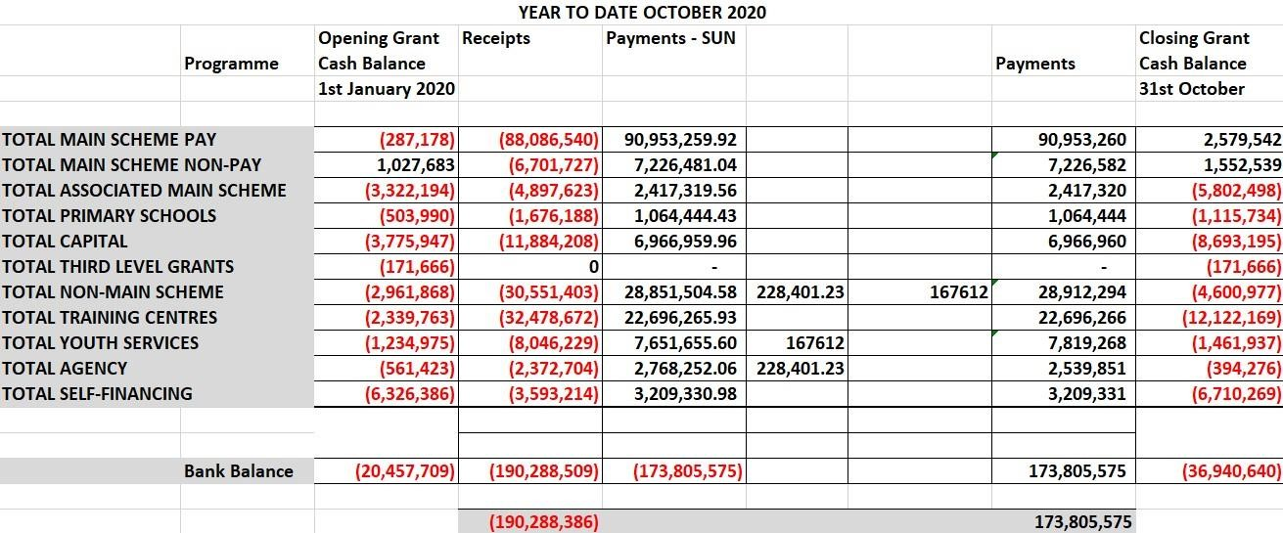
DDLETB had a balance of approximately €34m in the bank account at the end of August 2020
The following additional Grants to cover COVID-19 related expenditure was received from DES to date. These Grants are included in Associated Main Scheme, Primary and Capital in the above table.
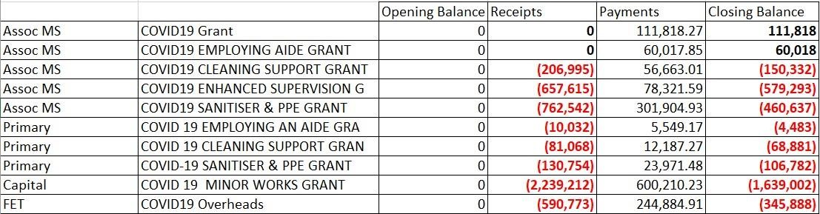

5.2.3. CEOs Report

Chief Executive Officer Update
Congratulations and formal thanks to Chairs and Vice Chairs. We look forward to the continued success and growth of DDLETB.
Since our last meeting, the organisation has been working collaboratively to operate at Risk Level 5 until 1st December 2020. That is our top priority. I would like to thank the Directors of Schools (Adrian and Nichola) who have continued to support the DDL Principals and Trevor Moore who is leading our FET services. The new FET Strategy was launched recently and SOLAS are now developing an action plan in collaboration with the ETB sector. DDLETB will have an important part to play in the implementation. The CEs are meeting with SOLAS tomorrow.
In relation to training for this Board and following on from discussions at previous meetings, I just want to bring the following to your attention as we propose the following over the next number of meetings and months;
- Today, Debbie will present a summary of the roles and responsibilities of this Board as laid out in legislation. This should serve as a high level reminder.
- Crowe Consultants will provide a more in-depth session in relation to Corporate Governance in December.
- In early 2021, the Directors of Schools will provide a session for members of BOMs which will take into account all of the different contexts.
- The new Board of Management manual is being developed by ETBI (which will incorporate the legal advice) and will be made available to you as soon as it is complete.

Director of Organisation Support and Development Update
Covid-19
Staff are continuing to work remotely. Staff in some areas are attending the workplace only where it is essential to do so. The Buildings and other OSD reports are available as part of the agenda. A summary presentation by Debbie Howlett will follow.

Directors of Schools Update
Directors of Schools: Patronage Campaign
Both Directors are leading and developing the DDLETB Patronage campaign strategy, with the assistance and implementation of same by part-time Communications Officer, Janet Murphy.
In 2018, the Government announced the establishment of 42 new schools over the four year period from 2019 to 2022. This was decided following on from a nationwide, forward-planning exercise carried out by the Department into the future need for primary and post-primary schools across the country. Since the 2018 announcement, two additional new primary schools established in 2019 and 2020 have been announced as well as the establishment of a new Irish-medium post-primary school in 2020 and two new post-primary schools in 2021, bringing total numbers of new schools for demographic purposes from 2019 to 2022 to 47 schools.

DDLETB is seeking the patronage of both Primary (CNS) and Post Primary (CC) in the following areas:
Primary
- Donaghmeade-Howth Area: The new school will be a Gaelscoil
- Sallynoggin – Killiney - DLR north
Note: The following 2 schools have been deferred from 2021
- Bray – Woodbrook - Shanganagh
- Clondalkin D22

Post Primary
- Booterstown - Blackrock & Dún Laoghaire
- Sallynoggin – Killiney - DLR north

These schools, identified as being Regional Solutions, are planned to serve more than one school planning area. Patronage campaign is well underway for all the above schools.
Progress to date:
- Social Media: Facebook and Instagram pages for each area with steadily increasing following in promotion of ETB schools: Total combined: 6300.
- Integrated mailing lists: Mailing lists integrated into the DDLETB websites and ETBI CNS websites resulting in bespoke notifications for Primary and Post Primary enquiries.
- Websites: Blogs and testimonials form CNS and CC Parents, staff and pupils on CNS and DDL websites linked with post notification on above platforms.
- Press Release: Howth - The Northside People.
- On-line information sessions: Teams meetings with Parents groups, crèches, and community groups – Link with our “Voice on the Ground”.

The DDLETB SMT request the assistance of the Board members in supporting the patronage campaign. Director of Further Education and Training Update
PLC registrations are performing very well. Although November 30th is the cut off for declarations, the majority of our colleges have completed this task. Therefore, we can predict with a degree of certainty that our PLC Return will be approx. 2,600 students. This is in line with 2018 and slightly below 2019 (2,741).

Employed Training is having a successful year to date. Year on year numbers are higher than 2019 in Traineeship Employed (911) and Skills to Advance (853). Online training provision has proved attractive to employed learners and companies are seeing an opportunity during the current crisis to upskill staff.
DDLETB, via the Blanchardstown Adult Education Service, began a new cohort of learners on the EXPLORE initiative in November. This was delayed due to COVID restrictions but delighted to say the initiative got up and running with the support of employers. The Explore initiative has been developed to help address the issue of Ireland's low level of participation in lifelong learning, particularly targeting persons over 35 years of age in manufacturing employment.

A new External Authenticator panel for DDLETB is being identified to ensure that ETB centres have a sufficient supply of suitably qualified and trained External Authenticators to ensure oversight of the quality assured assessment and certification process. In summer 2020, despite centres being closed, DDLETB learners achieved 18,220 minor awards, in 420 different modules. The FET team will commence planning in relation to the new FET Strategy 2020-2024.

5.2.4. Buildings Report

Major Capital Projects 2020
Name & Address Of Project. | Area. | Project Status/Update.
Balbriggan Community College, Pine Ridge, Chapel Street, Balbriggan. | North County Dublin  Fingal County Council Area | Construction of new School,  Stage 2B being prepared for the Department of Education. Outstanding Fee Up lifts to be resolved but progress made to date on this.
St Finian’s Community College, Castle farm, Swords. | North County Dublin  Fingal County Council Area | Construction of Extension, 13 General Classroom’s & Specialist Rooms.  DDLTEB working with the DOE on a revised Scope.
Ardgillan Community College, Castle land, Balbriggan, Co. Dublin. | North County Dublin  Fingal County Council Area | The project is a remedial /refurbishment of certain designated areas within college. Being managed by the DOE. Planning Permission is now lodged by DOE for remedial works.
Lucan Community College, Esker Drive, Lucan. | South West Dublin  South Dublin County Council. | Extension & Refurbishment.  Stage 2B report has gone to the Department of education.  Approval to proceed with Pre-Qualification of Contractors.
Colaiste Chillian, 96-116 Old Nangor road, Clondalkin, Dublin 22. | South West Dublin,  South Dublin County Council. | Approval to proceed with Pre-Qualification of Contractors
Benicasa Special School.  1 Mount Merrion Avenue, Blackrock, Co. Dublin | South East Dublin.  Dunlaoghaire/Rathdown County Council. | Refurbishment of existing Building.  At stage 2B with the DOE.  Also Awaiting a decision on a fee uplift.

Major Capital Projects 2020 continued
St Kevin’s Community College, Font Hill Road, Clondalkin. Dublin 22. | South Dublin County Council Area. | SEN 2 Classrooms.  Design Team appointed.  Stage 1 being prepared.
Danu Community Special School, Barnwell Road, Hansfield, Dublin. | West County Dublin.  Fingal County Council Area. | Refurbishment of Classrooms.  Design Team Tenders Returned
GS Reachrann,  Grange Abbey Road, Dublin 13. | North Co. Dublin ? | At Stage 2b, currently awaiting decision from DOE, approval to proceed with pre- qualification of contractors.
Skerries Community College,  Balbriggan St, Town parks, Skerries, Co.  Dublin. | North Co Dublin.  Fingal County Council Area. | Approval granted By DOE for new extension.
Mount Seskin Community College, Jobs town, Tallaght, Dublin 24. | South Co Dublin  South Dublin County Council | Budget Approved for new SNU. Design team being approved.
Collinstown Park SEN, Rowlagh, Clondakin, Dublin 22. | South Co Dublin  South Dublin County Council. | Design Team Appointed. Stage 1 is being prepared.
Summer Work’s Programme 2020. |  | Currently Out to Tender.
TEMPORARY ACCOMADATION PROJECTS 2020

Name & Address of Project. | Area. | Project status/Update.
Ardgillan Community College Castle land, Balbriggan, Co. Dublin. | North Co Dublin  Fingal County Council Area. | Contractor on site  Projected Completion Date December 2020.
Fingal TA  Sea town Rd, Town parks, Swords, Co.  Dublin. | North Co Dublin  Fingal County Council Area | Ongoing discussions between the DOE, Fingal County Council and the DDLETB.
Griffeen Community College, Ninth Lock Rd, Lucan, Co. Dublin | West Co Dublin.  South Dublin County Council. | Project processing on Site.  Projected Completion Date December 2020.

Property Update : Leases/Licences

Leases
- Sarsfield House Balbriggan – Lease negations for the renewal of the 2nd/3rd Floor Lease were ongoing since last year. Lease has been finalised and was signed this month.
- Baldoyle Training Centre Satellite Unit – Lease for this centre was out in April 2020. The renewal lease is with our solicitors for review at present. Licences
- Firhouse CC Sports Complex – Part of the Sports Complex is licenced out to Small Steps Together Crèche Renegotiations of rents ongoing at present due to centre closure re Covid-19.
- Lucan Community College – A 2 year licence was issued in January 2020 for use of the schools playing pitch by Arthur Griffith Park FC.
- Holmpatrick National School – Licence Expired in October 2020. A licence is being drafted to renew the school’s occupation of our building for a further 5 years. With our solicitor at present.
- Scoil Aoife Community National School – Licence being drafted to allow Care & Cuddles Pre-school use an area in the school. With our solicitor at present.
- Former Senior College Dun Laoghaire (Eblana) – Temporally being used by the Department of Education & Skills to house Dun Laoghaire Educate Together National School. This is due to remedial works at their school – Licence drafted and awaiting signature.
- Citywest Campus – Temporally being used by the Department of Education & Skills to house schools affected by remedial works – Licence drafted and going to DoES for consideration.

Other

- Ériu Community College - Ériu CC are temporally using rooms in Luttrellstown Community Centre. User Agreement Signed with Fingal County Council

Purchase of Site for Griffeen Community College

Proposed Ken Farrell Seconded Cllr. Pamela Kearns

- Correspondence from Government Department
  - Ltr dated 27th October 2020 from DES Buildings re: lease of Burgandy House Swords
  - Ltr dated 15th October 2020 from Ministers office re: acknowledgement of receipt of letter in relation to the shortage of school places in Dublin 15
  - Department Circular letters

- Correspondence from other
  - Ltr dated 10th November 2020 from Fingal County Council re: Appointment of Cllr Pamela Conroy to the DDLETB board.

- Annual Report amended

Proposed Cllr Joe Newman Seconded Gerry McGuire

- Board of Management Members appointments Deferred

- Board of Management members review
Cllr Cathal Boland to replace Cllr Joe Newman on the board of Swords Youthreach Proposed by Ken Farrell Seconded by Cllr Joe Newman

- Any other Business

ETBI Board Member Training, Wednesday 9th December at 4.30pm

Purchase of a site for Griffeen CC of 5.7 acres was Proposed by Ken Farrell Seconded by Cllr Pamela Kearns

12. Next meeting
18th January 2021
Daneve Harris
Daneve Harris (Feb 16, 2021 18:11 GMT)
Chairperson
16/02/2021

