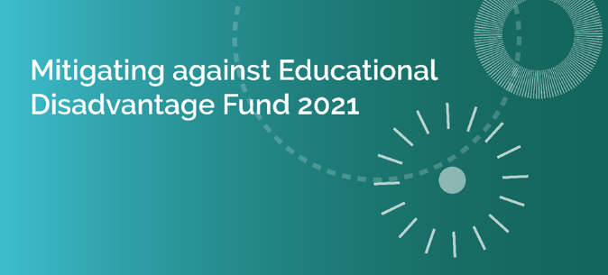
External Application Form for Funding
Note: Projects to be completed by 2021 year-end. Funding applications must be submitted through your local ETB.
Section 1. Community Group/Project Information
Part 1 - to be completed by all applicants
Part 2 - if applicable, where the ETB does not have the up-to-date details relating to Tax Clearance and Bank Account.
Section 1 – Part 1 – Community group/project
Name of Community Group:
Title of project proposed:
Contact details
Contact Person |  |  |  |  | Role within organisation
Community Group Address
email |  |  |  |  |  | Phone number
Funding
Have you received Mitigating against Educational Disadvantage funding from another source? |  |  |  |  |  |  |  |  | Yes/No
If yes, please answer the following questions
Source(s) of this funding |  |  |  | Intended purpose of this funding

Section 1 – Part 2 – Complete if applicable
Tax Clearance (Please attach details of your current Tax Clearance Access with this application)
Tax registration number:
Tax clearance certificate number:
CHY number (if applicable)
Bank details
Name of bank
Address of bank
Sort code |  |  |  |  |  |  | Account number
IBAN

Section 2 – project costs/funding
Cost of project | €
Grant request (the grant amount sought in this application) |  |  |  | €
If the total cost of the project is greater than the amount of the grant sought, please outline where and how the balance of funding will be secured:
Project costs for each of the following, where applicable (grant amount sought for each)
Digital Technologies |  | Learner Assistance Fund | Out-reach/ mentoring |  | COVID-19 Recovery Exceptional Circumstances
€ |  | € | € |  | €

Section 3 – Project details
Project proposed
Please provide a synopsis of the project proposed under the specific funding criteria that the grant is sought for:
Funding Criteria | Target Group(s) | Funding Purpose
Digital Technologies
Learner Assistance Fund
Out-reach/mentoring
COVID-19 recovery exceptional circumstances
Please include any additional information regarding the target group(s) you wish to add to support this application:
Please provide information demonstrating how this funding intends to mitigate against educational disadvantage for the cohort you are working with:
Please outline how the funding can complement and/or enhance the current provision of similar education in the area.
Please clarify how this funding will support your learners to achieve positive outcomes as a result of this support:
How will the benefits of this funding be measured?
Please provide information on how this project represents value for money and indicate what steps the project has taken to ensure avoiding duplication with existing services in the area:

Section 4 – Submission Details
I declare on behalf of insert organisation name
That I have the appropriate authority to make this submission for funding. This application for funding form is fully completed and the information provided is a full and accurate account of how the funding (if allocated) will be used in 2021.
Signature |  |  | Print name
Position in organisation |  |  | Date

Applications to be submitted to your local ETB: ETB to provide details of where applications should be sent
Closing date for receipt of applications: ETB to provide details

