 | 
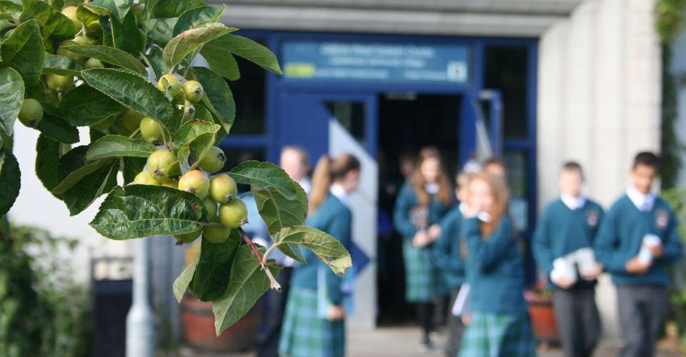 | 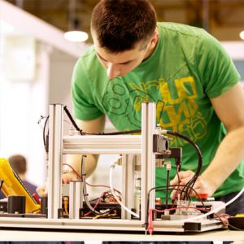

  - Cleaning Guidelines for the Prevention of Covid-19 Infections:
Covid-19 : Advice in support of the Governments Return to the Workplace Safely | Cleaning Guidelines
June 2020

Table of Contents
Introduction 3
How Does The Novel Coronavirus Transmitted? 3
General Cleaning In All Types Of Premises 4
Cleaning Toilets 5
Special Cleaning For Areas Previously Occupied By Persons Infected With Covid-19 6
How Should Cleaning Workers Protect Themselves From Viral Infection? 7
Contacting Health Services 8
Further Information 8

Derived from HSE guidance document:
Management of Infectious Disease

Introduction

These guidelines are intended for both general cleaning and for disinfecting areas that have been exposed to a person who is ill with CODIV-19. Areas in which a person with a confirmed CoviD-19 infection has previously spent time need to be disinfected before resuming their use. These cleaning guidelines can also be applied in general cleaning to prevent the spread of communicable diseases and protect cleaning staff from infections. The guidelines have been drawn up in co-operation with the World Health Organisation (WHO).

How Does The Novel Coronavirus Transmitted?

The new coronavirus is primarily transmitted through respiratory droplets and contact when a person coughs or sneezes. The infection risk from coronavirus (COVID-19) following contamination of the environment decreases over time. It is not yet clear at what point there is no risk. However, studies of other viruses in the same family suggest that, in most circumstances, the risk is likely to be reduced significantly after 72 hours.
Even if the coronavirus is found on surfaces using highly sensitive laboratory methods, this does not mean that the virus is effectively transmitted via surfaces.
In everyday life, you can reduce your risk of infection by maintaining good hand hygiene.

General Cleaning In All Types Of Premises
- Start cleaning from cleaner areas and proceed towards dirtier areas. All surfaces that are frequently touched (e.g. door handles, armrests, table tops, light switches, water taps) need to be cleaned thoroughly and frequently.
- In public premises where people touch the surfaces, the cleaning should be done daily at least. If possible even more often e.g. between 2-4 hours especially during the epidemic.
- The public premises of workplaces must be cleaned using different equipment than the premises used by employees.
- Use a mildly alkaline all-purpose detergent for cleaning. The cleaning of sanitary facilities can be enhanced by using a disinfectant.
- Wear gloves to protect the hands when cleaning surfaces. Use tight-fitting disposable gloves, for example, as all-purpose gloves, or chemical resistant gloves. Learn more about the instructions on how to remove gloves
- In particular, bins of bio- and mixed waste are coated with easily removable, leakproof bags in waste bins. Monitor waste bins and do not let them get more than three-quarters full. Waste bins are emptied daily, especially in public premises. The collected bin bags must be closed tightly.
- Carefully clean the equipment used in cleaning at the end of the cleaning process. Wash reusable cleaning cloths at a temperature of at least 90°C or disinfectant. Clean your keys, the handles of the cleaning cart and the floor cleaning equipment and the contact surfaces of the cleaner containers with the disinfecting multi-purpose cleaner.
- After cleaning, the permanent gloves must either be carefully washed and dried. Disposable gloves are placed in mixed waste. Wash your hands up to your elbows with water and soap when the gloves are taken off.
- Work clothes is changed to your own clothes before leaving the workplace. The work clothes must be washed at the workplace or your employer must acquire appropriate laundry services.

Cleaning Toilets

There are differences in instructions on how to clean toilets. Carefully planned aseptic work instructions do not need to be changed according to these instructions. However, it is essential to note that viruses spread through faeces and that cleaning a toilet bowl may create small droplets.
- Wear disposable protective gloves whenever you clean a toilet. When you clean a toilet bowl, wear long protective gloves that go up to your elbow on top of the disposable gloves and clean the long gloves with a disinfectant afterwards. The long gloves must have a designated container in the cleaning cart from which the gloves can be put on easily without touching the outer surface of the gloves, except for the opening. Put the disposable gloves worn underneath the long gloves in a waste bin after you have cleaned the toilet. Learn more about the instructions on how to remove gloves
- Clean the door handles, taps, bidet shower, countertops, basins, mirrors, walls behind the basins and the paper and soap dispensers in the toilet with a wet cloth and the disinfecting multi-purpose cleaner. Pay special attention to cleaning contact surfaces.
- Apply a small dose of the detergent on the toilet bowl, on both sides of the lid and on the seat. Close the lid of the toilet and flush the toilet.
- Apply the toilet bowl cleaner on the bowl and its vertical surfaces while paying special attention to stains. Put on the long cleaning gloves. Clean the bowl with a toilet brush. Wash the brush when you flush the toilet and close the lid. Clean the outer surfaces of the bowl and any stains on the wall with a cloth.
- Recommended operating order on the toilet bowl: 1. Water tank and its knob, and swivel of cleaning cloth; 2. top cover and swivel of cloth; 3. seat ring and swivel of cloth; 4. Lower toilet seat.
- When you exit the toilet, do not touch the door handle or use a paper towel to open the door.
- Put the cleaning cloth in the laundry bag or use a disposable cloth. Disinfect the long gloves and put them in their designated container.
- Put the disposable gloves in mixed waste and put on new gloves.
- Wipe the floor with the floor cleaning equipment and the multi-purpose cleaner.

Special Cleaning For Areas Previously Occupied By Persons Infected With Covid-19

- Use cleaning equipment that can be easily washed after use and make sure to clean the equipment thoroughly before next use. When possible, use disposable cleaning equipment, such as disposable wipes, to clean the premises.
- The cleaning should primarily be done using the ordinary methods and supplies, such as a mildly alkaline all-purpose detergent. Use a disinfectant for commonly touched surfaces, sanitary facilities and visible stains of body fluids. Absorb stains of body fluids using a disposable absorbent cloth before using disinfectant.
- After the general cleaning has been completed, treat any surfaces that have been touched with disinfectant. The disinfectant can be alcohol-based (e.g. 70% ethanol), hydrogen peroxide (e.g. 0.5%) or chlorine-based (e.g. sodium hypochlorite solution; concentration 0.05%, use 1:100 dilution if the initial concentration is 5%). The sanitary fixtures in toilets must be treated with a higher concentration of chlorine (e.g. 0.1%). Observe the recommended concentrations and contact times indicated on the products. Disinfectants, such as chlorine-based substances, can damage surfaces. Rinse off chlorine solutions that are stronger than 0.5%. Surfaces treated with a 0.1% chlorine solution must be wiped with a wet disposable wipe when the indicated contact time has passed. Mark the expiration date on the prepared dilutions of disinfectants.
- Place waste generated during cleaning in a separate waste bag, close the bag tightly and double-bag, then stored securely for 72 hours then thrown away in the regular rubbish after cleaning is finished
- Towels and other textiles, such as bedding, should primarily be washed using 90 degree programmes. Use a disinfectant laundry detergent if the textile is not compatible with a sufficiently high washing temperature.

How Should Cleaning Workers Protect Themselves From Viral Infection?

- Use workwear and footwear that is easy to clean. When cleaning areas that have been previously occupied by a person infected with COVID-19, wear an impermeable long-sleeved protective gown and/or apron as an additional layer over your clothing.
- Use protective gloves during cleaning (e.g. nitrile rubber gloves, minimum thickness 0.3 mm, compliant with the EN 374-1 standard). Ensure an adequate supply of protective gloves of the correct size.
- Where necessary, use double gloving when cleaning sanitary facilities and handling disinfectants. Wear thin disposable gloves as the inner layer and chemical resistant gloves as the outer layer. Dispose of the disposable gloves after use in mixed waste. Learn more about the instructions on how to remove gloves
- Wear a respirator when using chlorine-based disinfectants
- If the cleaning work involves significant airborne droplets or splashing, use a respirator (FFP3) and a face shield or eye protection, especially when cleaning areas which have been previously occupied by a person infected with COVID-19.
- Clean the equipment carefully at the end of the cleaning process.
- When you take off protective equipment, be careful not to touch their outer surfaces.
- After taking off your gloves and other personal protection, clean your hands with warm water and soap or an alcohol-based hand sanitizer. If water and soap are not available, use an alcohol-based hand sanitizer and wash your hands when you have the opportunity to do so. Wash your hands and forearms after cleaning.

Contacting Health Services

If you suspect you have been infected by the COVID-19 coronavirus, contact your GP immediately.

Further Information
NSAI
World Health Organisation (WHO)

