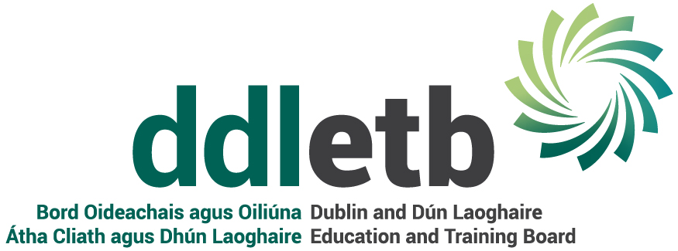
CCTV PRIVACY NOTICE

By entering an ETB premises, you acknowledge that your images shall be processed by the CCTV system of Dublin & Dún Laoghaire ETB. This Privacy Notice gives you some helpful information about who we are, what CCTV images we collect, why, who we share it with and why, how long we keep it, and your rights. If you need more information, please see our Data Protection Policy and/or our CCTV policy available at www.ddletb.ie

- We are Dublin & Dún Laoghaire ETB. Our address and contact details are DDLETB, 1 Tuansgate, Belgard Square East, Tallaght, Dublin 24. We provide primary level education, secondary level education, second chance education; further education and training including apprenticeships; Youthwork, community-based education programmes; prison education, outreach programmes, specialist programmes etc. and other programmes/courses as maybe delivered/funded/sponsored in whole or part or in co-operation with other bodies/agencies etc. For further information, see section 1 of our Data Protection Policy available at www.ddletb.ie

- We operate Closed Circuit Television Systems (“CCTV”) on our premises both during the daytime and during the night hours each day. CCTV is used at external points on the premises (e.g. at front gates, in the car-park, etc.) and at certain internal points (e.g. front desk/reception area, corridors etc). In areas where CCTV is in operation, appropriate notices will be displayed. We use CCTV for security purposes; to protect premises and assets; to deter crime and anti-social behaviour; to assist in the investigation, detection, and prosecution of offences; to monitor areas in which cash and/or goods are handled; to deter bullying and/or harassment; to maintain good order and ensure the Code of Behaviour is respected; to provide a safe environment for all staff and students; for verification purposes and for dispute-resolution, particularly in circumstances where there is a dispute as to facts and the recordings may be capable of resolving that dispute; for the taking and defence of litigation. For further information on how we use this CCTV and the legal basis for same, please go to section 2 of our CCTV Policy available at www.ddletb.ie This CCTV Privacy Notice and the CCTV Policy should be read together with the DDLETB Data Protection Policy, a copy of which is available at www.ddletb.ie

- We share and transfer CCTV images/recordings to third parties. We share information with our CCTV provider/s <insert name of CCTV provider e.g. Netwatch etc.>. For example, we may show the CCTV images to a student’s parent/guardian as part of a Code of Behaviour process. In appropriate circumstances, we also share CCTV images/recordings to An Garda Síochána (for the investigation, detection and prevention of offences); to social workers, HSE, and/or TUSLA (in respect of any child protection and/or child safeguarding matters); to the Department of Education and Skills and/or any section 29 Appeals Committee (in relation to any Code of Behaviour, suspension, or expulsion process); to the Teaching Council (where we are legally required in relation to any process under the Teaching Council Acts 2001 – 2015, including fitness to teach investigation); to the ETB’s insurance company and the ETB’s legal advisors (for dispute resolution and litigation purposes) etc. For further information on who we share your data with, when and in what circumstances, and why, please see section 3 of our Data Protection Policy available at www.ddletb.ie

- We do not transfer your personal data to a third country or international organisation.

- We do not engage in automated decision making/profiling.

- CCTV is generally held for 28 days. In certain circumstances, CCTV recordings may be held for longer, for example:
- where a break-in or theft is recorded (in which case they will be held and passed to An Garda Síochána, and/or the ETB’s insurance company and legal advisors).
- Where an injury/accident occurs (in which case CCTV may be retained and may subsequently be passed to the ETB’s insurance company, its legal advisors, the Health & Safety Authority.
- Where a breach of the Code of Behaviour is reported resulting in a student being disciplined, in which case the recordings will be retained to be viewed by parents of the affected student (if the images can be appropriately redacted/pixelated to protect the personal data of third parties), the Board of Management, the ETB, and/or a duly constituted section 29 appeals committee convened by the Department of Education and Skills for the purposes of hearings, appeals, dispute resolution and/or verification purposes.
These examples are not exhaustive, and there will be other situations where the CCTV is retained for longer than 28 days where there is a legal basis and/or we are legally required to do so. For further information on the retention periods, please go to section 6 of our Data Protection Policy available at www.ddletb.ie .

- You have the following statutory rights, that can be exercised at any time:
- Right to complain to supervisory authority.
- Right of access.
- Right to rectification.
- Right to be forgotten.
- Right to restrict processing.
- Right to data portability.
- Right to object and automated decision making/profiling.
For further information, please see section (7) of our Data Protection Policy available at www.ddletb.ie , or alternatively contact our Data Protection Officer.

- We have appointed a Data Protection Officer (DPO) on an interim basis, Paddy Lavelle can be contacted at dataprotection@ddletb.ie. If you have any queries, please consult our Data Protection Policy (available at www.ddletb.ie) or contact our DPO.

Version number | 1
Policy drafted by | Corporate Services
Approved by Executive on | 11th January 2021
Date on which it became operational | 11th January 2021
Next review date | 11th January 2022

