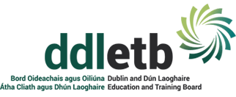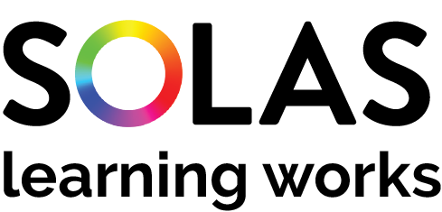
MITIGATING AGAINST EDUCATIONAL DISADVANTAGE FUND (MAEDF)
FUNDING APPLICATION FORM
This form is for external groups proposed initiatives
Note please initiatives to be completed by 2020 year-end.
Section 1. Community Group/Project Information
(Part 1 to be completed by all applicants, Part 2 – if applicable, where the ETB does not have the up-to-date details relating to Tax Clearance and Bank Account).
Section 1 - Part 1
Community Group/Project Details
Name of Community Group:
Title of Project Initiative proposed:
Details of Contact Person
Contact Person: |  |  |  |  | Role in organisation
Address:
Email: |  |  |  | Telephone
Funding
Have you received Mitigating against Educational Disadvantage Funding from another source? |  |  |  |  |  |  | Yes ☐ No ☐
If yes, please answer the following questions
Source(s) of this funding: |  |  |  |  | Intended purpose of this funding:

Section 1 – Part 2
Tax Clearance (Please attach details of your current Tax Clearance Access with this application)
Tax Registration Number:
Tax Clearance Certificate Number:
CHY Number (if applicable):
Bank Details
Name of Bank:
Address of Bank
Sort Code: |  |  | Account Number:
IBAN:

Section 2 – Financial Details

Financial Details of Project Initiative
Cost of Project: |  | €
Grant Request (the grant amount sought) |  | €
If the total cost of the project is greater than the amount of the grant sought, please outline where and how the balance of funding will be secured:
Estimated costs for each of the following:
Digital Technologies | Learner Assistance Fund | Reach out/Mentoring | COVID-19 Exceptional Circumstances
€ | € | € | €
Section 3 - Proposal Details
Statement of proposal
Please provide a synopsis of the target group and under which category you are applying for this funding:
Digital Technologies
Learner Assistance Fund
Reach out/ Mentoring
COVID-19 Exceptional Circumstances

Section 3 - Proposal Details – continued
Please include any additional information regarding the target group(s) you wish to add to support this application:
Please provide information demonstrating how this funding intends to mitigate against educational disadvantage for the cohort you are working with:
Please clarify how this funding will support your learners to achieve positive outcomes as a result of this support:
How will the benefits of this funding be measured?
Please provide information on how this project represents value for money and indicate what steps the project has taken to ensure avoiding duplication with existing services in the area:
Section 4 – Submission Details
I declare on behalf of: insert organisation name
That I have the appropriate authority to make this submission for funding. This request for funding form is fully completed and the information provided is a full and accurate account of how the funding (if allocated) will be used in 2020.

Signature |  | Print name
Position in organisation |  | Date

Applications to be submitted to: aedinotoole@ddletbaes.ie
Aedin O’Toole
Dublin & Dun Loaghaire ETB

Closing date for receipt of applications: 5 pm on Friday 27 November 2020

